**Computing Studies & Information Systems**

"Applied Research Project"

Fall 2022: CSIS 4495 – Section 050

**Final Report**

**TeamSavvy**



* **Name:** Jasmine Kaur **Student ID:** 300345933
* **Name:** Jaspal Singh **Student ID:** 300345938
* **Name:** Harman Lal **Student ID:** 300343291
* **Name:** Joling Weng **Student ID:** 300335548

Table of Contents

Statement of the Problem: 4

Significance of the study 4

Who would benefit from this project and how? 4

Users 5

Proof of Progress 6

Android App for employee’s biometric 6

APIs 9

UI Design using Adobe XD 12

Front-end 15

**Login** 15

**Sidenav** 17

**Header and Navigation** 18

**User Profile** 18

**Dashboard** 19

**Projects** 21

**Employee List** 23

**Timesheet** 24

**Task** 26

**Payroll** 28

**Jobs** 29

Database 31

**Structure of the Database** 32

**Tables in our database** 32

Features/module with objectives 34

About our project and addressed objectives 34

Set up the environment 35

**For setting up APIs** 35

**For running application** 35

Software Design Architecture 35

**UML – Use Case Diagram** 35

**Design Pattern applied w/ clear explanation on why it was chosen and how it was implemented** 36

Test done with explanations 45

Friendly user interface 46

Easy and simplified internal flow 47

Employee Engagement 47

Mobile Clock in/ Clock out 47

Set up on another machine 47

Workload distribution 49

References 51

**Front-end libraries** 51

**SQL Server** 51

Appendix 52

Progress report 1 52

Progress report 2 66

Progress report 3 108

# Statement of the Problem:

TeamSavvyhelps create an environment that motivates communication and keeps employees and managers working together to meet company goals.It also helps the company to manage the information and activities of employees.

The issue with the existing system is to access data about employee projects, leaves, payroll, and jobs applied internally, for accessing these details an individual has to use different web platforms.

Our system proposes that a person can access the details for projects, work history, team hierarchy, peers, timesheets, leaves and payroll information on one platform. The managers and company owners can access the records of employees and also check the profile of the candidates who applied for jobs on their company website with an improved user interface for a better user experience.

# Significance of the study

## Who would benefit from this project and how?

**Employee Engagement:** Our platform will provide employees to add their details, apply for leaves, and check their work history and payroll details on one platform. This will save time for an individual to concentrate on tasks for company growth. Employees can track their growth and improve their working efficiency.

**Biometric:** We will create an android app to get user biometric timestamp and will store it in the database. Employee can use his biometric to clock-in and clock-out of the system.

**Create Dashboard:** Our project will provide the dashboard of collective data of employees. A manager or company owner can perform descriptive analysis on employee’s data; with respect to programming languages, projects, leaves (sick leave, casual leave) in specific period and, salary. **We will give different graph options to select from and, can create multiple graphs to visualize data and show the dashboard on preview mode and can download it.** The HR at a company can do analytics; for example, number of employees have knowledge of programming language, salary of each employee in specific project. We will represent this information in a graphical format.

**Create Task:** The employee can fill his hours he is working on a particular task and then change the status of task to in-progress, after completing the task employee can change the task status to finish. The notification will be sent to the manager that this task has been completed. Manager can track the progress of the tasks assigned to team members.

**Improve communication:** Our platform provides the information of each employee to others by search option that will let them to stay connected, and an easy path for new joiners to get to know their peers. All in all, improve the connection which will reduce the problem of communication gap within an organization.

## Users

Employee

* An employee will have access to a calendar where he can see clock-in and clock-out for a day
* Check total working hours
* Apply for leaves
* Check his payroll details (Read only),
* Get information of other employee working in an organization for communication
* Can get the team hierarchy
* Check the number and details of projects he is working on
* Employee will have the profile page where he will have his information saved or can update if required
* Can apply on internal jobs
* Apply for resignation

Admin (HR or Manager)

* An admin will have all the functionality that employee has
* Able to see information of employees in his team
* He can perform CRUD operations on them
* Check payroll info and can give increment to an employee
* Admin will have details of project’s budget and deadline
* Can assign project to employee
* Modify involvement of employees in different projects,
* Can approve leaves of an employee
* Check timesheets
* Create internal job postings for employees.
* Super admin (Company Owner): A super admin can perform CRUD operations on admins and employees.

# Proof of Progress

## Android App for employee’s biometric

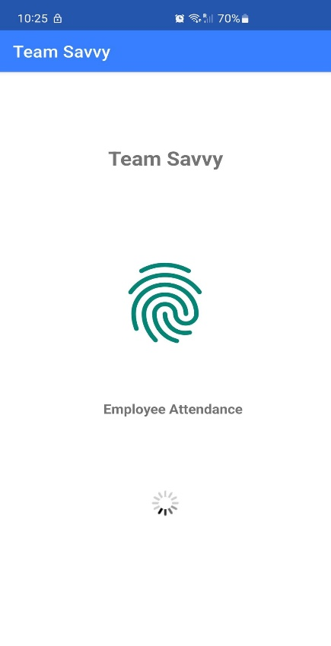

Landing screen for an employee showcasing the project name, image, message for an employee for the attendance and loader.

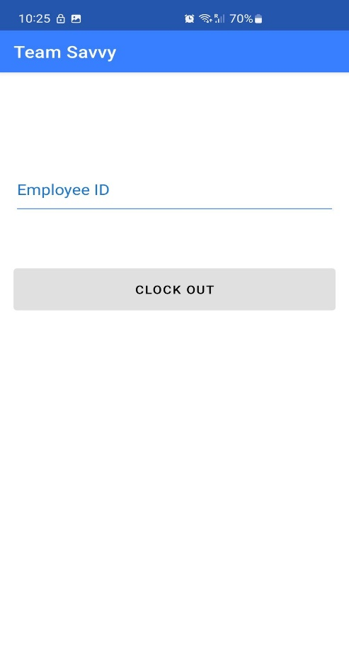

This screen will ask employee for their employee

ID and allow him to clock-in or clock-out.

We are still working on design and few features.

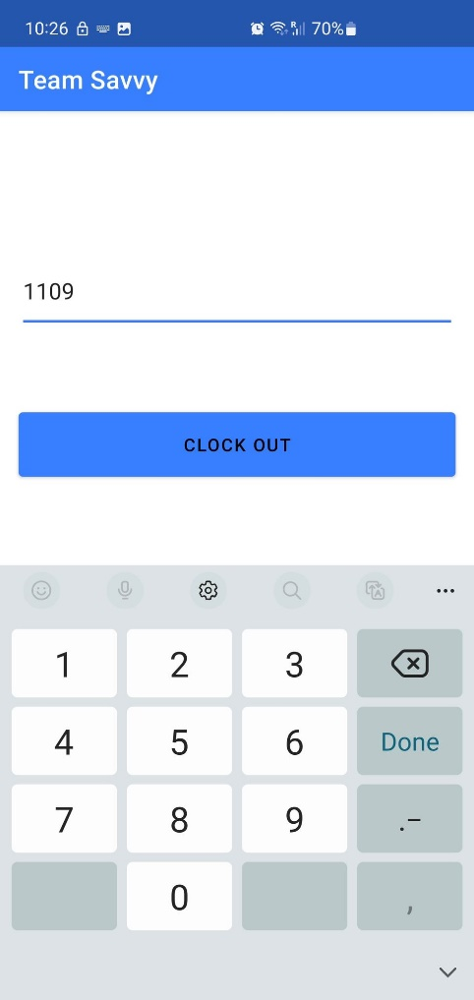

After entering the employee id the button will be activated.

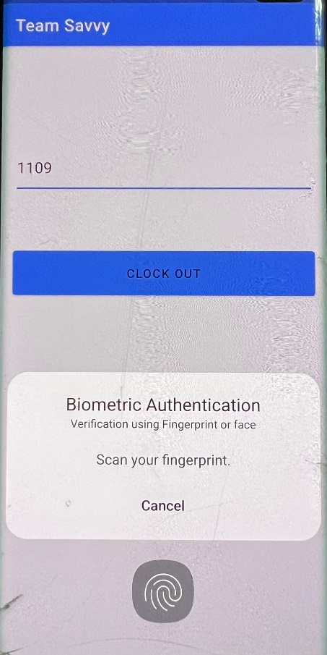

The app will ask for biometric verification, if the fingerprint matches to the record of fingerprint

in device the app will accept and allow user to clock-in or clock-out.

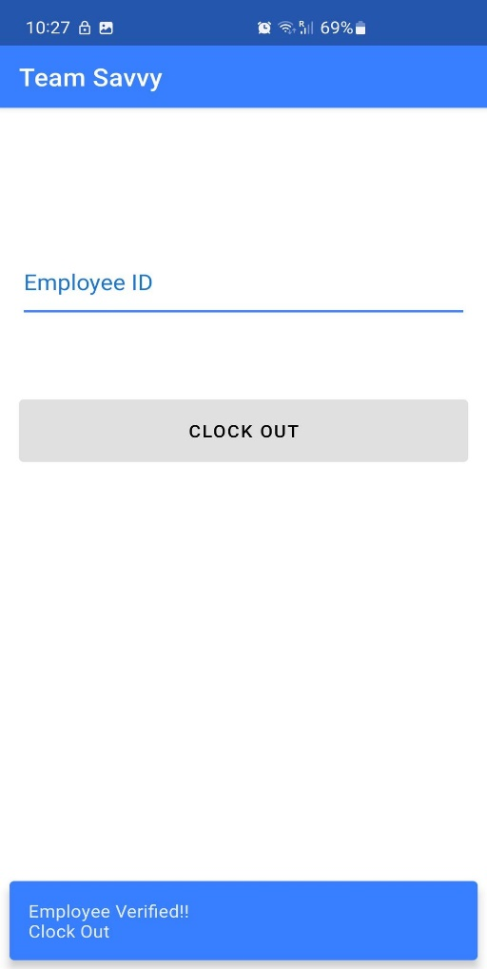

At last, the app will show the snack bar to show if an employee has been verified or not also displays the status clock-in or clock-out.

## APIs

We have created API in .NET CORE using Entity Framework, LINQ, Automapper and swagger documentation.

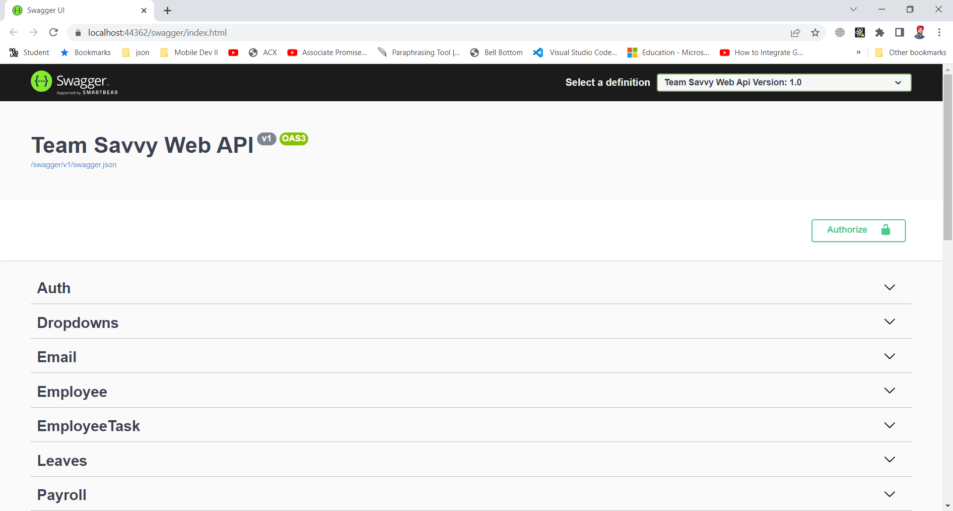

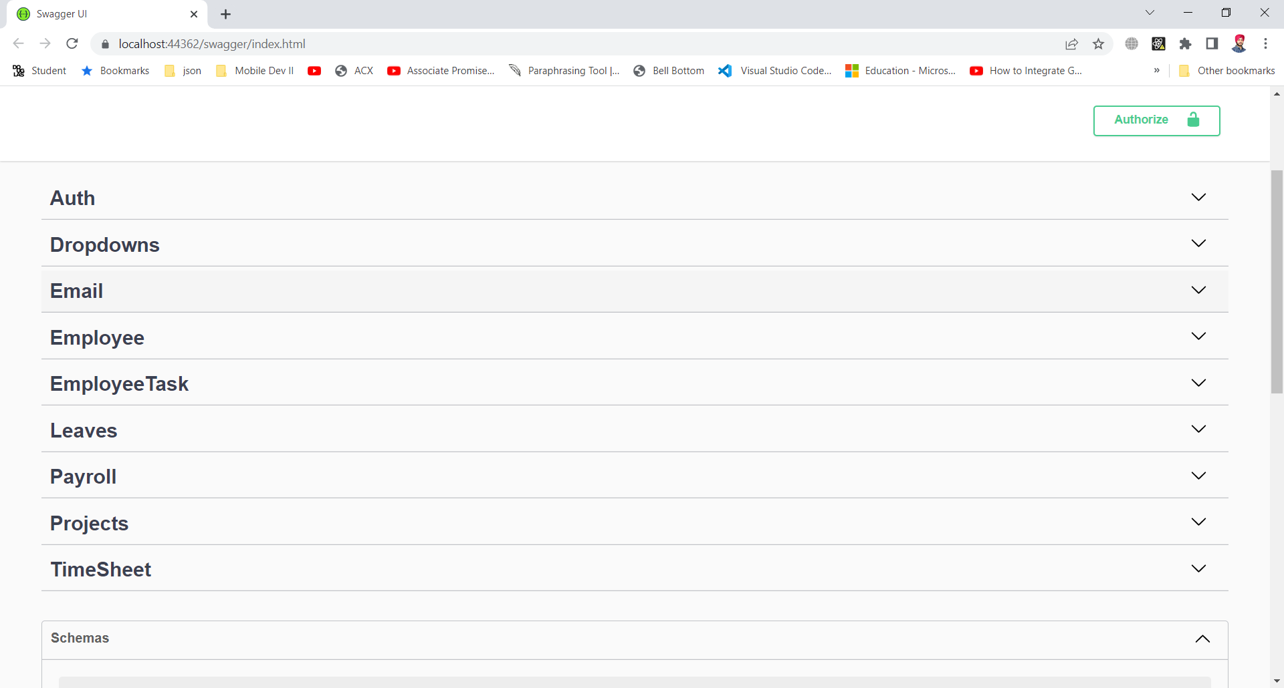

This is the swagger documentation to give a user interface to an API so developer can test API like postman. In this interface we can test all the request like post, delete, update, and get request. Above are the endpoints for Auth (Authorization), Dropdown, Email, Employee, Employee Task, Leaves, Payroll, Projects and Timesheet controllers.

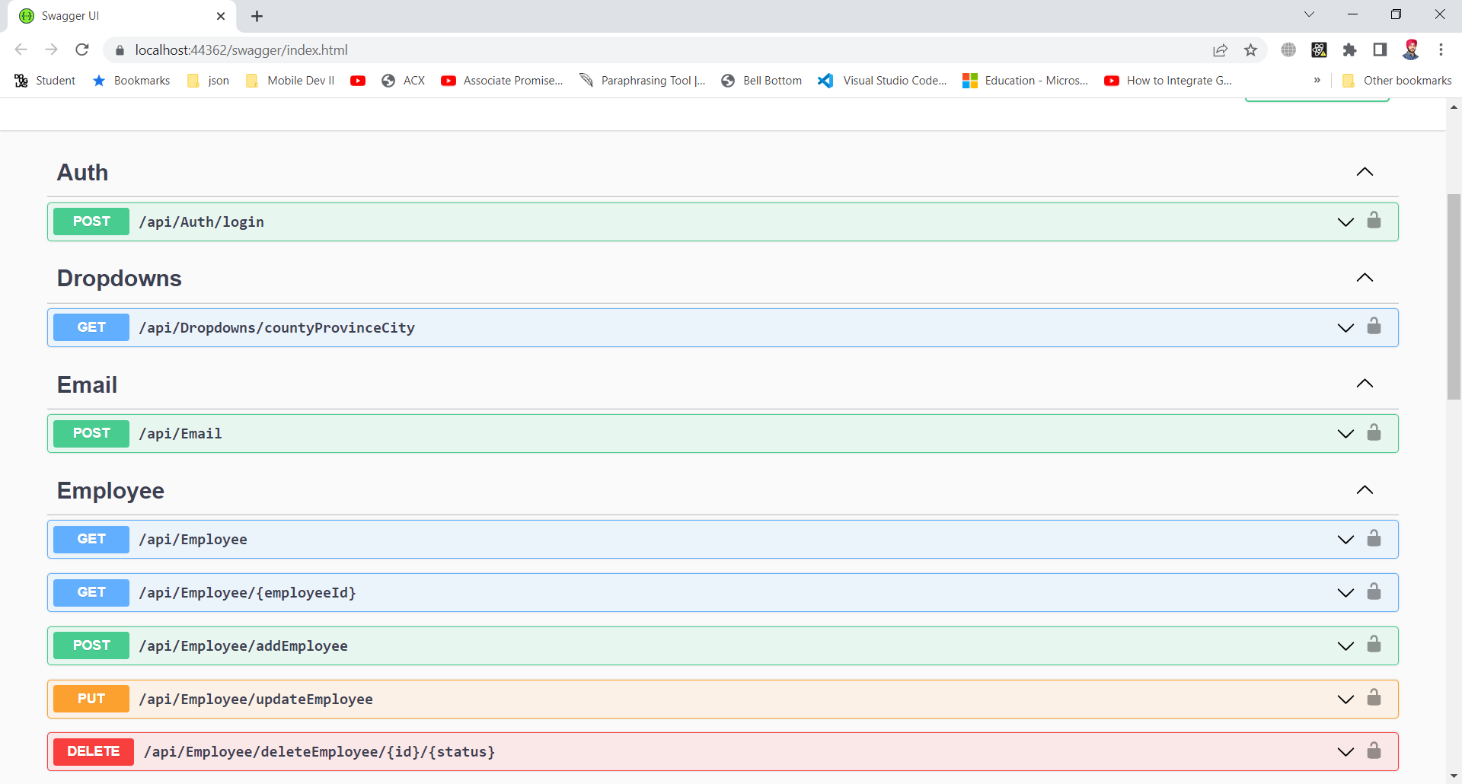

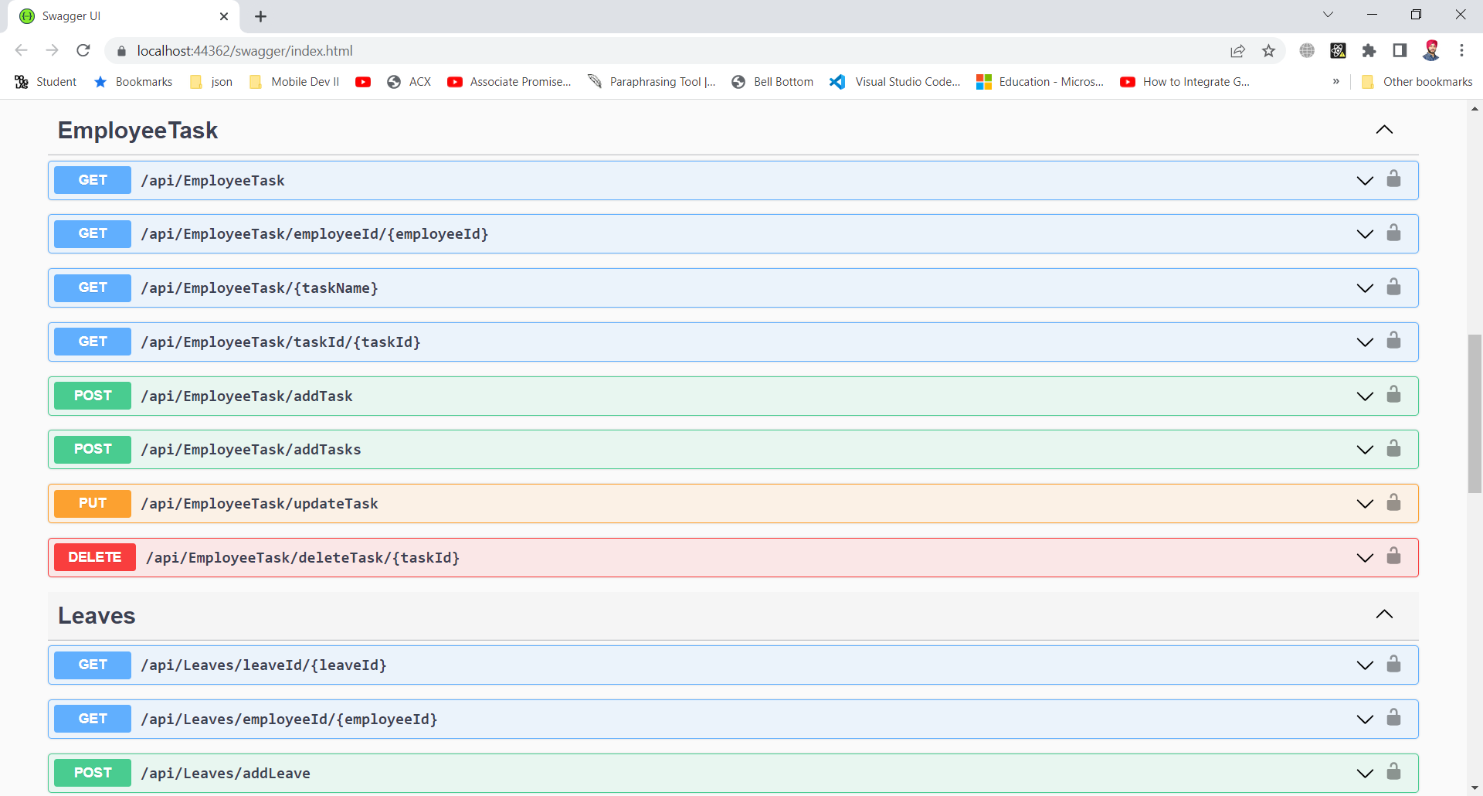

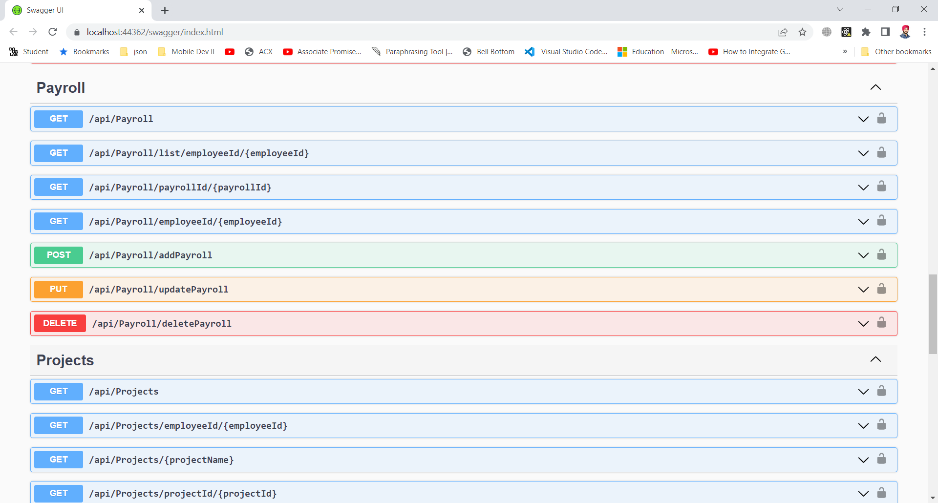

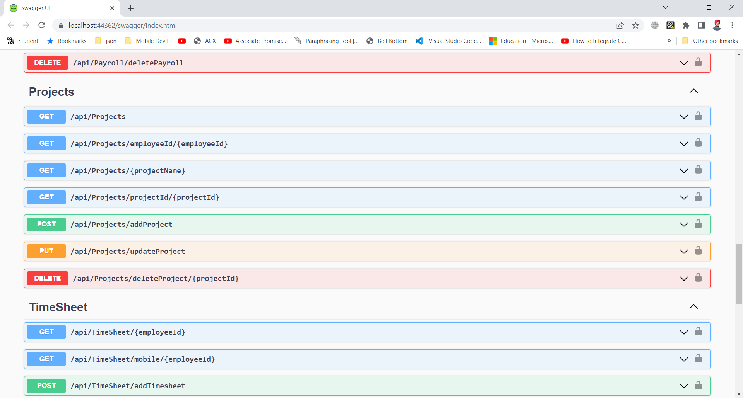

Above screenshots showing separate endpoints (GET,POST,PUT,DELETE) of all controllers created.

## UI Design using Adobe XD

The snapshots below show the flow of our application. Design Link:

<https://xd.adobe.com/view/732c0d35-1e41-41d7-876c-25bde1a844a9-267f/?fullscreen>

**Login:**

The employee and admin will login with the predefined credentials provided by organization.

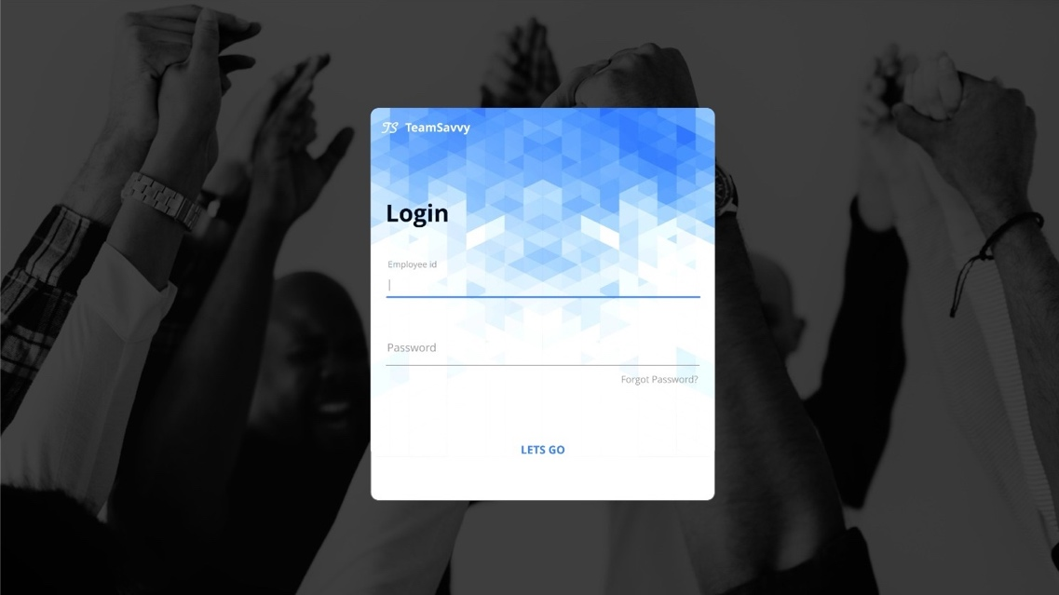

**Timesheet:**

This screen will show the information of employee clock-in and clock-out, with total hours they worked per week. Additionally, employee can apply for leaves and it will be displayed on the calendar

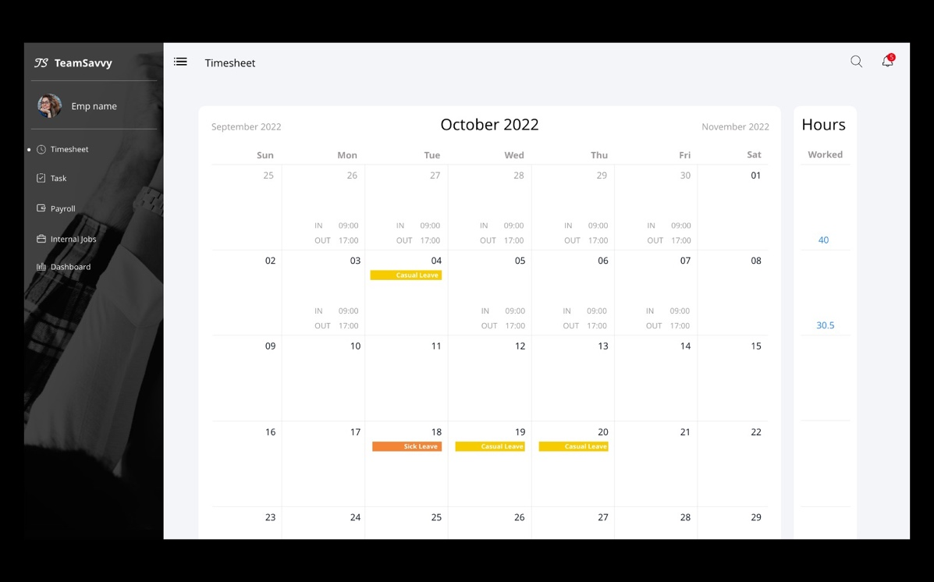

**Task:**

Task screen will have the assigned task for an employee, which he can modify to add hours, start date, and end date. Employee can also change the status from assigned to in-progress and then by using update status in in-progress lane he can change status to completed.

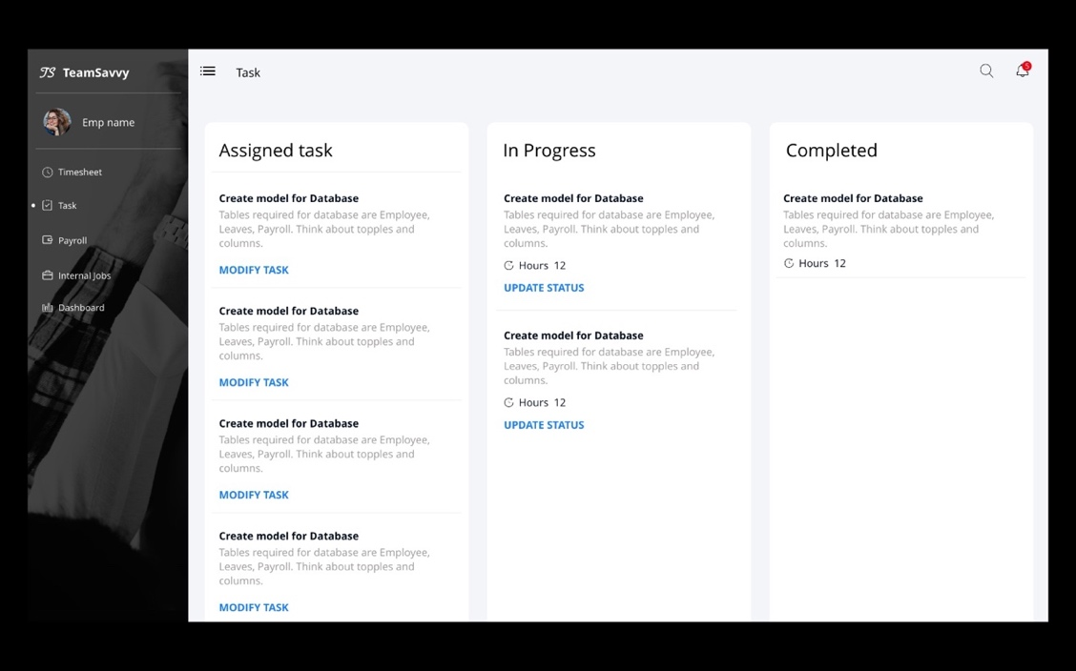

**Payroll:**

This screen will have the collection of pay slips with information of each month, total hours, and earnings, from here user can view each pay slip. The Pay Slip contains all the Earnings of an employee at the company from the date he has joined.

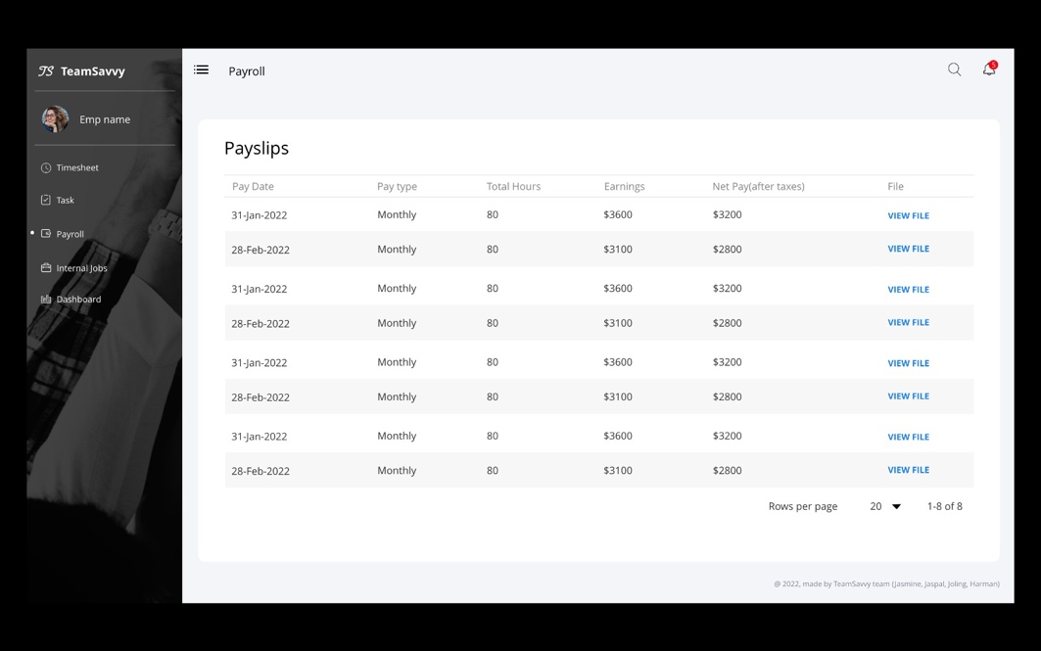

**Internal Jobs:**

This screen will display employee with the internal jobs postings which he can read the description and apply for the jobs.

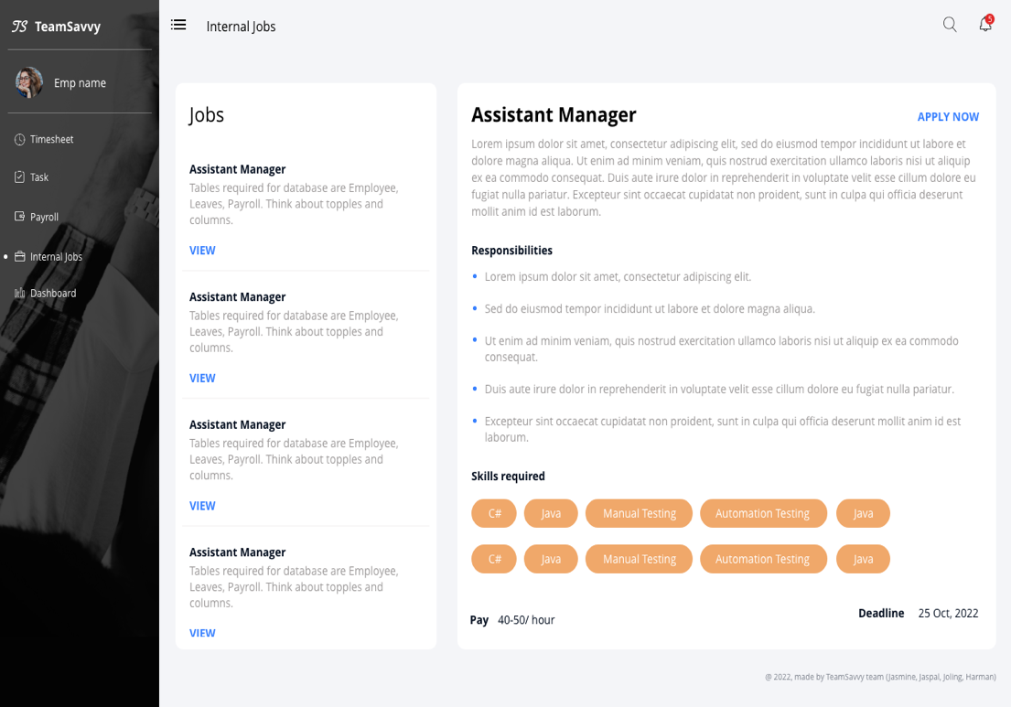

**User Profile:**

This screen will show the personal details, team members, position, department, skill set and bank details of an employee.

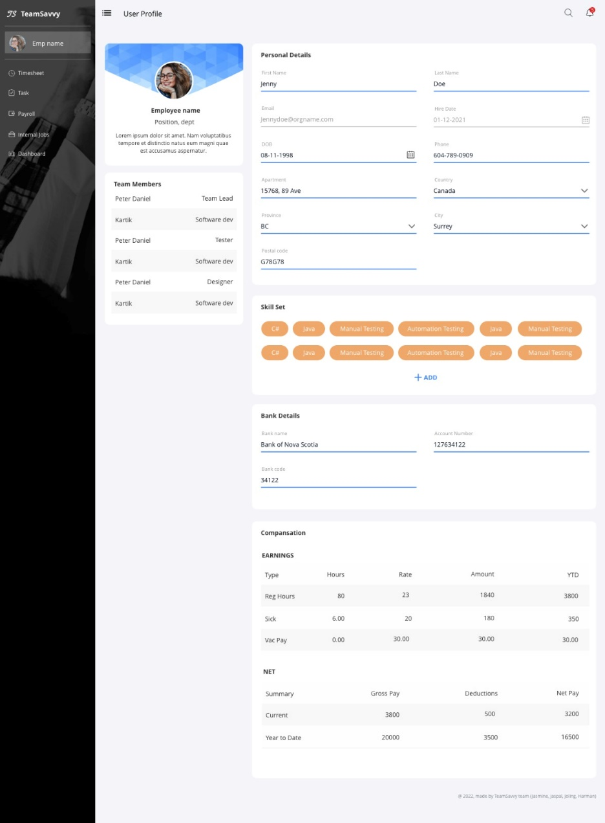

**Dashboard:**

This screen is for manager and HR, here they can view projects, team members, tasks, and other information. This screen will also have feature to create graphs widgets with predefined dropdowns. Manager can download, modify and delete the graph.

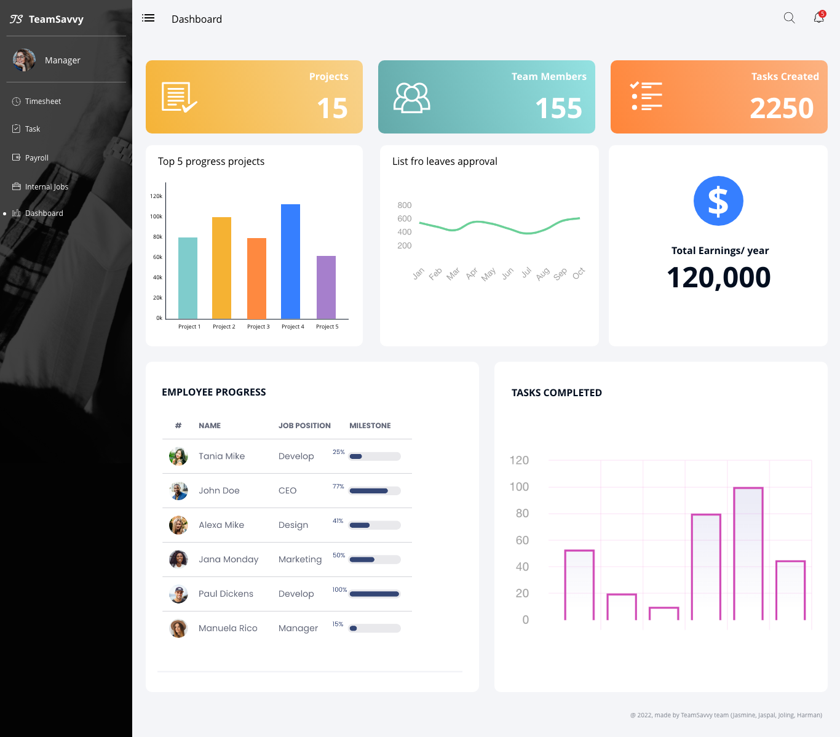

## Front-end

We started working with react js, bootstrap for developing our front-end with responsive screens, we decided to start with role ’employee’. Pages we have achieved so far:

### **Login**

This screen will allow users to login with credentials provided by organization or can reset password using OTP

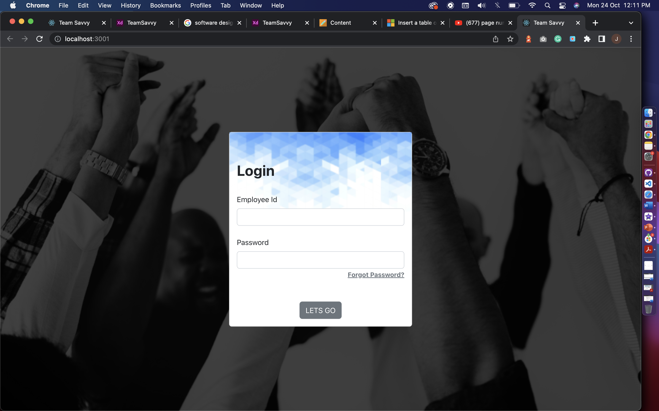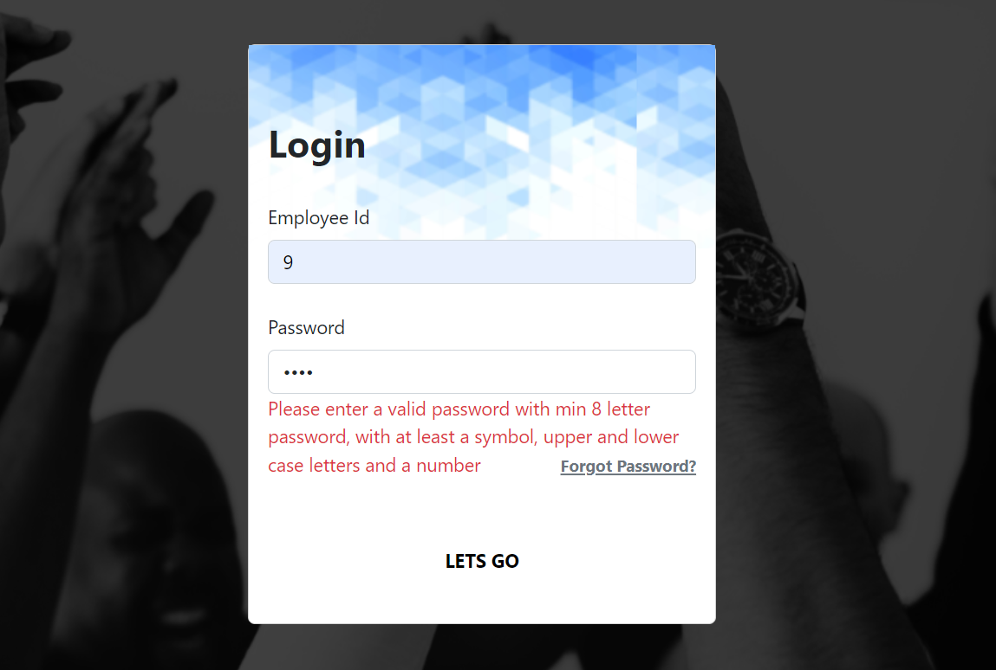

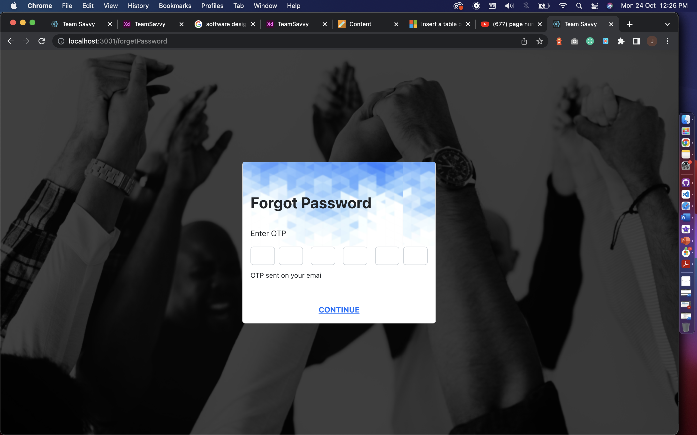

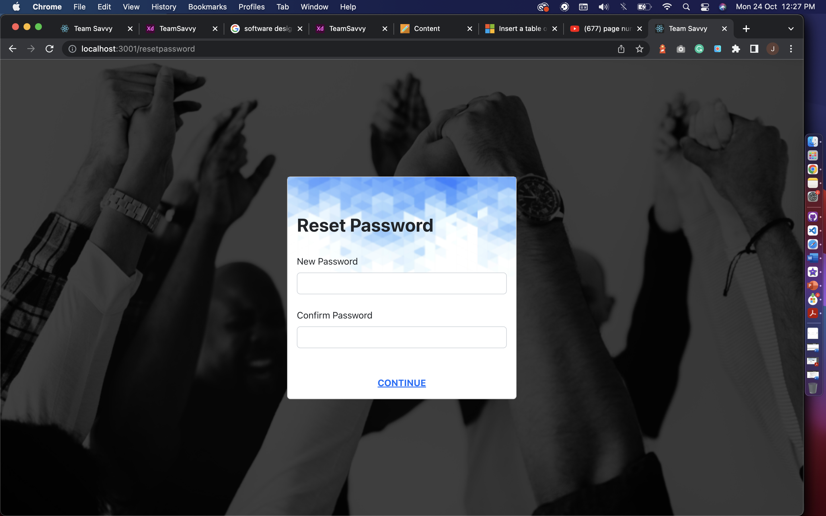

### **Sidenav**

The animated sidebar with navigation links to access the platform.

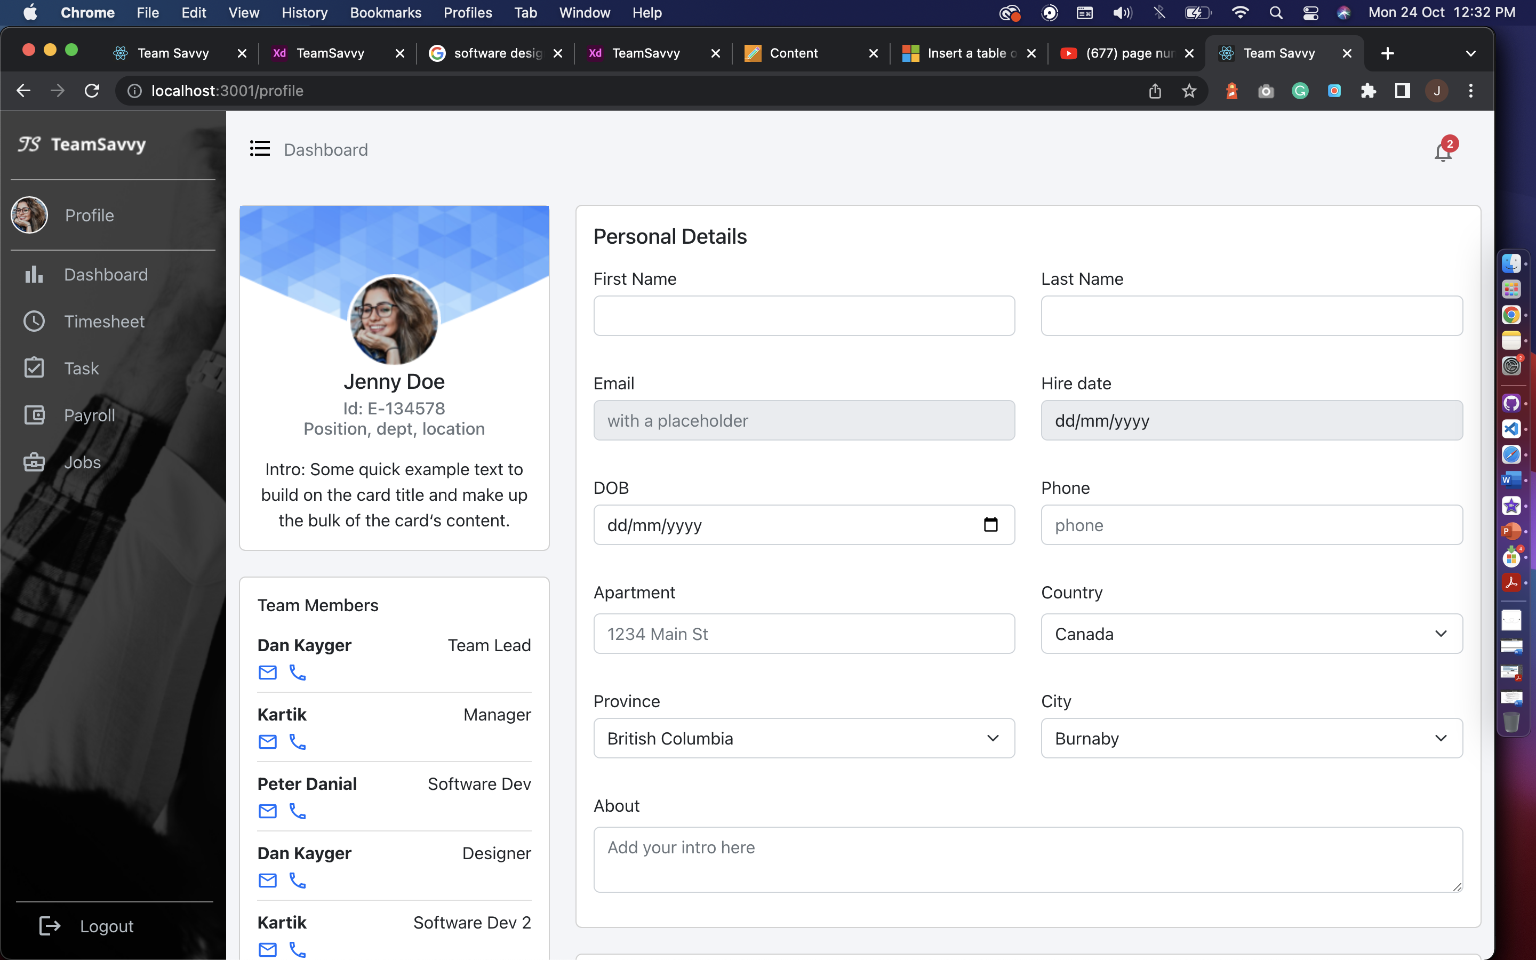 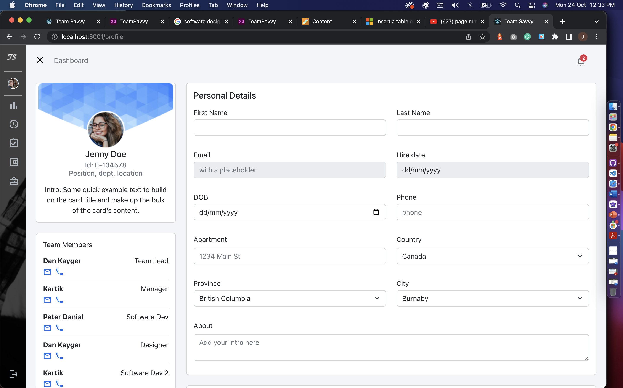

**Open** **Closed**

### **Header and Navigation**

Header has dashboard title which will be breadcrumb for navigation. Below are some examples from different pages.

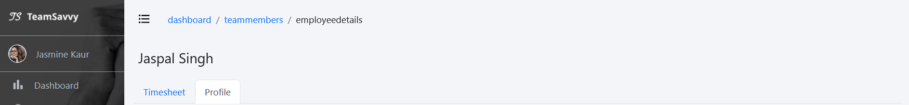

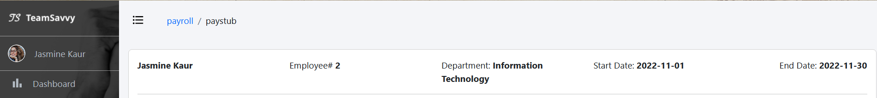

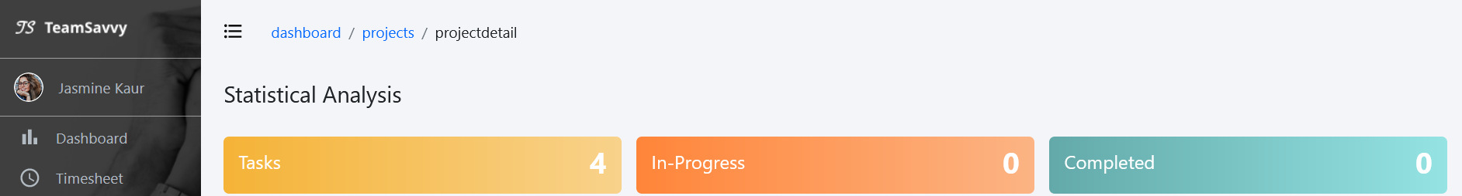

### **User Profile**

The user profile page has employee information, which is consist of Personal details, Team members with their contact details, Skill set and add new skill option, bank details, and resign option.

Features in this page:

* **Allow to change personal information & add skills**
* **Resign with one click**
* **Stay connected with team members**

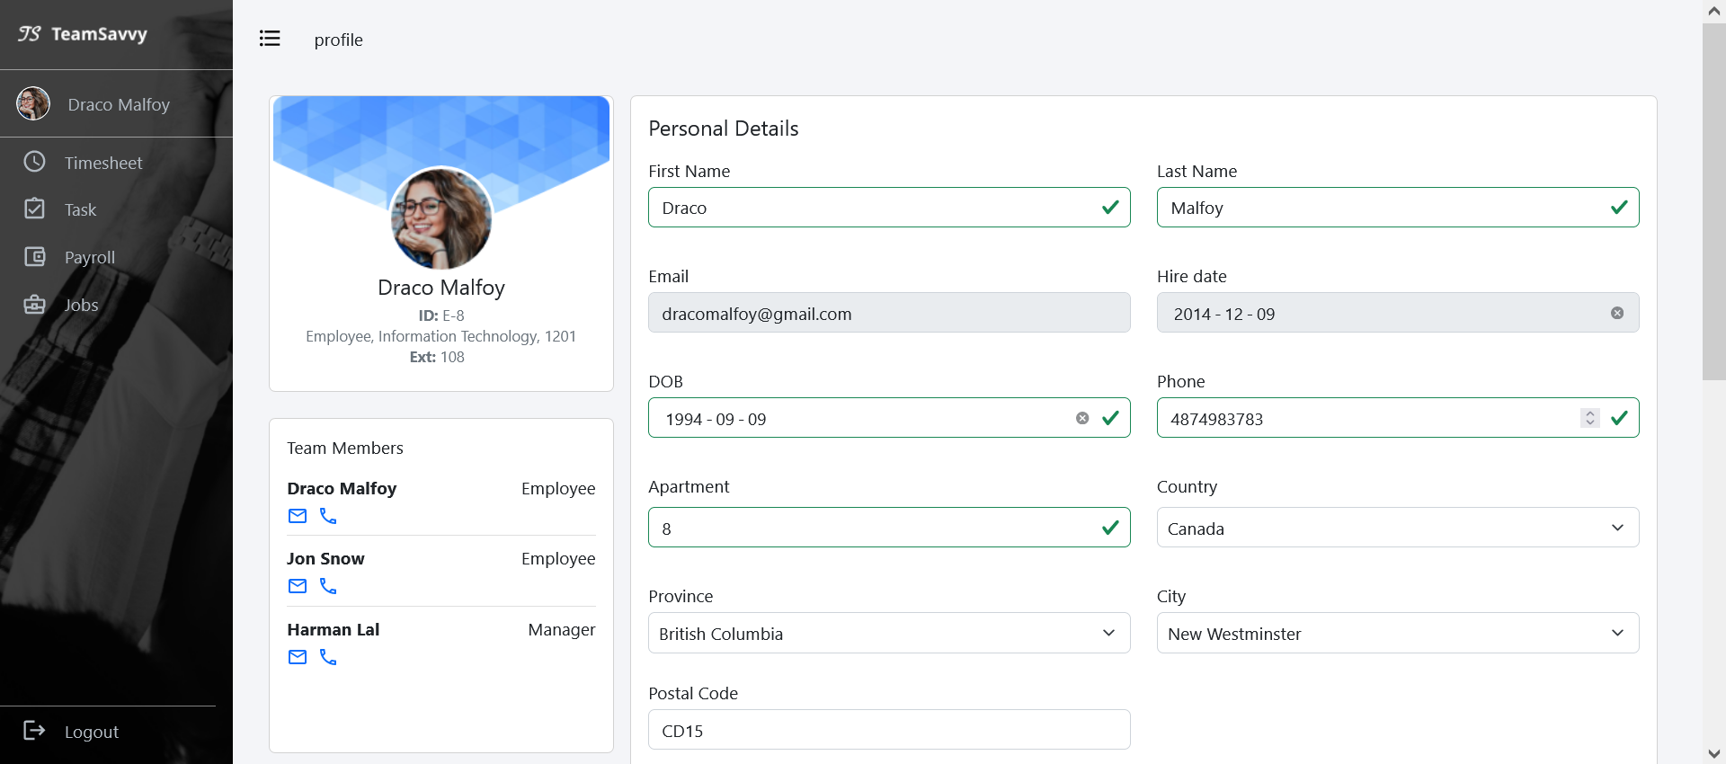

Figure 1: employee personal info page

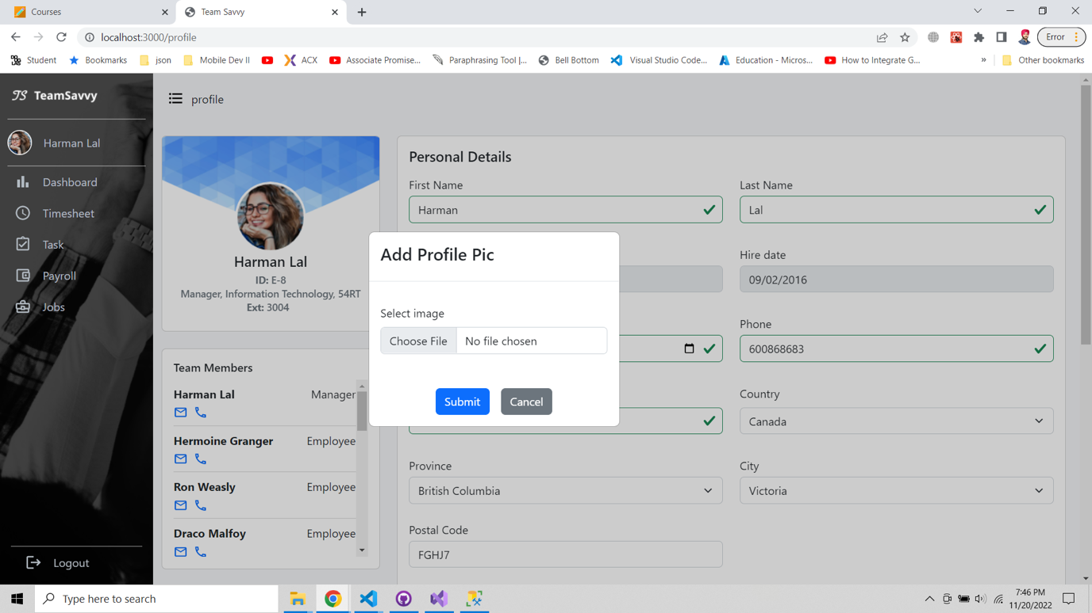

Figure 2: From this screen employee can update his profile image by selecting a file from system.

### **Dashboard**

Dashboard is one of the main features of this application. It is the best tool for managers to handle project process, manage team members and do descriptive analysis using queries. Below we will explain in detail how to use these tools.

Features in this page:

* Projects list
* Team members list
* Project budget chart
* Team members leave approval
* Charts created based on queries

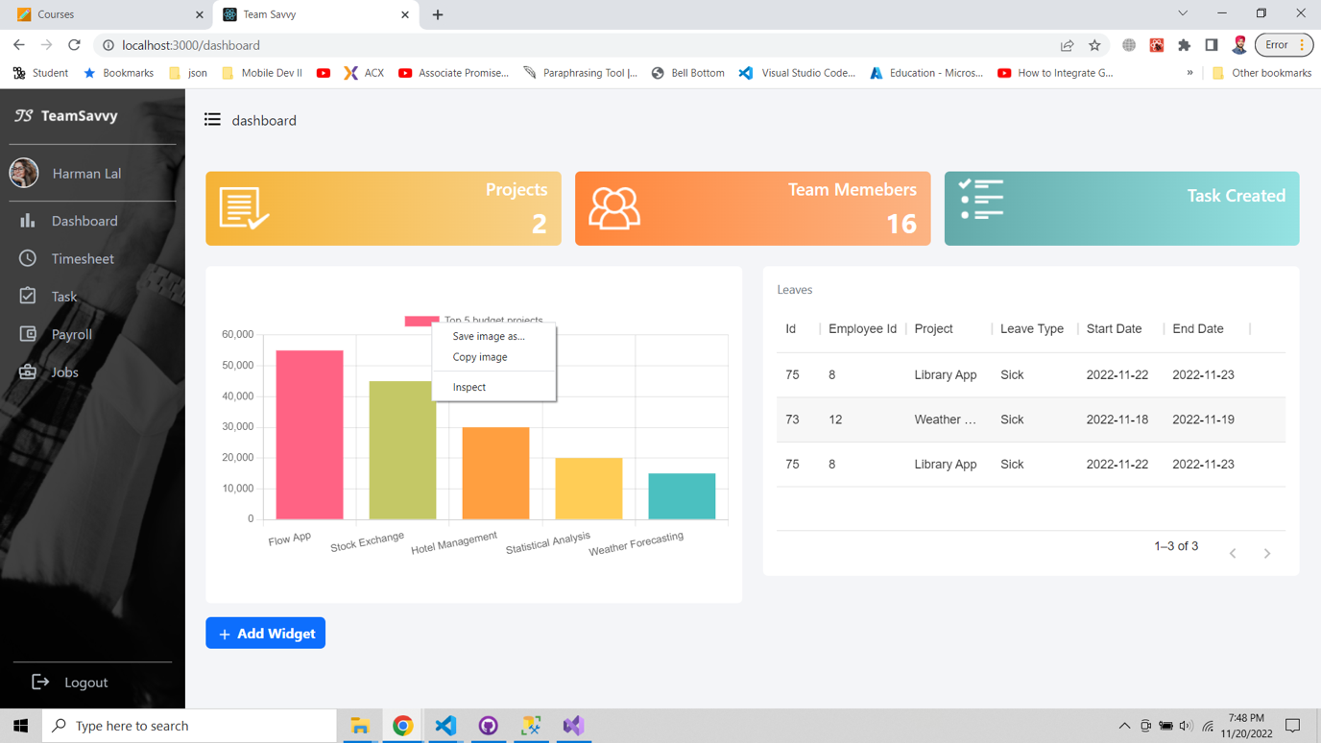

Figure 3: Manager or HR can save the graph as image for future use.

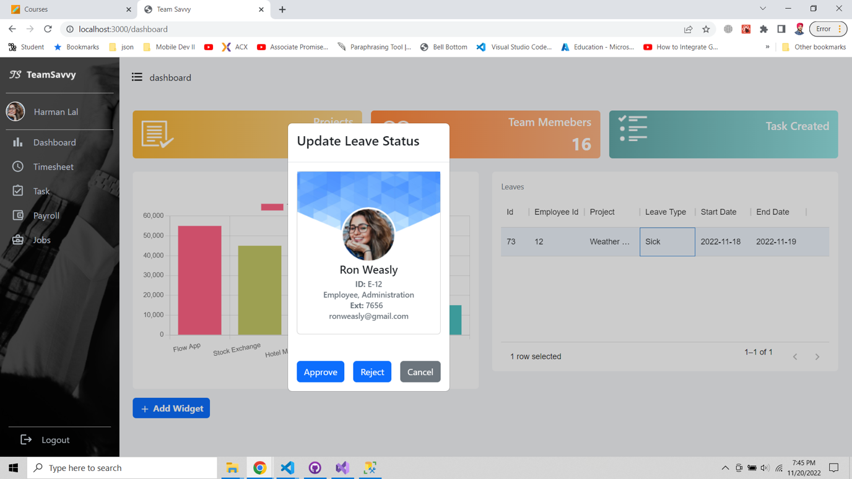

Figure 4: Reject or approve leave popup for HR or manager which will show user images, name, ID, contact details of an employee.

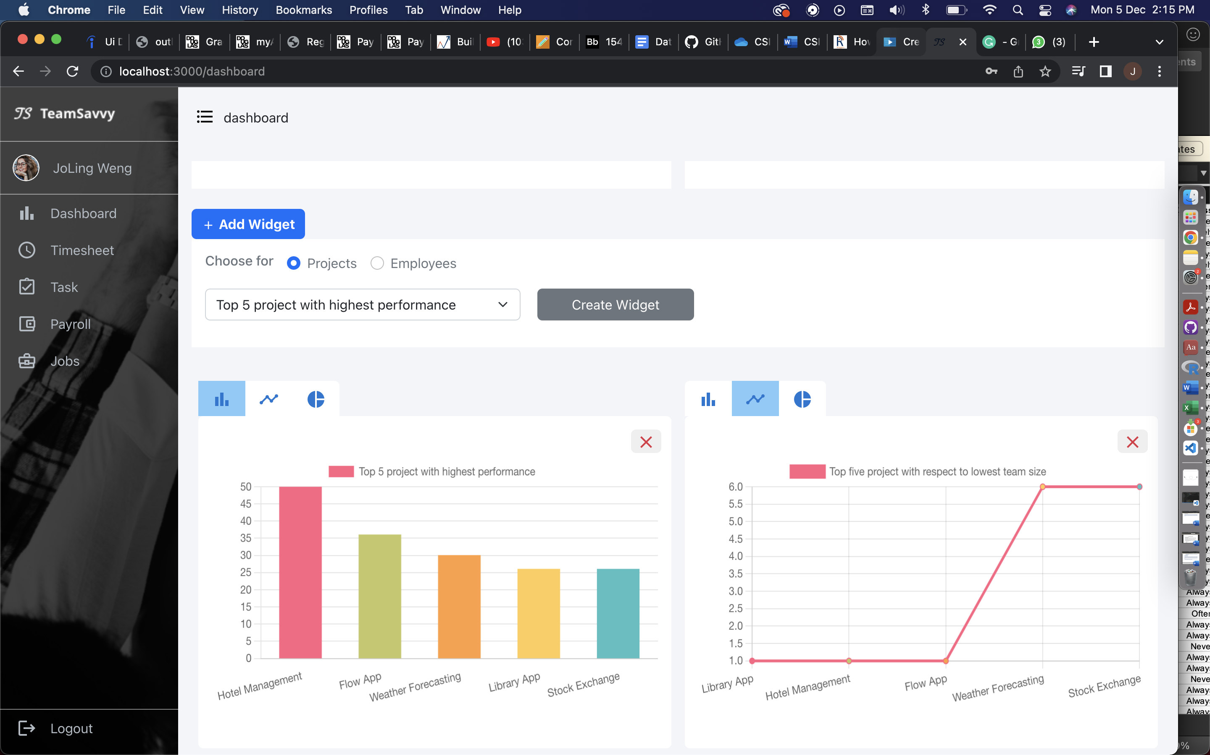

Figure 5: Add widget section to add new chart with the predefined queries

### **Projects**

This screen has project list customised for HR and manager. HR can see all the projects in company and on click of view link, they can see project details which will have number of tasks created, completed and details of each task. Create project button is only for manager to create new project it will show popup for entering project details, end, start date and budget.

Features – HR View:

* Check all projects and project details

Features – Manager View:

* Check their own projects and project details
* Create new project
* Delete project

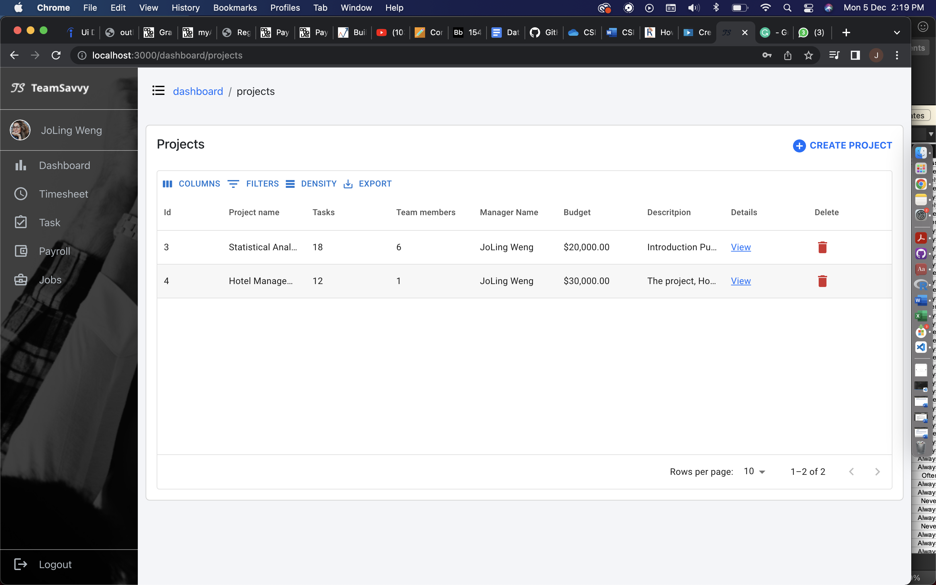

Figure 6: project list - manager view

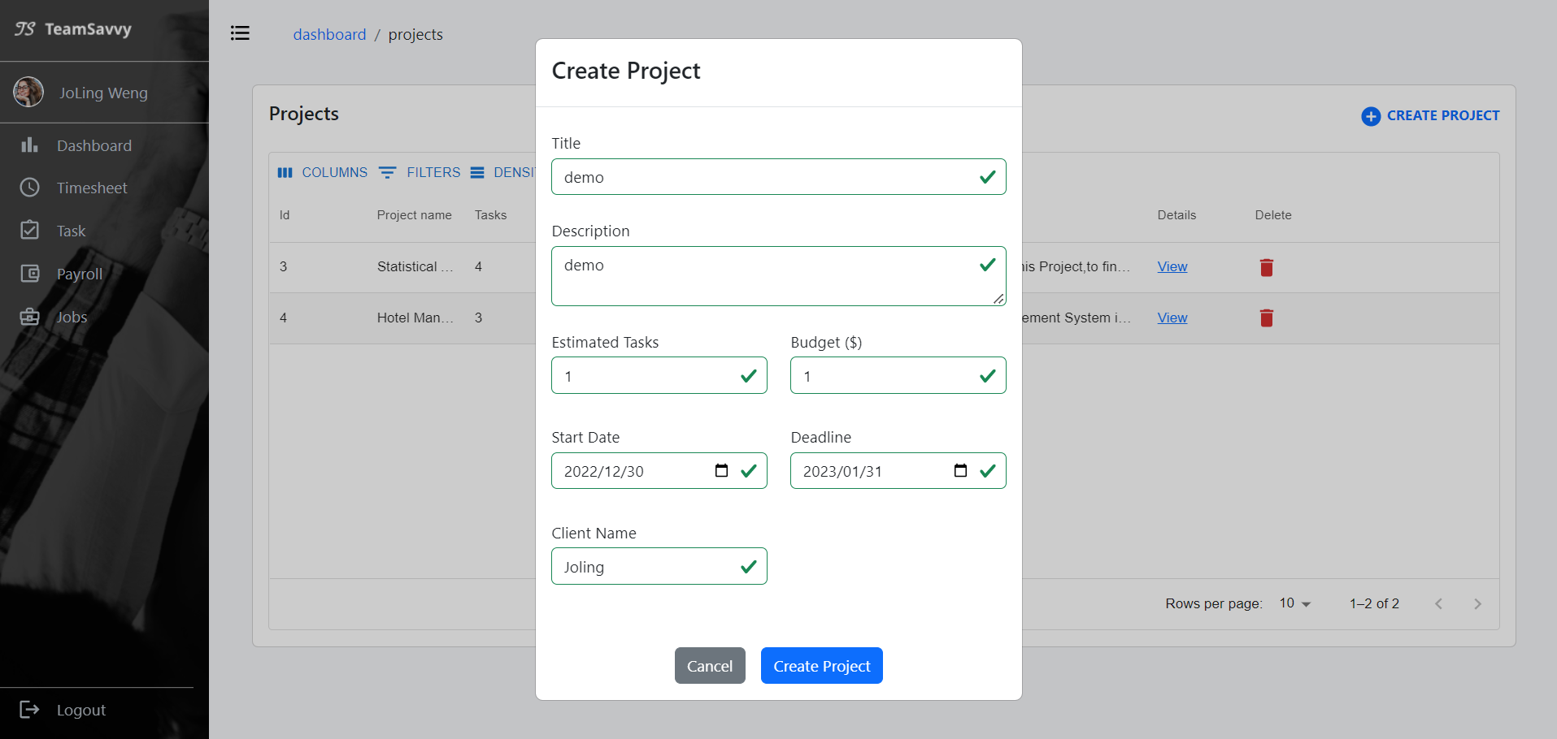

Figure 7: project list - create project by manager

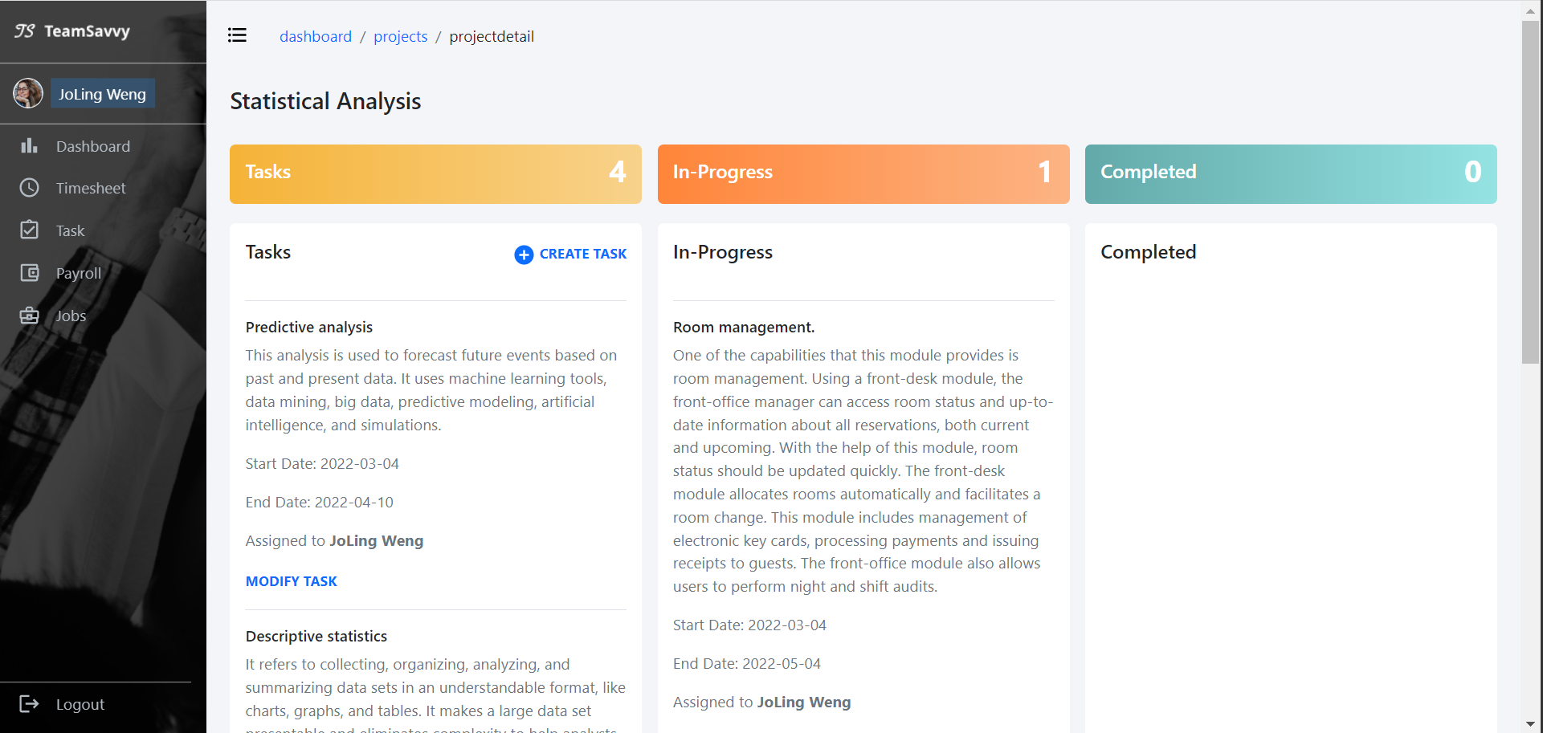

Figure 8: project detail - manager view

### **Employee List**

This screen displayed after click on employee list widget in dashboard and this is for HR where they can check the employee details, check progress based on number of completed task and can also add a new employee by clicking on link and new page will open with empty profile to enter the details of new employee.

Features in this page – manager view:

* Check employee list by project
* Check employee performance

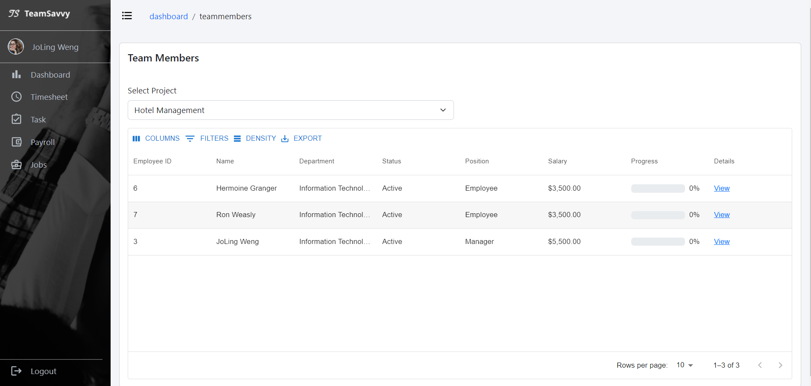

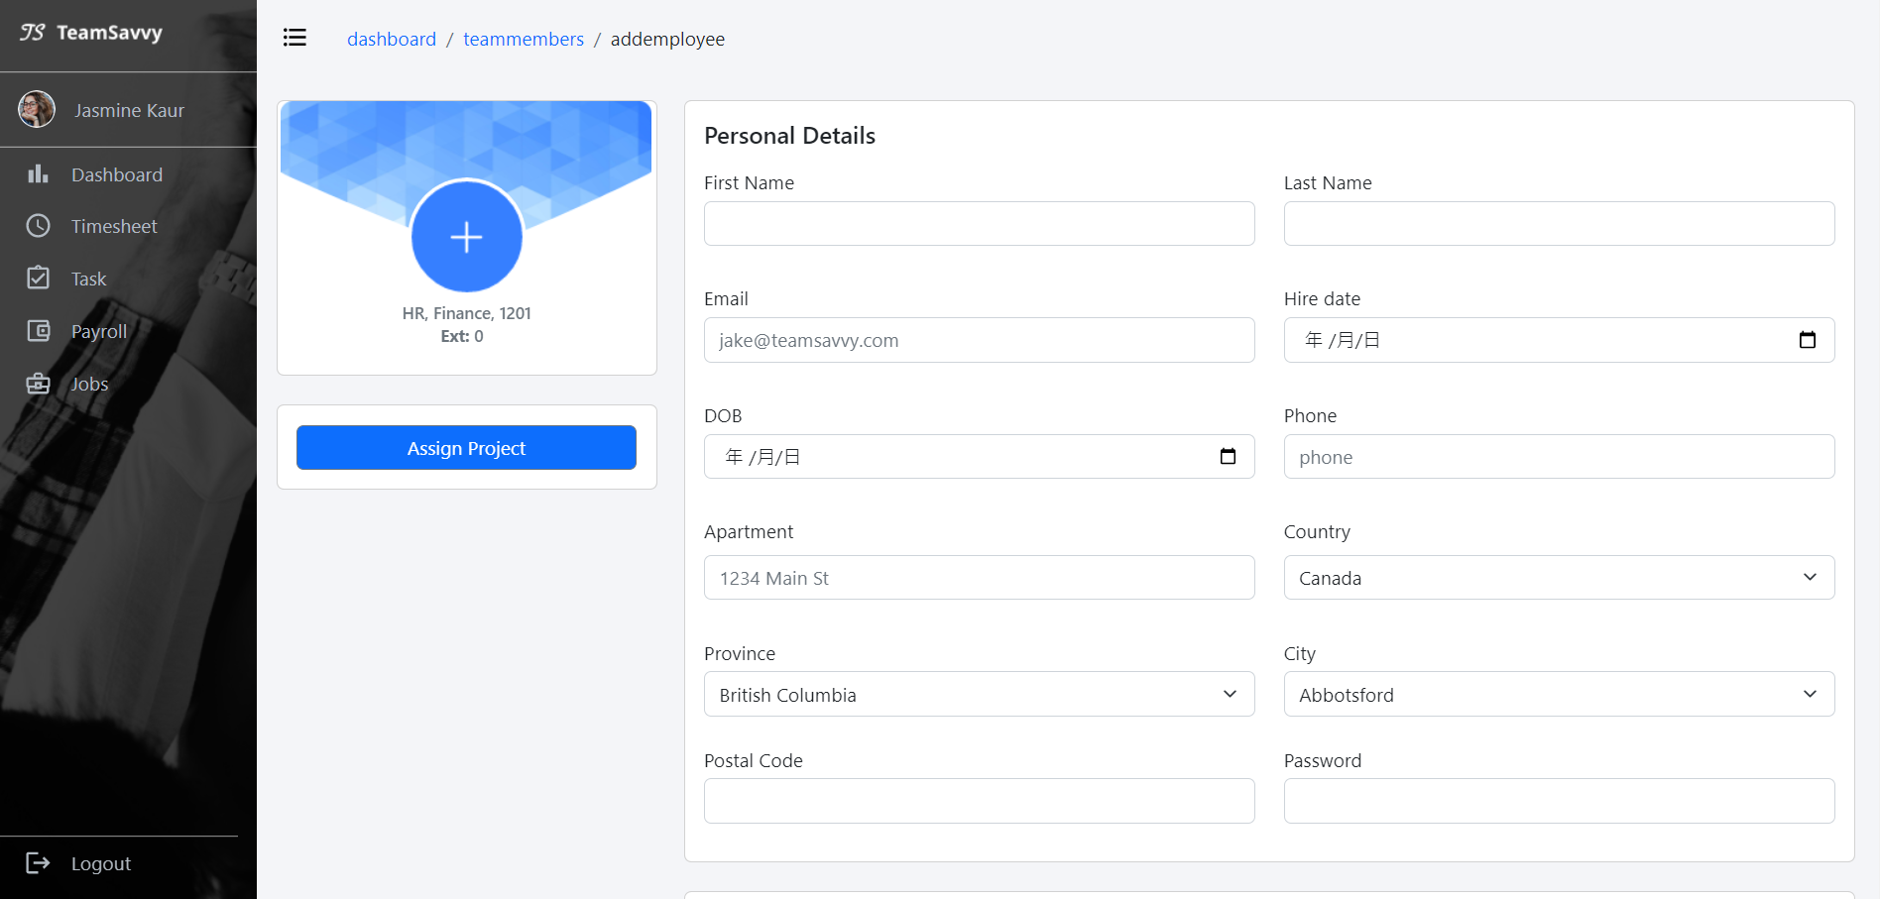

Figure 9: hr create new employee account

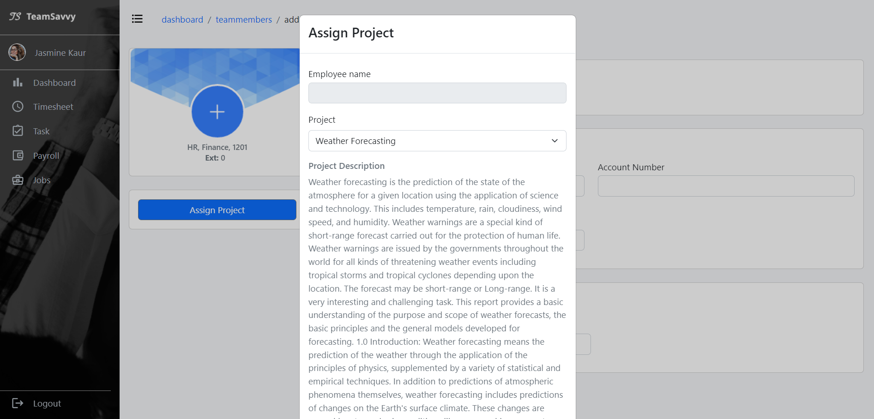

Figure 10: new employee can be assigned to project when creating account

**Timesheet**The screen has leave indicators, in and out time of an employee which will be connected from mobile app to the web platform. Employee can apply for leaves and delete applied leaves.

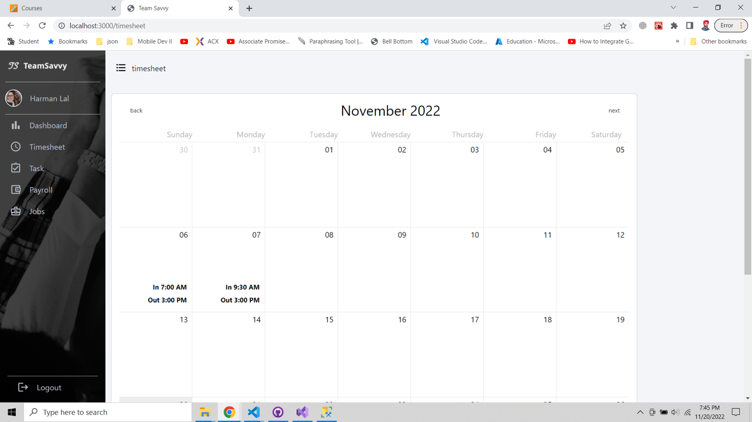

Figure 11: Employee can apply for leaves by clicking on date cell.

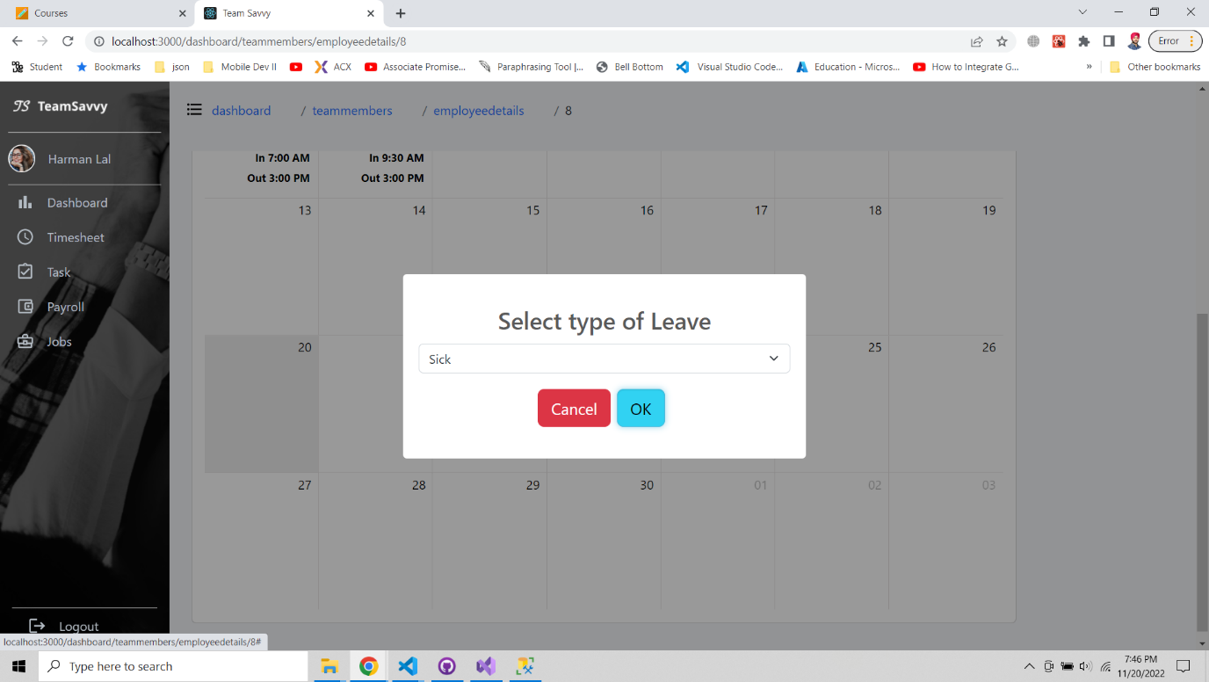

Figure 12: apply leaves modal

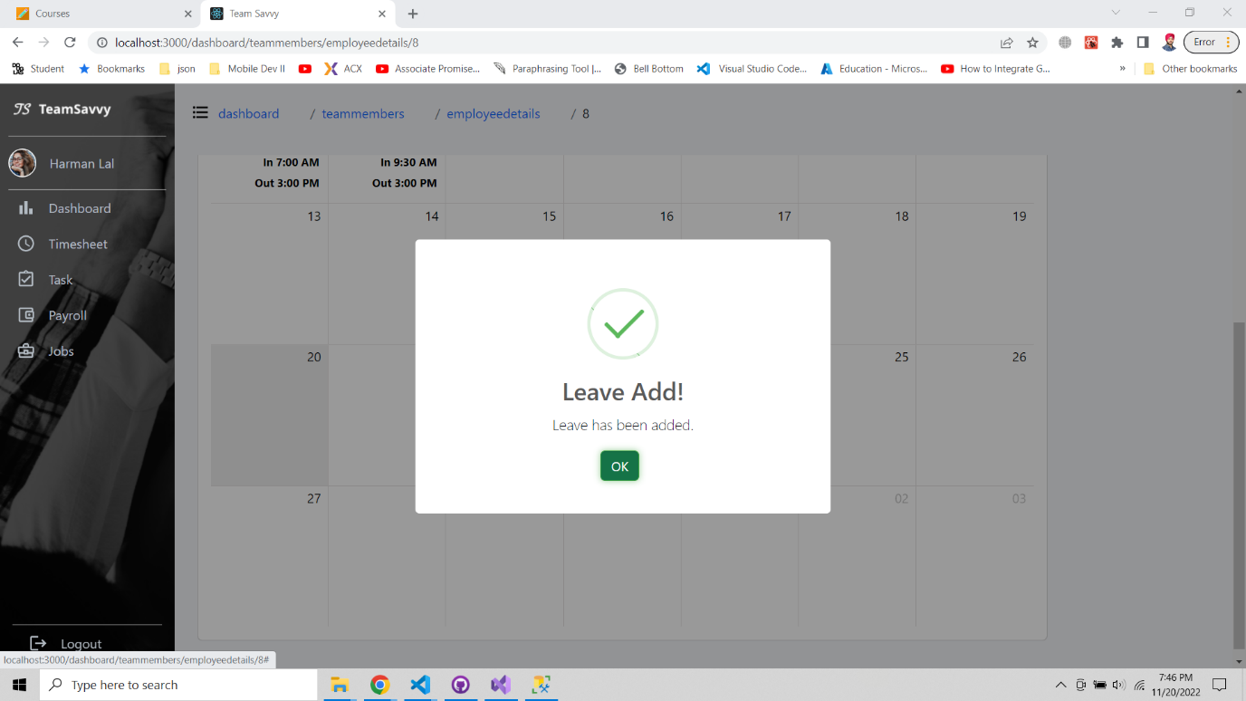

Figure 13: Leave added popup screen

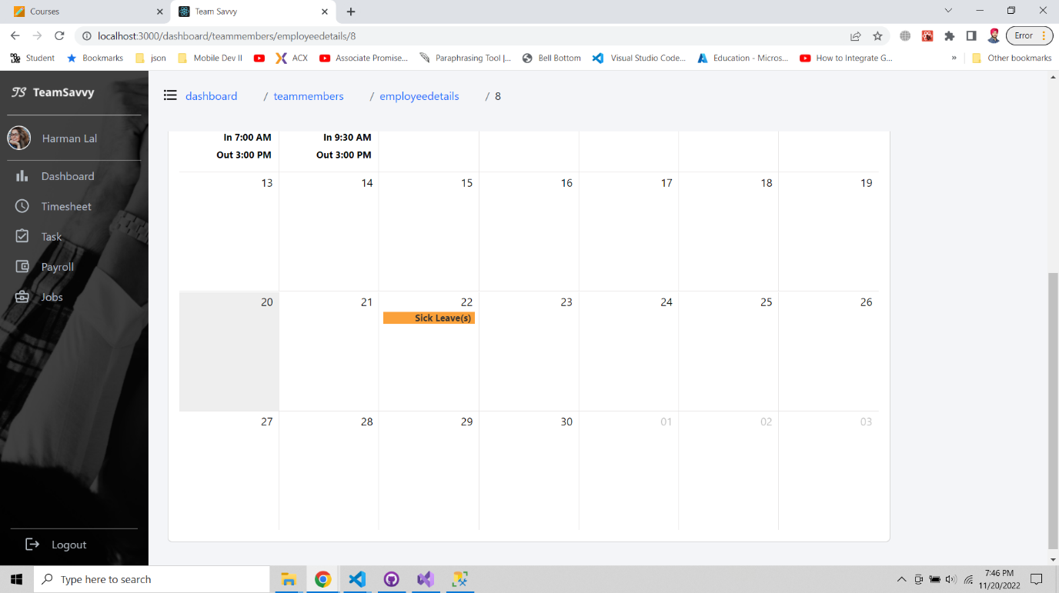

Figure 14: Leave has been added on the calendar

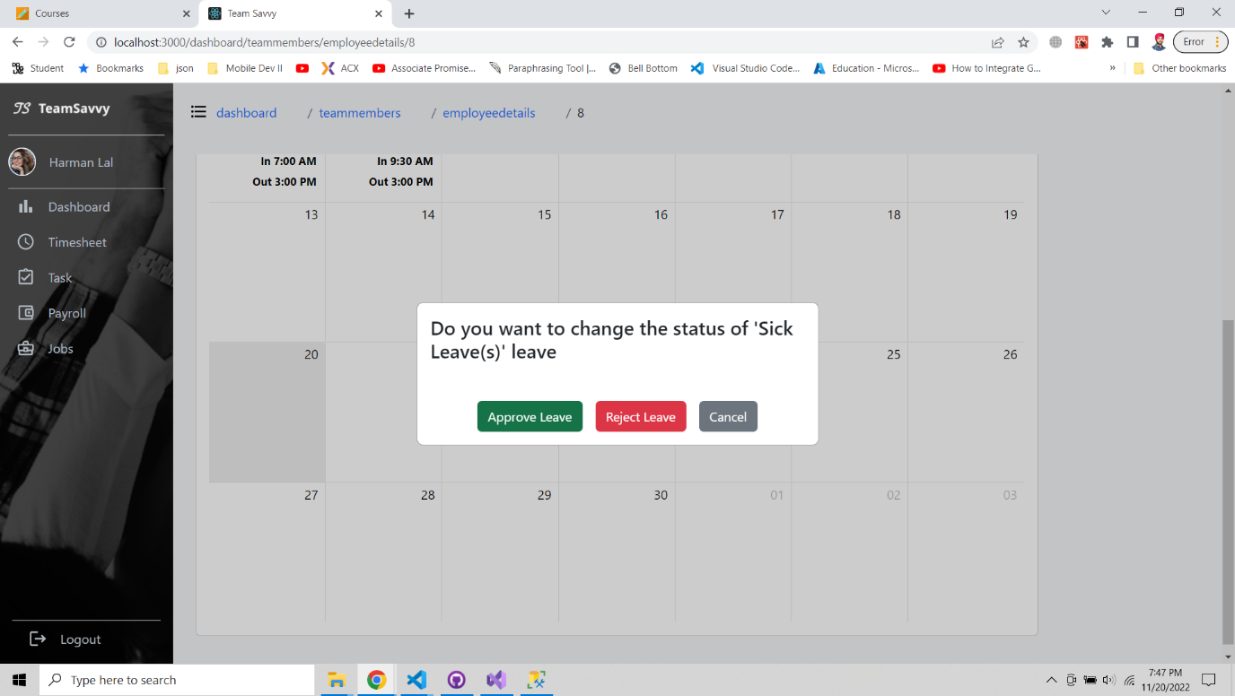

Figure 15: Delete leave popup screen.

**Task**The task page has feature to show assigned, in progress and completed tasks for an employee. We are assuming the employee only working in one project at a time. On click of modify task user will get pop-up to add hours and change status of the task. On update status, the employee can only change status to completed task.

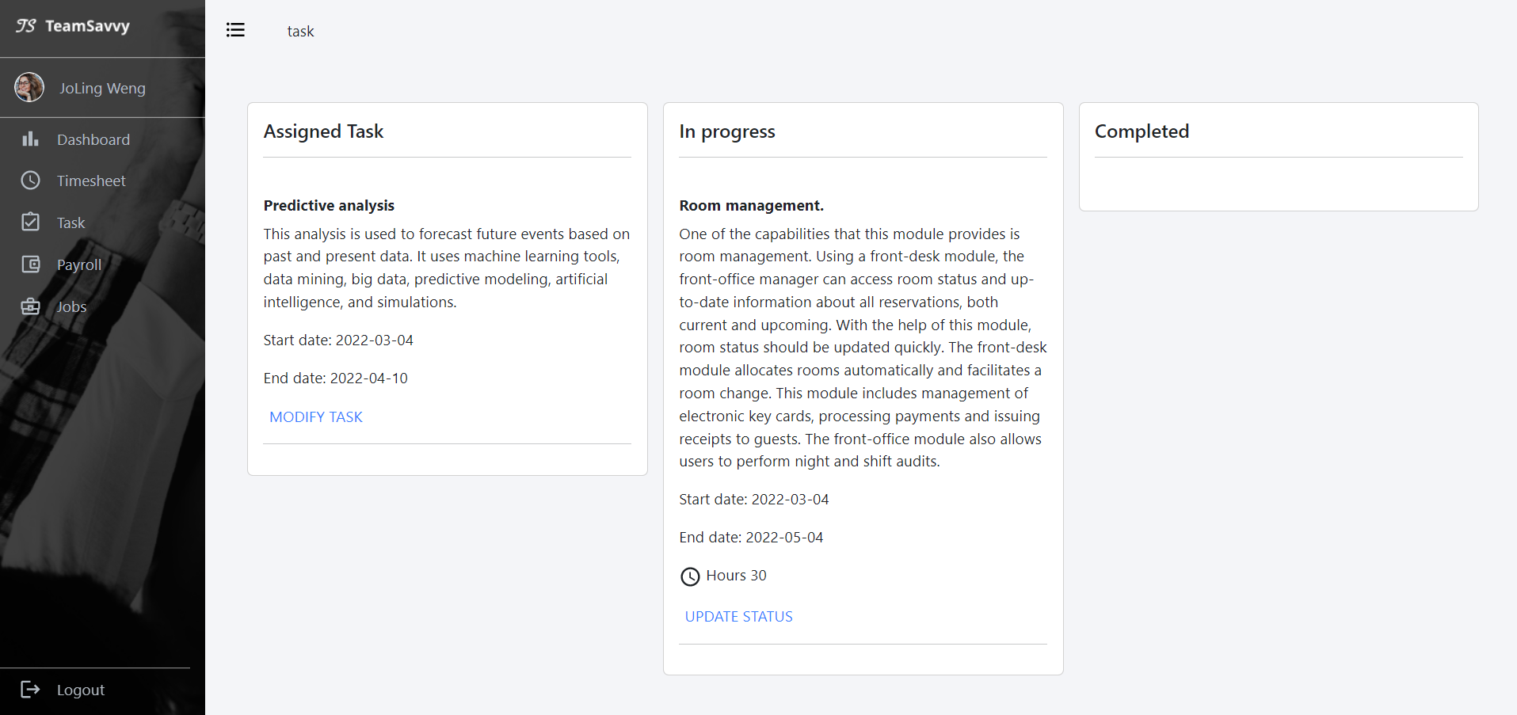

Figure 16: view of tasks under your name

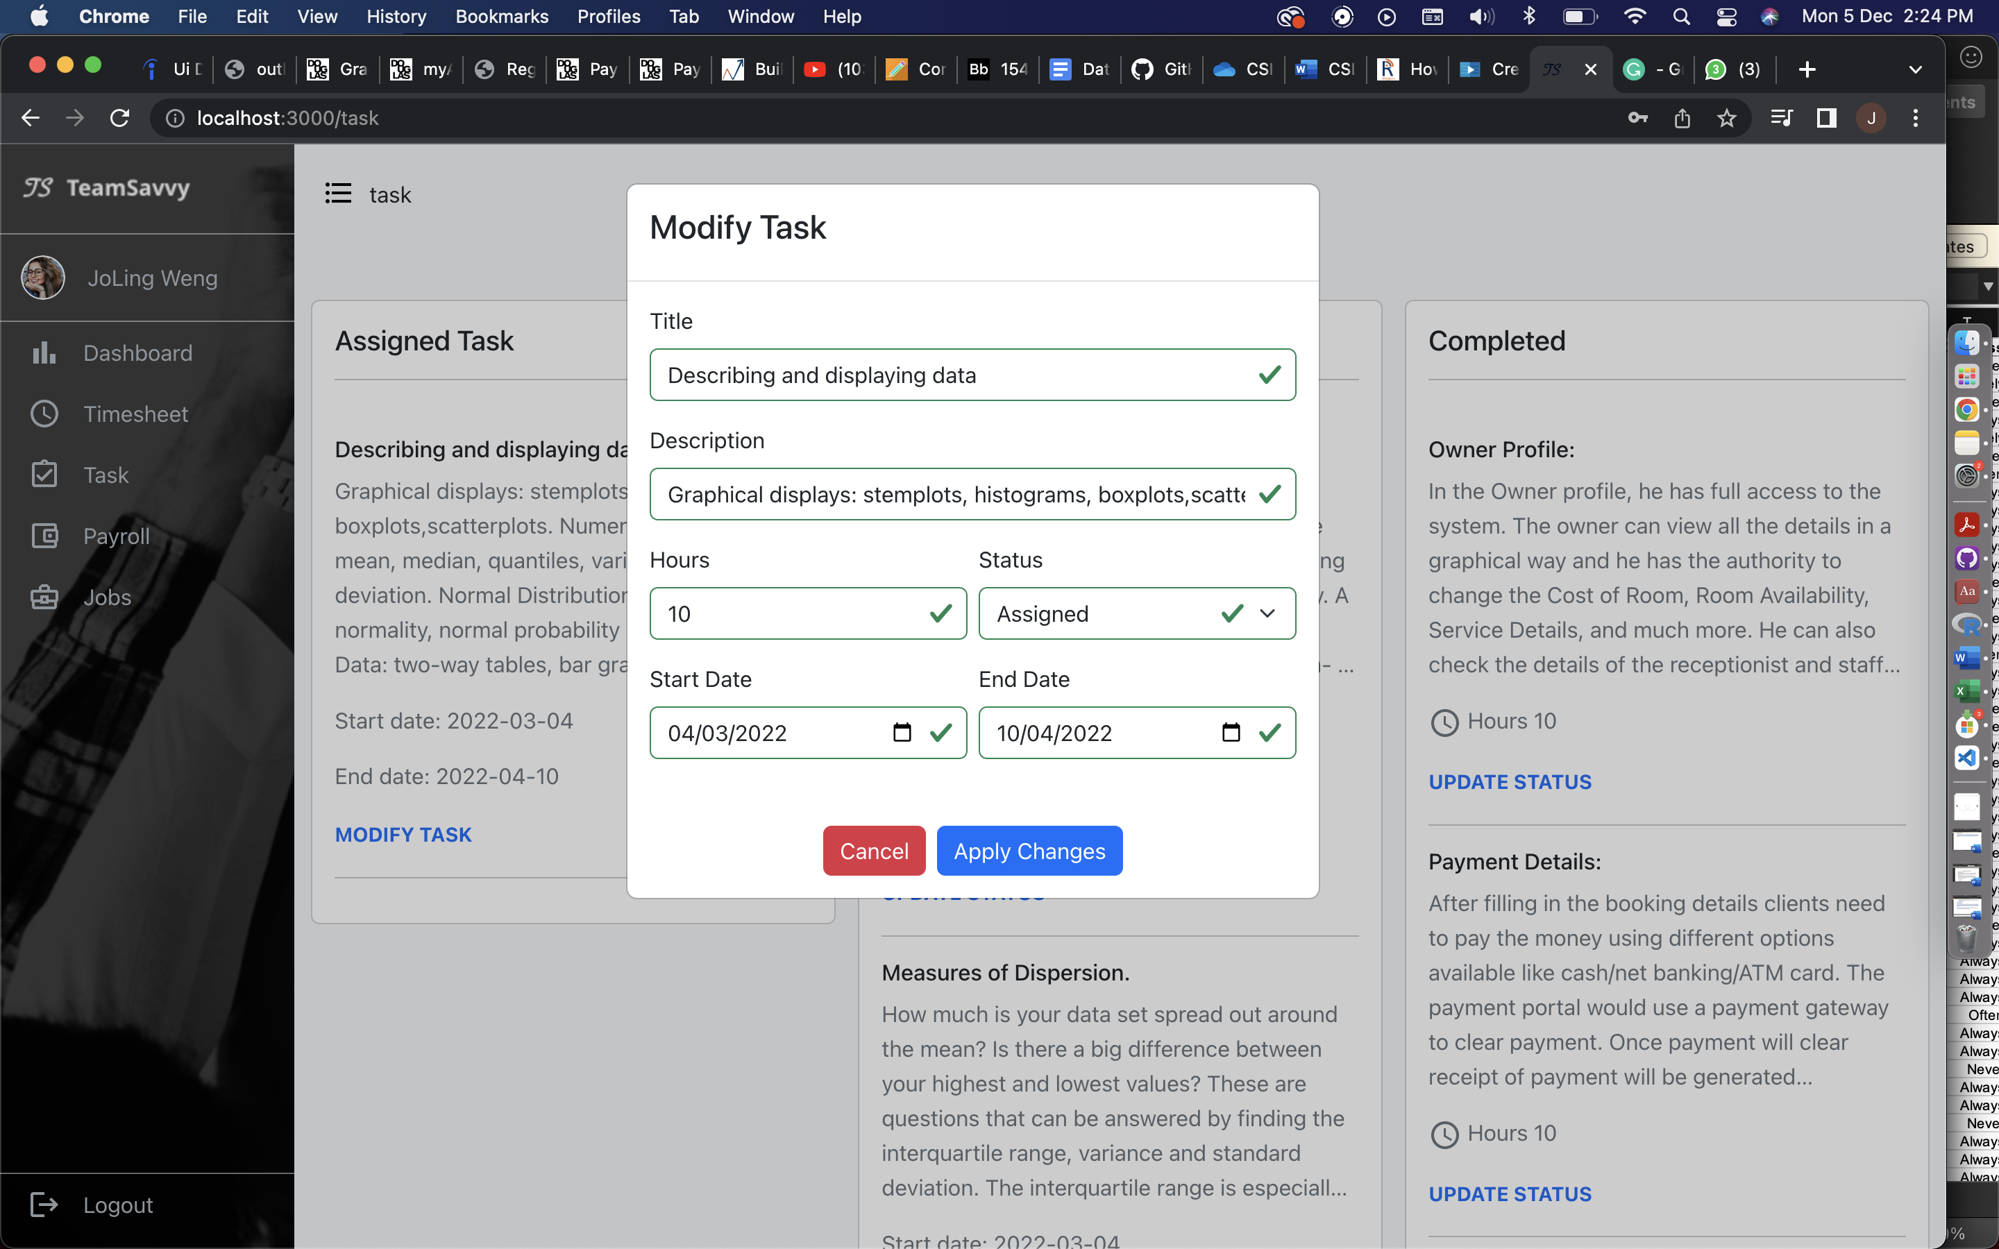

Figure 17: modify task once assigned

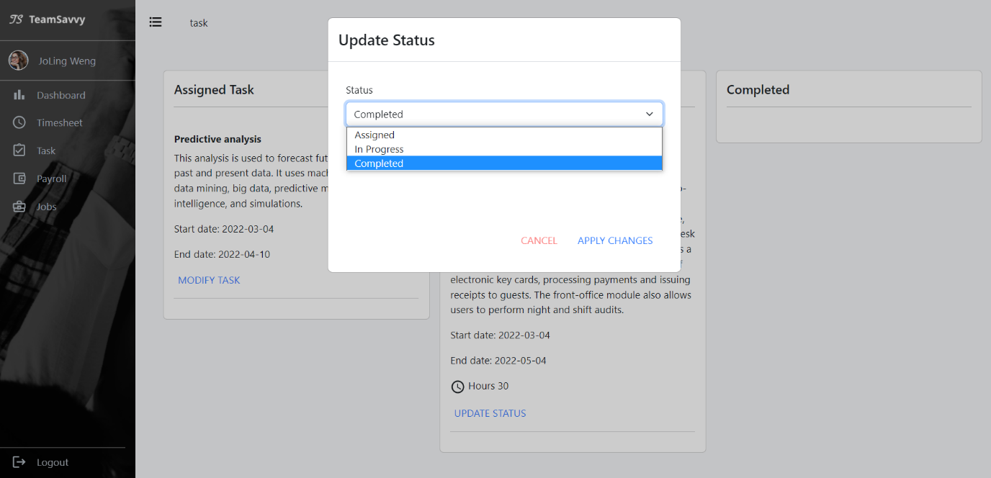

Figure 18: update task when finished

**Payroll**The payroll has payslips screens where employee can check the list of pay stubs and can view the pay stubs individually by clicking on view file.

Features in this page:

* Check your payroll by month
* Click on VIEW FILE to see in detail

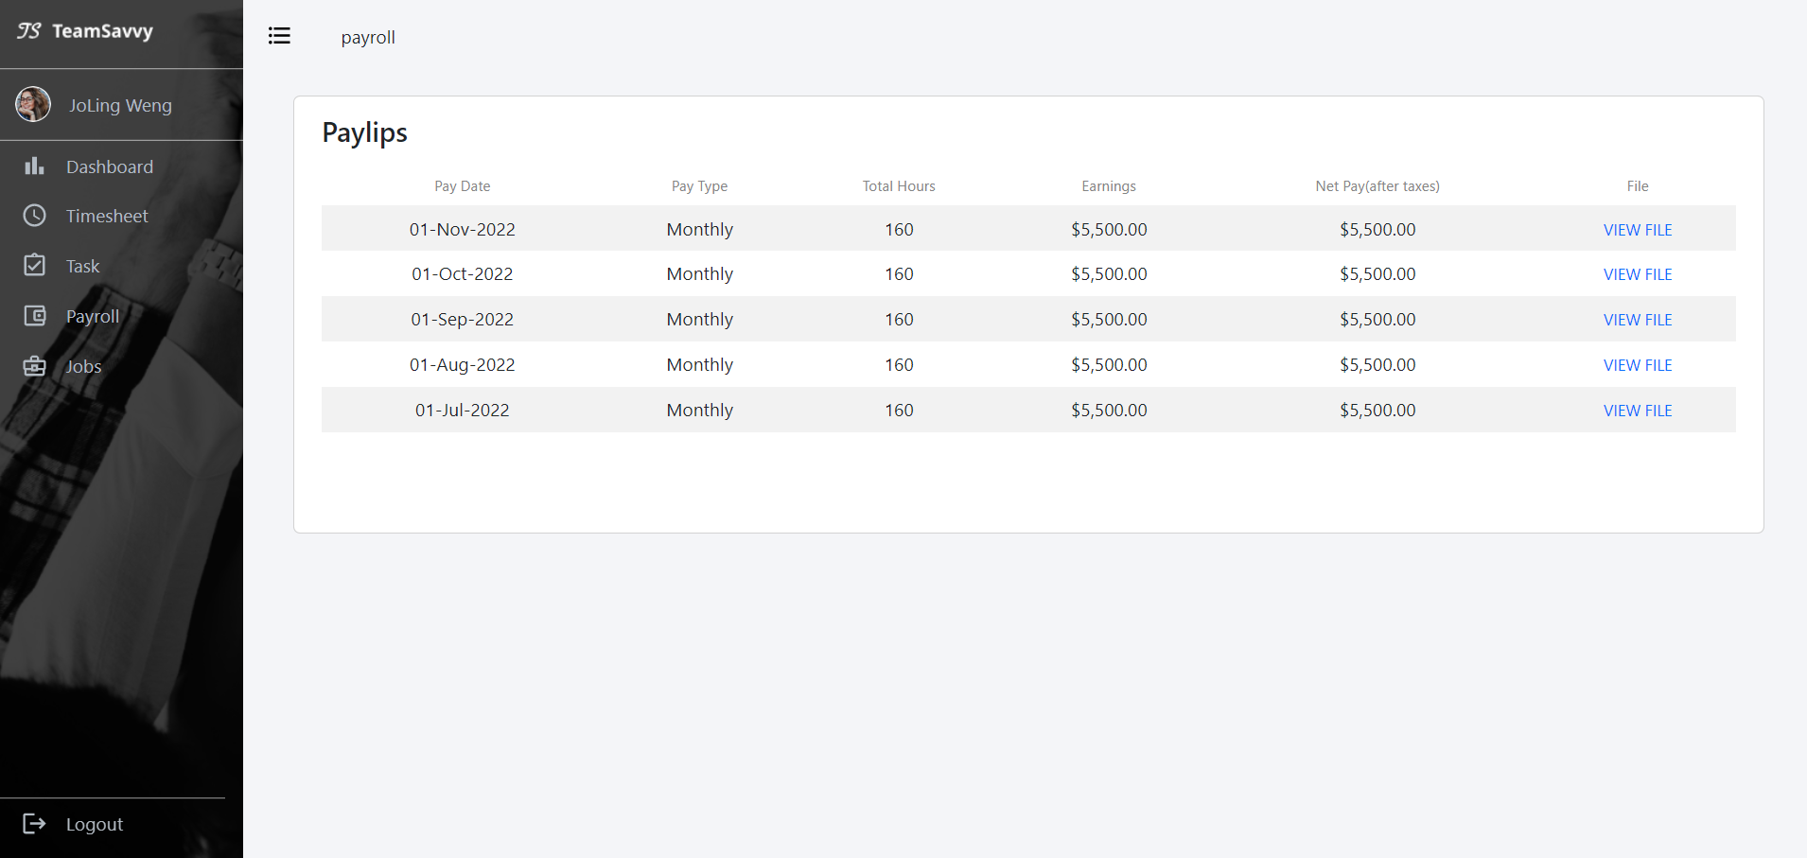

Figure 19: payroll list

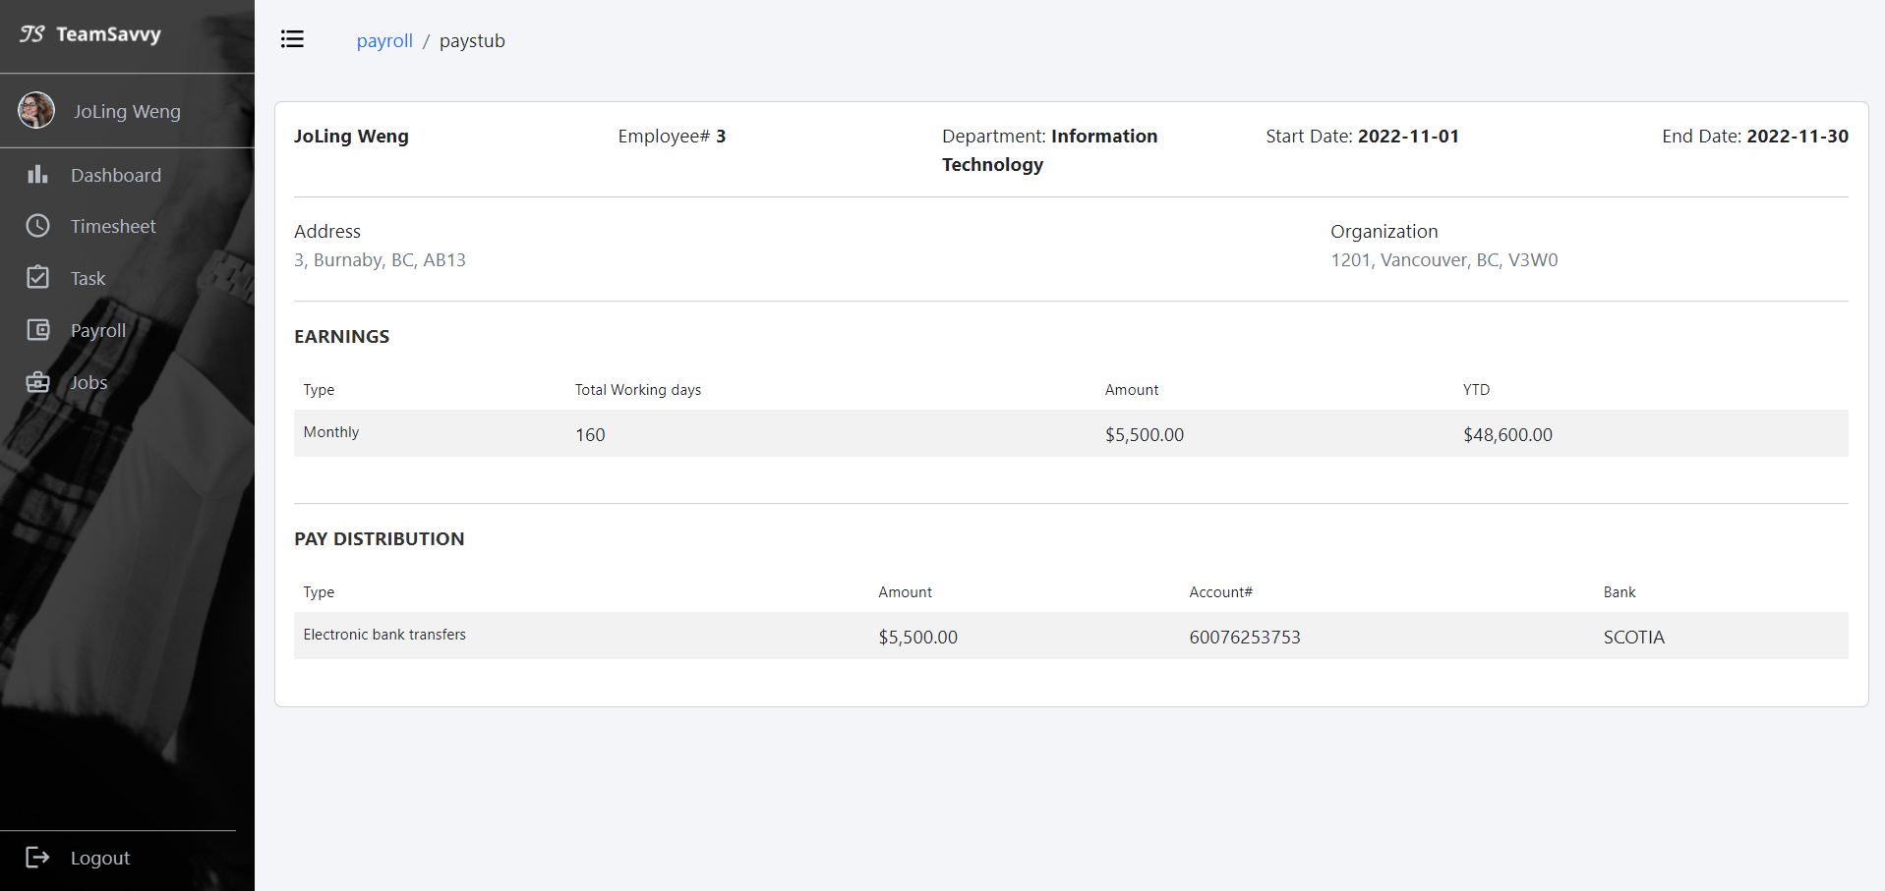

Figure 20: pay stub - payment detail

**Jobs**The jobs page for employee have internal jobs created by HR and employee will not see the create job option. Employee can directly apply using Apply now button. HR will get the notification on their portal from where they can check the profile of an employee who applied.

Features – Employee View:

* View job postings
* Apply for internal jobs
* Duplicate application prevention

Features – HR View:

* Create new jobs
* Delete job postings
* List of employees applied for jobs

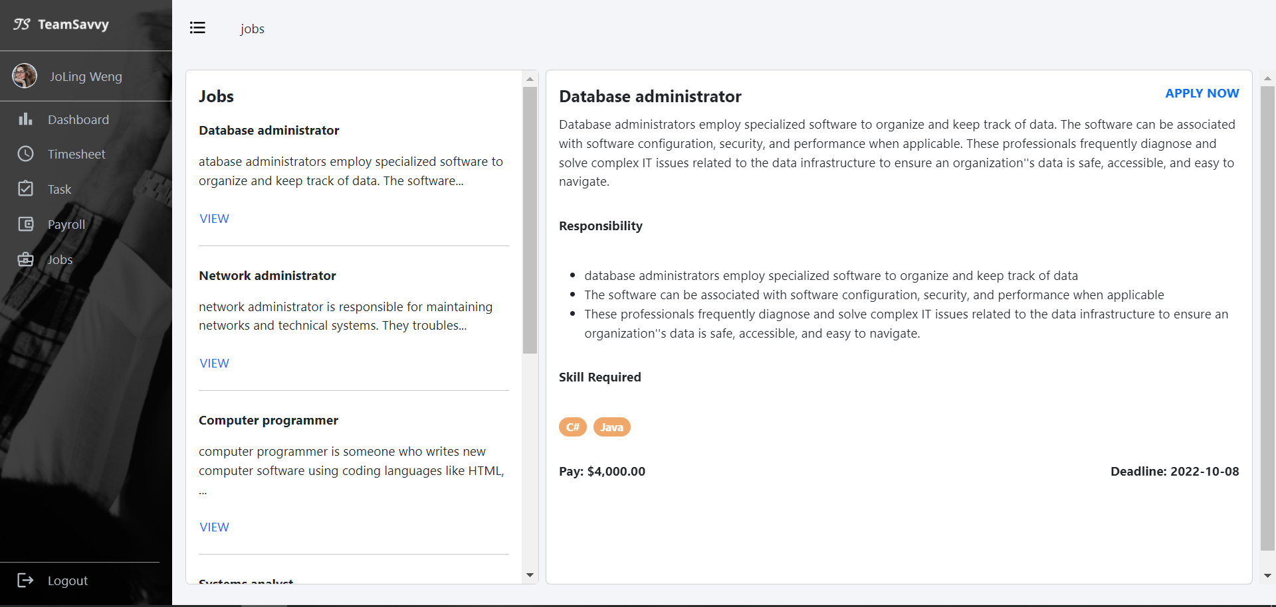

Figure 21: internal job page - employee view

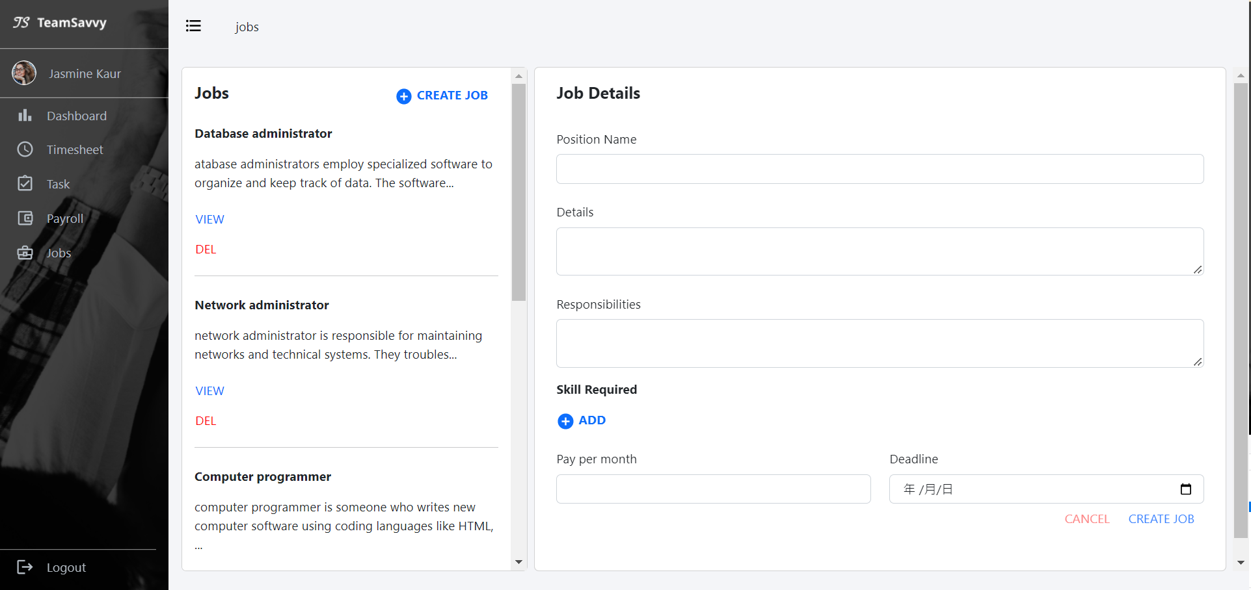

Figure 22: internal job page - hr view

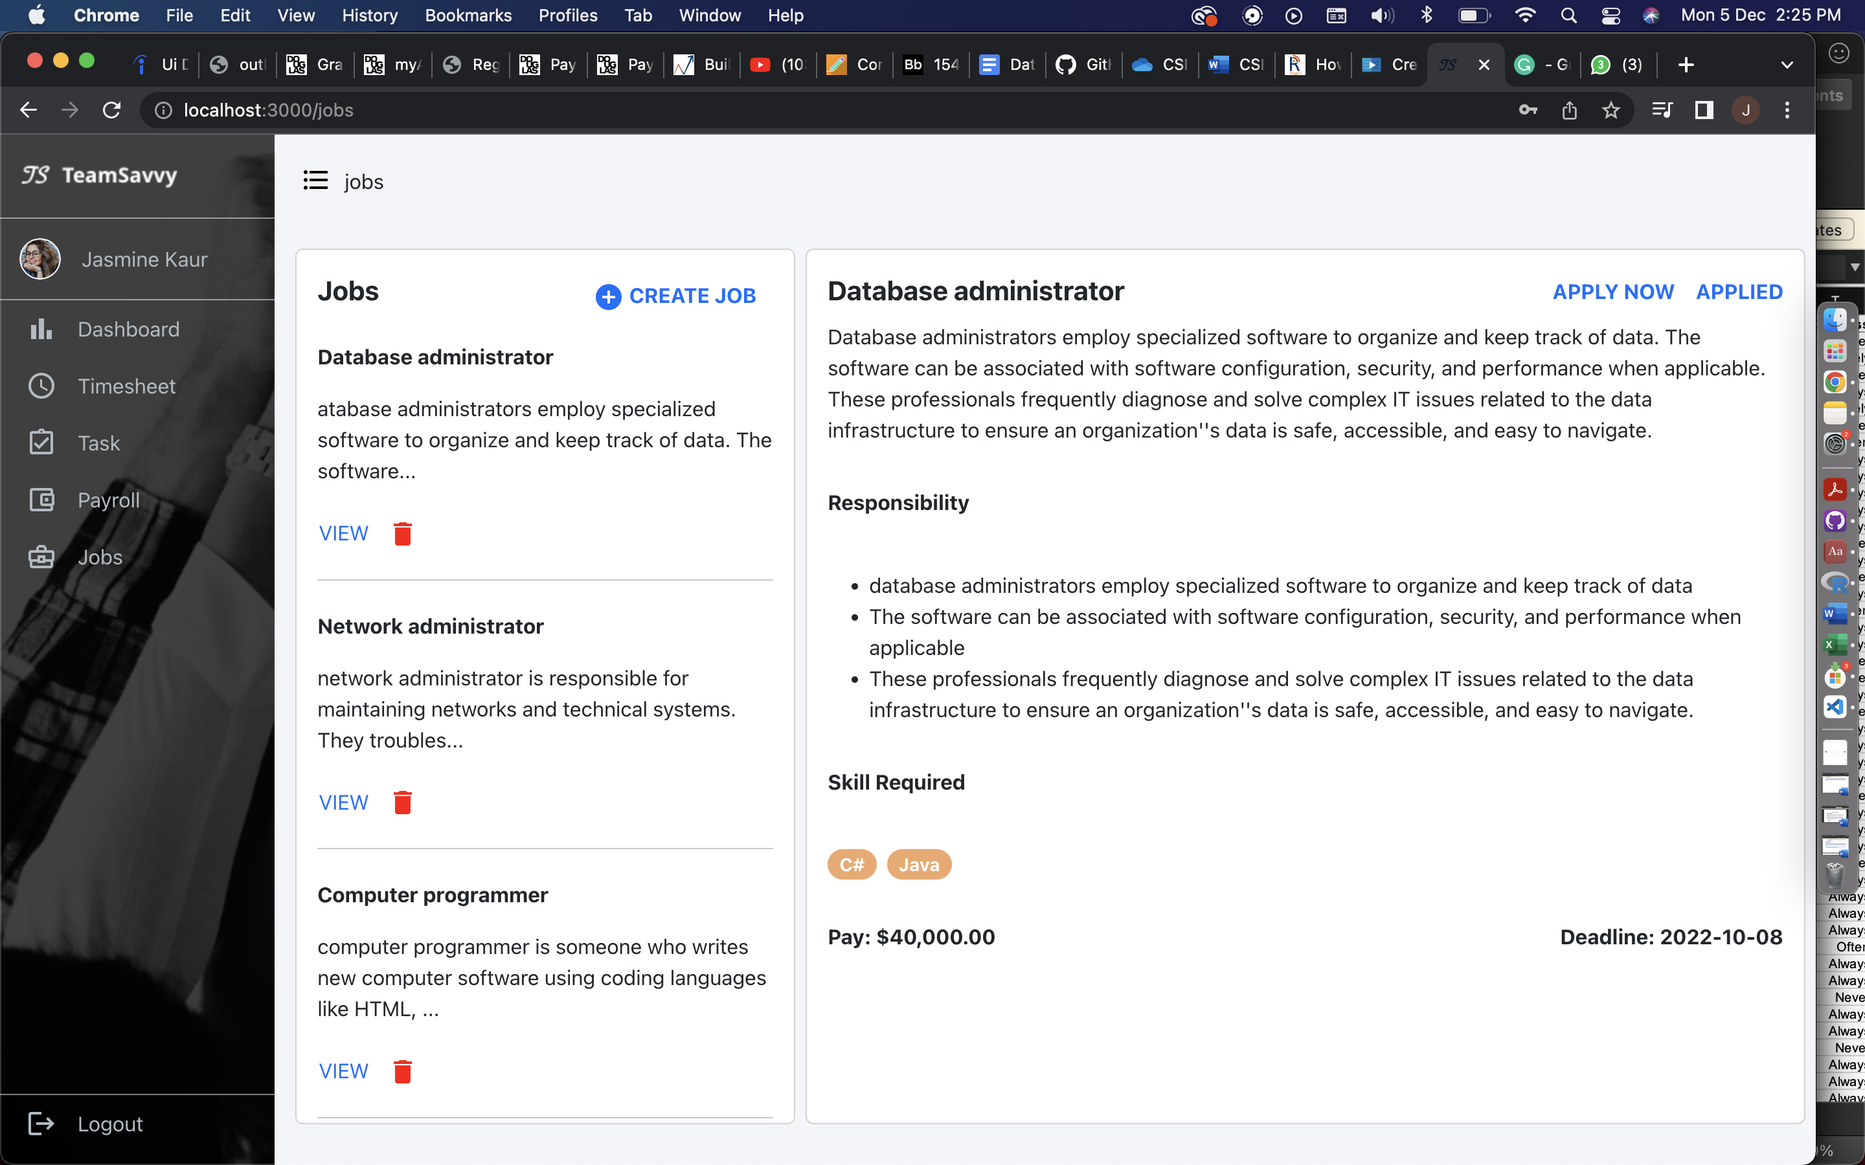

Figure 23: internal job page - hr view

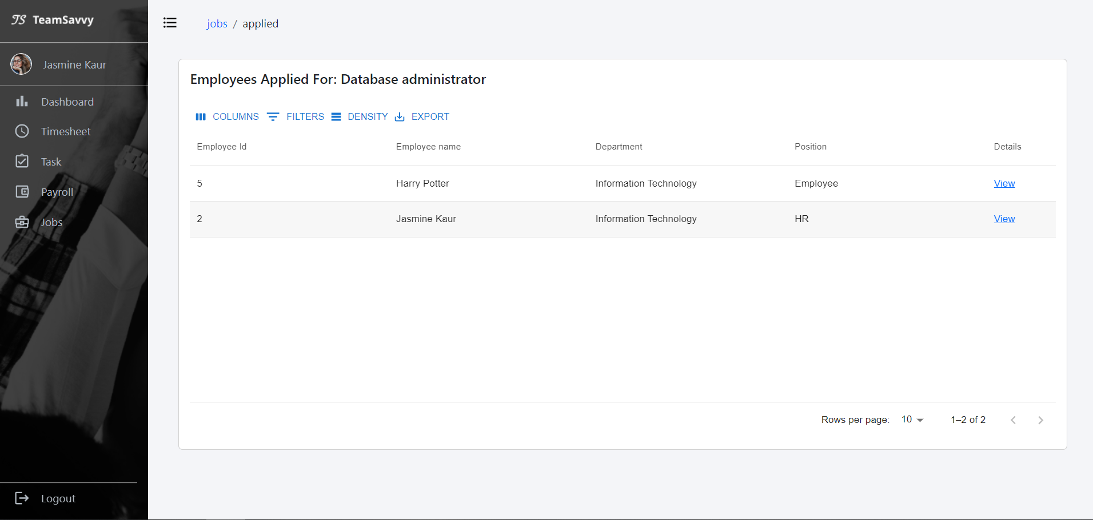

Figure 24: applied employee list

## Database

We’ve created all the Tables that are required for the functioning of the Application. These tables interlinked with each other has all the attributes that gives us the glimpse of how the Application will work.

### **Structure of the Database**

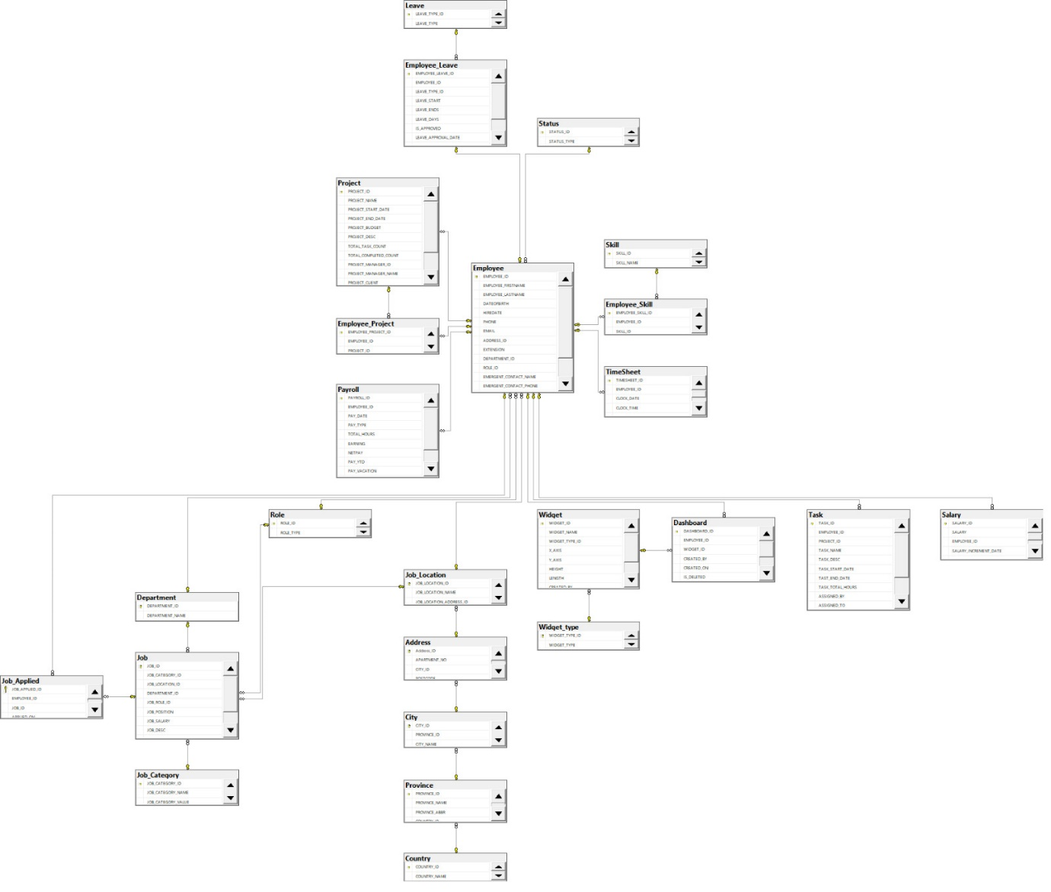

### **Tables in our database**

* **Employee**: PK-EmpID, FK – AddressID, DepartmentID, ProjectID, RoleID, StatuesID, First Name, Last Name, DOB, HireDate, Phone, Extension, Email, Bank Account No.
* **Project**: PK- PojectID, FK – Project Manager ID, Project Name, Project Start Date, Project End date, Project Budget, Project Description, Total Task Count, Total Inprogress Count, Total Completed Count, Project Manager, Project Client, Project Load, Project Total Emplyee
* **Leave**: PK – Leave Type ID, FK – Employee ID, Leave Start Date, Leave End Date, Leave Days, Leave Approval Date, Leave Approved By, Leave Status
* **Employee_Leave**: PK – Employee Leave ID, FK – Employee Type ID
* **Employee_Project:** PK – Employee Project ID, FK – Employee ID, Project ID
* **Payroll**: PK – Payroll ID, FK – Employee ID, Pay ID, Pay Date, Pay Type, Total Hours, Earning, Net Pay, Pay_Vacation, Pay_Sick
* **Status**: PK – Status ID, Status_Type
* **Skill**: PK – Skill ID, Skill Name
* **Employee_Skill**: PK – Employee Skill ID,FK – EmployeeID, SkillID
* **Time_Sheet:** PK – TimesheetID, FK – EmployeeID
* **Role**:PK – RoleID, RoleName
* **Department**: PK – DepartmentID, DepartmentName
* **Job:** PK – JobID, FK – JobCategoryID , JobLocationID, DepartmentID, JobRoleID, JobSalary, JobDesc
* **Job Applied**: PK- Job Applied ID, FK – EmployeeID, JobID
* **Job Category:** PK – JobCategoryID, JobCategoryName, JobCategoryValue
* **Job Location**: PK – JobLocationID, FK – CityID, Location, PostalCode
* **Address:** PK – AddressID, FK - CityID, Apartment, Postal Code
* **City**: PK – CityID, CityName, FK – Province ID
* **Province:** PK – Province ID, FK – Country ID, ProvinceName, ProvinceAbbreviations
* **Country**: PK – CountryID, Country Name
* **Dashboard**: PK – DashboardID,FK – EmployeeID, WidgetID
* **Widget**: PK – WidgetID, FK – WidgetTypeID, WidgetName)
* **Widget_Type:** PK – WidgetTypeID, WidgetType
* **Task:** PK – TaskID, FK – EmployeeID, FK-ProjectID, TaskName, TaskDescription, TaskStartDate, TaskEndDate, TaskTotalHours, AssignedBy, AssignedTo, AssignedDate, TaskStatus
* **Salary**: PK – (SalaryID,SalaryIncdate), FK – EmployeeID, SalaryType, Salary

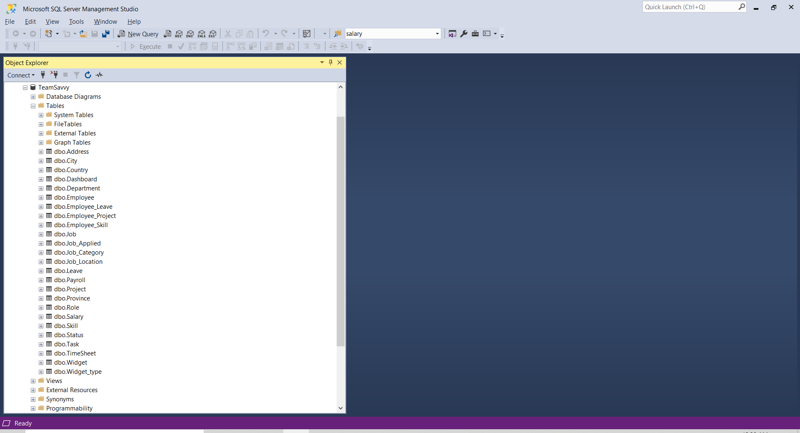

Above screenshot is about TeamSavvy database with all the tables required for application as of now and attaching the SQL script to generate the above database with tables and populate data.

# Features/module with objectives

* Our objective for the platform is to provide access of payroll, tasks, timesheet also internal company jobs to an employee at one place. We have developed side menu for easy navigation and pages to give easy access to this information to an employee.
* Our objective is for Manager or HR to have descriptive analysis using the data in our database. In our platform, manager can create custom graphs and some pre-defined widgets to give overview of the products, team members and tasks they are working on.
* Idea is to create timesheet and task together where employee can check for task pending as they are planning to take leave, rather than moving from platform to platform with our application with just one tab change like click on a timesheet he can apply for leave according to the task planning.
* To apply for an internal job employee must go to company website to apply and then upload their latest resume with skills and details. While with our platform employee can apply directly from jobs sections where HR will receive the profile of an employee in notification which will have listed the skills and other details employee have.
* For HR if they need candidates from a company working on specific programming language. They can use our graph feature to filter number of employees working on language.

# About our project and addressed objectives

Our objective is that an employee can access the details for projects, timesheet, team members, timesheets, leaves and payroll information on one platform. The managers and HR can access the records of employees and also check the profile of the candidates who applied for jobs in their company, provide dashboard for analysis with system data. An improved user interface for a better user experience, to address this we have developed our application.

Teamsavvy is an application for an organization to provide different functionalities for employees with different roles. We have divided our project into useful functionalities based on roles(HR, manager, and employee).

**Dashboard**: The application has a dashboard where the manager and HR can have an overview of projects, employees, and tasks. The dashboard also has a feature to create your own widget with predefined queries, widgets have different chart options for easy understanding. It also has a leave list from where a manager can see the applied leaves by employees. They can approve or reject those leaves.

**Timesheet**: The screen where employees can check their clock-in and clock-out timings which they can add using a mobile application designed fo adding hours. Also, can apply for leaves from the day forward, but cannot apply for leaves before the current day.

**Profile**: this page shows the designation, dept, contact information, team members, and personal and bank details of employees. Also shows the skill set; the employee can add or remove skills and also have a resignation button if clicked will shoot a mail to the manager and HR. HR can create new employees where they will add information about employees who just joined.

**Task**: Each employee will be assigned to just one project, on this page he can view tasks assigned by his manager. Modify the task to change its status to in progress or completed, and add more hours.

**Payroll**: The page shows the list of payslips from where an employee can access each month's payslip.

**Jobs**: This page is for internal jobs that have been created in the company by HR, employee can view and apply for the job just by clicking apply now. HR can view who has applied for the job and can create and delete new jobs.

# Set up the environment

### **For setting up APIs**

* Download Visual Studio
* Install Entity framework nuGet package
* Install Automapper nuGet package
* Install Swashbuckle.AspNetCore.Swagger

### **For running application**

* Install latest node Js
* Install latest packages for project using ‘npm install’
* Then ‘npm start’ to run application on local machine

# Software Design Architecture

### **UML – Use Case Diagram**

For our application we use use case diagram to show the flow and working of an application:

Below shows how each avatar interact with TeamSavvy system and how the system helps simplify their working process.

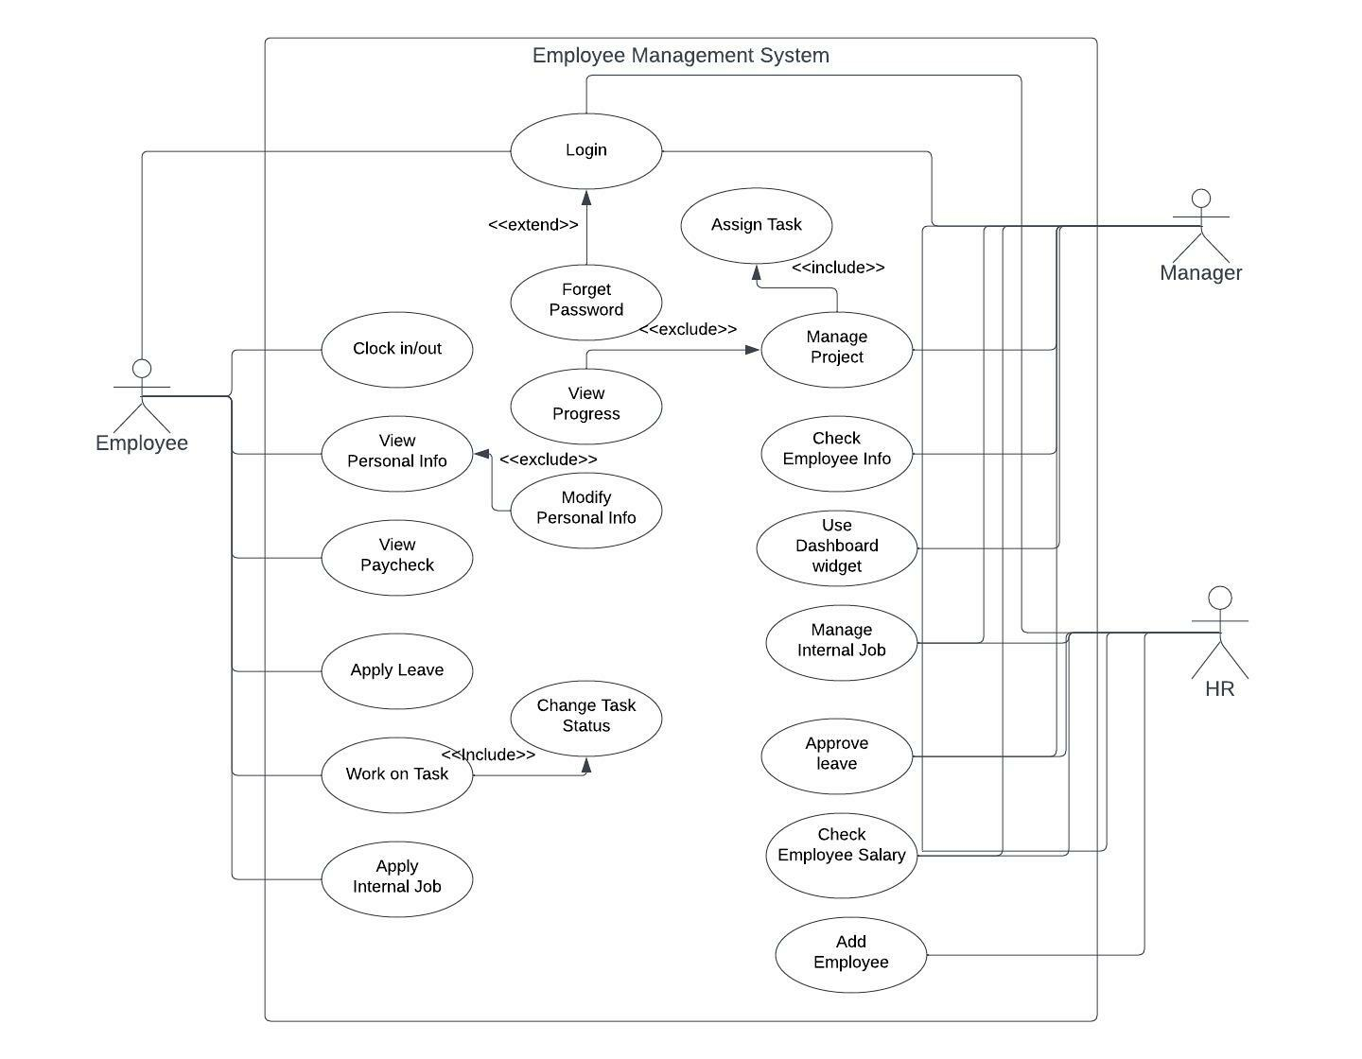

### **Design Pattern applied w/ clear explanation on why it was chosen and how it was implemented**

We have created the Web APIs in .Net Core. We follow the MVC architectural design pattern and Repository Design pattern. We choose MVC (Model-View Controller) design pattern as this gives us Soc (Separation of Concern) and make our code clear to understand and reusable, easier to modify and update.

In our project we created the BAL (Business Layer), DAL (Data Access Layer) and a separate Presentation layer this help in avoiding conflict in code and give power to do independent development simultaneously. We have followed five SOLID Principle while developing our application. We have created Interface which give us power to achieve modularity and extend our code without modification. We have used Dependency Injection to register our services where we have implemented Business Logic.

We have also used Repository Design Pattern to access data layer. We have created an abstract layer between data access and business logic of our application. This gives us a loosely coupled approach to access our database and make our code modular and reusable. It also increases abstraction level of our application, in our application we implemented IRepository.cs Interface, GenericRepository.cs and GenericUnitOfWork.cs class to achieve the Repository design pattern.

IRepository.c Interface

// <summary>

/// Repository contract.

/// </summary>

/// <typeparam name="TEntity"></typeparam>

public interface IRepository<TEntity> where TEntity : class

{

#region Public Methods

/// <summary>

/// Get db set.

/// </summary>

/// <returns></returns>

IQueryable<TEntity> GetQuery();

/// <summary>

/// Get all records in memory.

/// </summary>

/// <returns></returns>

IEnumerable<TEntity> Get();

/// <summary>

/// Get record in memory with no tracking.

/// </summary>

/// <returns></returns>

IEnumerable<TEntity> GetWithNoTracking();

/// <summary>

/// Get dbSet with no tracking.

/// </summary>

/// <returns></returns>

IQueryable<TEntity> GetQueryWithNoTracking();

/// <summary>

/// Get filtered record.

/// </summary>

/// <param name="filter"></param>

/// <param name="orderBy"></param>

/// <param name="includeProperties"></param>

/// <returns></returns>

Task<IEnumerable<TEntity>> Get(Expression<Func<TEntity, bool>> filter = null, Func<IQueryable<TEntity>, IOrderedQueryable<TEntity>> orderBy = null, string includeProperties = "");

/// <summary>

/// Get record using id.

/// </summary>

/// <param name="id"></param>

/// <returns></returns>

TEntity GetById(object id);

/// <summary>

/// Get async record using id.

/// </summary>

/// <param name="id"></param>

/// <returns></returns>

Task<TEntity> GetByIdAsync(object id);

/// <summary>

/// Insert record in DB.

/// </summary>

/// <param name="entity"></param>

void Insert(TEntity entity);

/// <summary>

/// Insert list of records in DB.

/// </summary>

/// <param name="entities"></param>

void Insert(IEnumerable<TEntity> entities);

/// <summary>

/// Update entity.

/// </summary>

/// <param name="entityToUpdate"></param>

void Update(TEntity entityToUpdate);

/// <summary>

/// uppdatye entities

/// </summary>

/// <param name="entitiesToUpdate"></param>

void Update(IEnumerable<TEntity> entitiesToUpdate);

/// <summary>

/// Delete object on the basis of id.

/// </summary>

/// <param name="id"></param>

void Delete(object id);

/// <summary>

/// Delete object on the basis of ids.

/// </summary>

/// <param name="ids"></param>

void Delete(IEnumerable<TEntity> ids);

/// <summary>

/// Delete entity.

/// </summary>

/// <param name="entityToDelete"></param>

void DeleteLogical(TEntity entityToDelete);

/// <summary>

/// Delete entities.

/// </summary>

/// <param name="entityToDelete"></param>

void Delete(TEntity entityToDelete);

#endregion

}

GenericRepository.cs

/// <summary>

/// Generic database repository

/// </summary>

/// <typeparam name="TEntity">Entity of database</typeparam>

public class GenericRepository<TEntity> : IRepository<TEntity> where TEntity : class

{

#region Private Member Variables

/// <summary>

/// Db context.

/// </summary>

private readonly DbContext _context;

/// <summary>

/// Dbset.

/// </summary>

private DbSet<TEntity> _dbSet;

#endregion

#region Constructors

/// <summary>

/// Initialises a generic repository with a dbcontext.

/// Instead of creating repository for getting every data,

/// generic repository is being used.

/// </summary>

/// <param name="context"></param>

public GenericRepository(DbContext context)

{

_context = context;

_dbSet = context.Set<TEntity>();

}

#endregion

#region Public Methods

/// <summary>

/// Get records from database using filters.

/// </summary>

/// <param name="filter"></param>

/// <param name="orderBy"></param>

/// <param name="includeProperties"></param>

/// <returns>Return filtered records.</returns>

public virtual async Task<IEnumerable<TEntity>> Get(Expression<Func<TEntity, bool>> filter = null, Func<IQueryable<TEntity>, IOrderedQueryable<TEntity>> orderBy = null,

string includeProperties = "")

{

IQueryable<TEntity> query = _dbSet;

if (filter != null)

{

query = query.Where(filter);

}

foreach (var includeProperty in includeProperties.Split

(new char[] { ',' }, StringSplitOptions.RemoveEmptyEntries))

{

query = query.Include(includeProperty);

}

if (orderBy != null)

{

return await orderBy(query).ToListAsync<TEntity>();

}

return await query.ToListAsync<TEntity>();

}

/// <summary>

/// Get list of records from database.

/// </summary>

/// <returns>Return list of records.</returns>

public virtual IEnumerable<TEntity> Get()

{

IQueryable<TEntity> query = _dbSet;

return query.ToList();

}

/// <summary>

/// Get dbset.

/// </summary>

/// <returns>Return dbset.</returns>

public virtual IQueryable<TEntity> GetQuery()

{

return _dbSet;

}

/// <summary>

/// Get list of records with no tracking.

/// </summary>

/// <returns>Return list with no tracking.</returns>

public virtual IEnumerable<TEntity> GetWithNoTracking()

{

IQueryable<TEntity> query = _dbSet;

return query.AsNoTracking<TEntity>().ToList();

}

/// <summary>

/// Get dbset with no tracking.

/// </summary>

/// <returns>Return dbset with no tracking.</returns>

public virtual IQueryable<TEntity> GetQueryWithNoTracking()

{

return _dbSet.AsNoTracking<TEntity>();

}

/// <summary>

/// Find record by id in DB.

/// </summary>

/// <param name="id"></param>

/// <returns>Return record by id.</returns>

public virtual TEntity GetById(object id)

{

return _dbSet.Find(id);

}

/// <summary>

/// Find record by id in DB asyncroniously.

/// </summary>

/// <param name="id"></param>

/// <returns>Return async record by id.</returns>

public virtual async Task<TEntity> GetByIdAsync(object id)

{

return await _dbSet.FindAsync(id);

}

/// <summary>

/// Generic method to insert record in DB.

/// </summary>

/// <param name="entity"></param>

public virtual void Insert(TEntity entity)

{

_dbSet.Add(entity);

}

/// <summary>

/// Generic method to insert records in DB.

/// </summary>

/// <param name="entities"></param>

public virtual void Insert(IEnumerable<TEntity> entities)

{

_dbSet.AddRange(entities);

}

/// <summary>

/// Update record.

/// </summary>

/// <param name="entityToUpdate"></param>

public virtual void Update(TEntity entityToUpdate)

{

_dbSet.Attach(entityToUpdate);

_context.Entry(entityToUpdate).State = EntityState.Modified;

}

/// <summary>

/// update list of records.

/// </summary>

/// <param name="entitiesToUpdate"></param>

public virtual void Update(IEnumerable<TEntity> entitiesToUpdate)

{

foreach (TEntity entity in entitiesToUpdate)

{

_dbSet.Attach(entity);

_context.Entry(entity).State = EntityState.Modified;

}

}

/// <summary>

/// Delete record.

/// </summary>

/// <param name="id"></param>

public virtual void Delete(object id)

{

TEntity entityToDelete = _dbSet.Find(id);

Delete(entityToDelete);

}

/// <summary>

/// Delete list of record.

/// </summary>

/// <param name="entitiesToDelete"></param>

public virtual void Delete(IEnumerable<TEntity> entitiesToDelete)

{

foreach (TEntity entity in entitiesToDelete)

{

Delete(entity);

}

}

/// <summary>

/// Delete entity

/// </summary>

/// <param name="entityToDelete"></param>

public virtual void DeleteLogical(TEntity entityToDelete)

{

PropertyInfo prop = entityToDelete.GetType().GetProperty("Deleted", BindingFlags.Public | BindingFlags.Instance);

if (null != prop && prop.CanWrite)

{

prop.SetValue(entityToDelete, true, null);

}

Update(entityToDelete);

}

public virtual void Delete(TEntity entityToDelete)

{

if (_context.Entry(entityToDelete).State == EntityState.Detached)

{

_dbSet.Attach(entityToDelete);

}

_dbSet.Remove(entityToDelete);

}

#endregion

}

GenericUnitOfWork.cs

/// <summary>

/// Generic class for db queries.

/// </summary>

/// <typeparam name="TContext"></typeparam>

public class GenericUnitOfWork<TContext> : IDisposable where TContext : DbContext

{

#region Private Member Variables

/// <summary>

/// Generic unit of work contains a dictionary of repositories.

/// </summary>

private Dictionary<Type, object> _repositories = new Dictionary<Type, object>();

#endregion

#region Constructors

/// <summary>

/// A constructor with a generic dbcontext. This avoids coupling with a particular dbcontext.

/// </summary>

/// <param name="context"></param>

public GenericUnitOfWork(TContext context)

{

Context = context;

}

#endregion

#region Public Properties

/// <summary>

/// context property

/// </summary>

public TContext Context { get; } = null;

#endregion

#region Public Methods

/// <summary>

/// Create context connection of particular table in entity.

/// </summary>

/// <typeparam name="TEntity"></typeparam>

/// <returns>Return context object.</returns>

public GenericRepository<TEntity> Repository<TEntity>() where TEntity : class

{

if (_repositories.Keys.Contains(typeof(TEntity)))

{

return _repositories[typeof(TEntity)] as GenericRepository<TEntity>;

}

GenericRepository<TEntity> repo = new GenericRepository<TEntity>(Context);

_repositories.Add(typeof(TEntity), repo);

return repo;

}

/// <summary>

/// Save changed data in DB.

/// </summary>

/// <returns>Return number of record saved.</returns>

public int SaveChanges()

{

return Context.SaveChanges();

}

/// <summary>

/// Save changed data in DB asyncronously.

/// </summary>

/// <returns>Return number of record saved.</returns>

public Task<int> SaveChangesAsync()

{

return Context.SaveChangesAsync();

}

/// <summary>

/// Disposed bool variable initialise.

/// </summary>

private bool disposed = false;

/// <summary>

/// Method to dispose DB connection.

/// </summary>

/// <param name="disposing"></param>

protected virtual void Dispose(bool disposing)

{

if (!disposed)

{

if (disposing)

{

Context.Dispose();

}

}

disposed = true;

}

/// <summary>

/// Method for garbage collection of unused objects.

/// </summary>

public void Dispose()

{

Dispose(true);

GC.SuppressFinalize(this);

}

#endregion

}

# Test done with explanations

Being an employee management system, the purpose of TeamSavvy is to improve employees’ satisfaction and productivity to help a company achieve its overall goal. It helps monitor, assess, and control employee’s performance and attendance as well as simplify some processes that used to be trivial in traditional systems.

Due to the time limitation, we used functional test and end-to-end test methods to perform the software testing. While inspecting all functions connecting to API and database, and getting correct data, we tested different user flows (admin/ HR/ Manager/employee) to verity that everything works as expected.

## Friendly user interface

For the “how do you know if the potential users see it as “friendly” user interface?” question. Ideally, it will be helpful if we can have “real” potential users to check and evaluate it. Considering the time constraint, we instead using a general check list to do the self-assessment.

* Optimize for mobile device:

Although our application should be performed on a desktop monitor, if an employee wants to check something urgently, it is still workable. Most of the data is clear to see on mobile phone size screen.

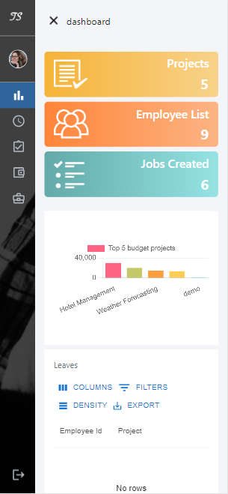 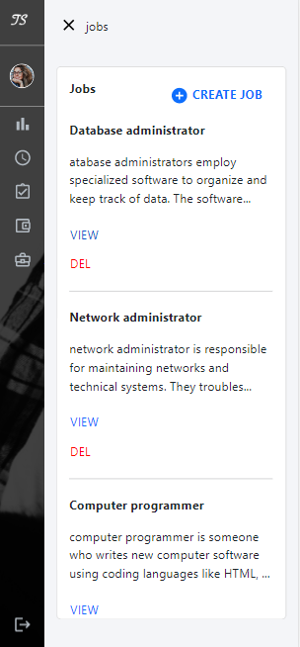 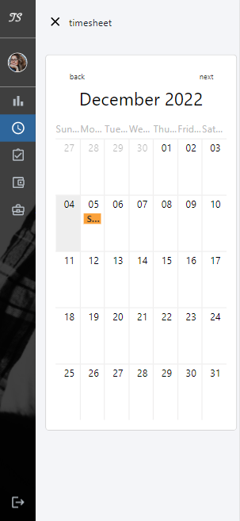

( iPhone 12 Pro with size 390 x 844 )

* Develop an interlinking strategy for your site

The use of sidebar and breadcrumbs makes navigate to previous page or any other pages convenient.

* Be consistent with your design style:

The design of our application is consistent as the design was done before the coding part began and all team members follow the original design for front-end coding.

* Create content that is easy to consume

|  |  |
| --- | --- |
| Legible font | The font size is proper and easy to read. |
| Spelling and grammar | No significant grammar and spelling error found when testing. |
| Proper contrast | Simple light grey and white background colour with black fonts makes the content easy to read. |

## Easy and simplified internal flow

* Apply for internal job with one click
* Mobile clock in/ clock out tool
* Resign from current job with single click
* Apply leaves on calendar

## Employee Engagement

Below all the functions have been thoroughly tested and work as expected.

|  |  |
| --- | --- |
| Function | explanation |
| Modify personal information | Yes. user info page ( click on user name) |
| Apply for leaves | Yes. Timesheet page |
| Work history | Yes. Check in task page for tasks in each status. |
| Payroll details | Yes. Check in paystub for more detail |

## Mobile Clock in/ Clock out

The mobile application for employee to clock in/ clock out has been successfully implemented. While getting the timestamp from mobile app, each employee’s attendance will be shown on their own timesheet. Manager and HR can also see it through the employee list in the dashboard page.

# Set up on another machine

#### For setting up APIs

* Download [Visual Studio 2022](https://visualstudio.microsoft.com/downloads/)

Select the version base on your device

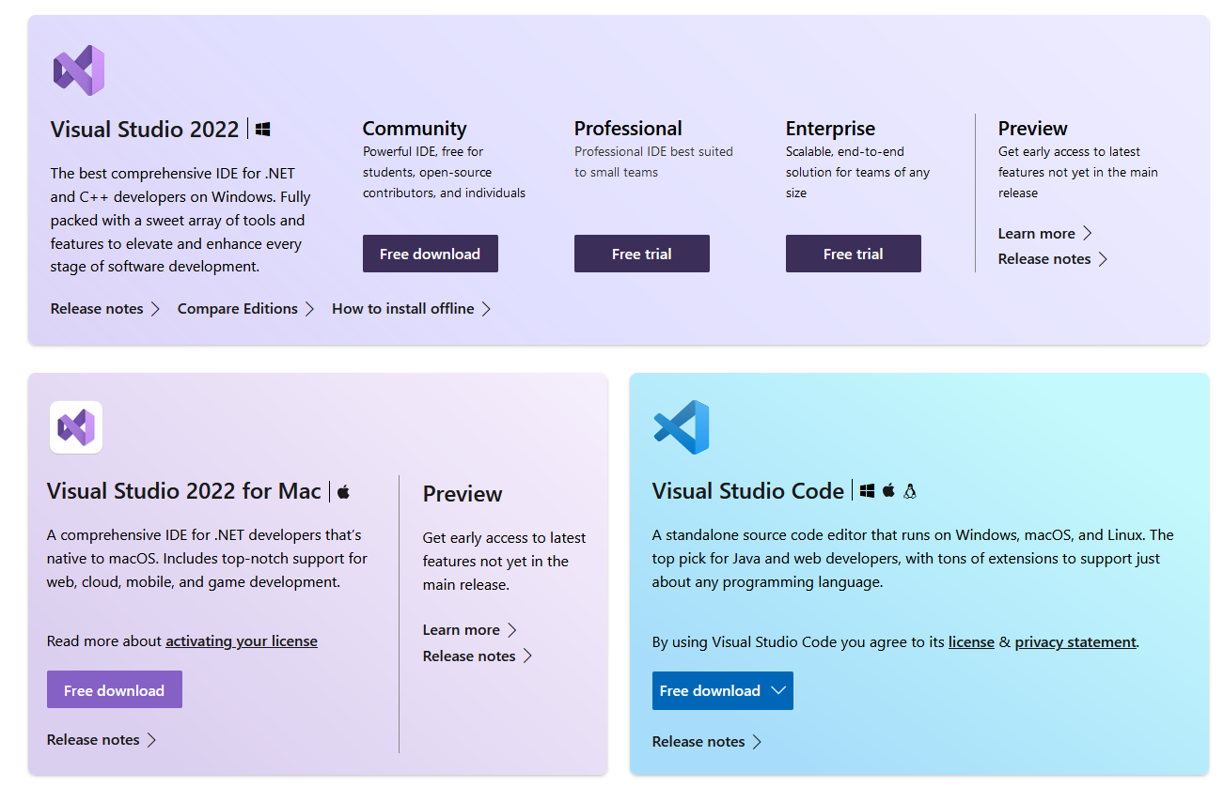

* Install Entity framework nuGet package

Use .NET CLI

dotnet add package EntityFramework --version 6.4.4

* Install Automapper nuGet package

Use .NET CLI

dotnet add package AutoMapper --version 12.0.0

* Install Swashbuckle.AspNetCore.Swagger

Use .NET CLI

dotnet add package Swashbuckle.AspNetCore.Swagger --version 6.4.0

#### For running application

* Install latest [nodeJS](https://nodejs.org/en/)

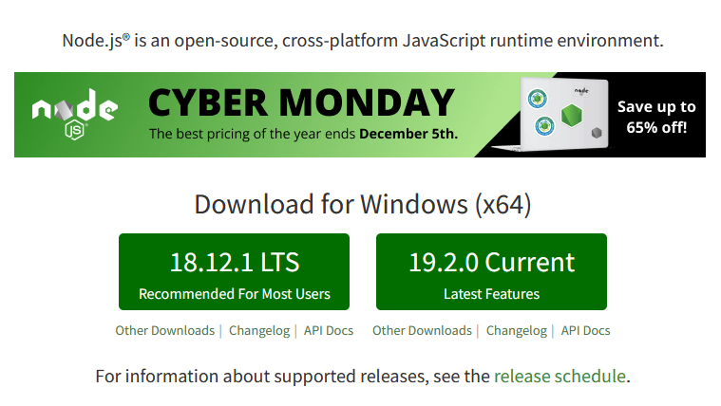

* Install latest packages for project using ‘npm install’ in terminal
* Then ‘npm start’ to run application on local machine in terminal
* Use login details for:

**HR**:

Emp id- 2

Password- QWEqwe@2

**Manager**:

Emp id- 3

Password- QWEqwe@2

**Employee**:

Emp id- 6

Password- QWEqwe@2

# Workload distribution

|  |  |
| --- | --- |
|  | contributor |
| UI design | Jasmine |
| Database | Jaspal, Joling, Harman |
| Front-end | Jaspal, Jasmine, Joling |
| Back-end | Jaspal |
| Mobile app | Jaspal |

A Gantt chart, a Network Diagram and Timeline on Microsoft Project:

Network Diagram: We have completed the content under the green box so far. Every other task is in progress.

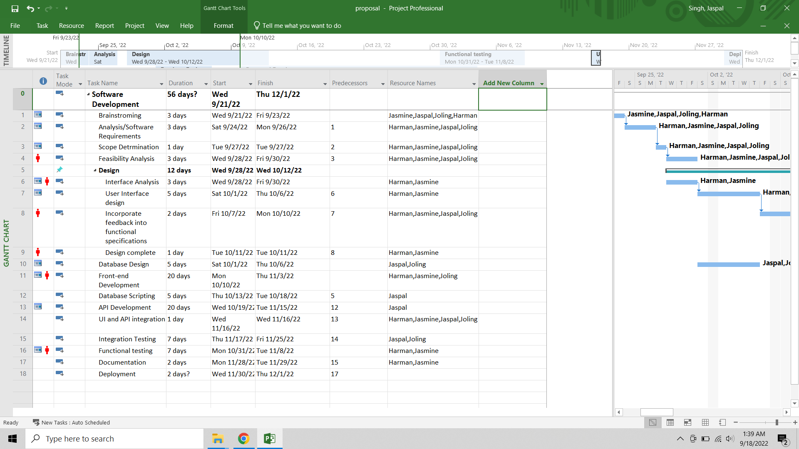

Gantt chart:

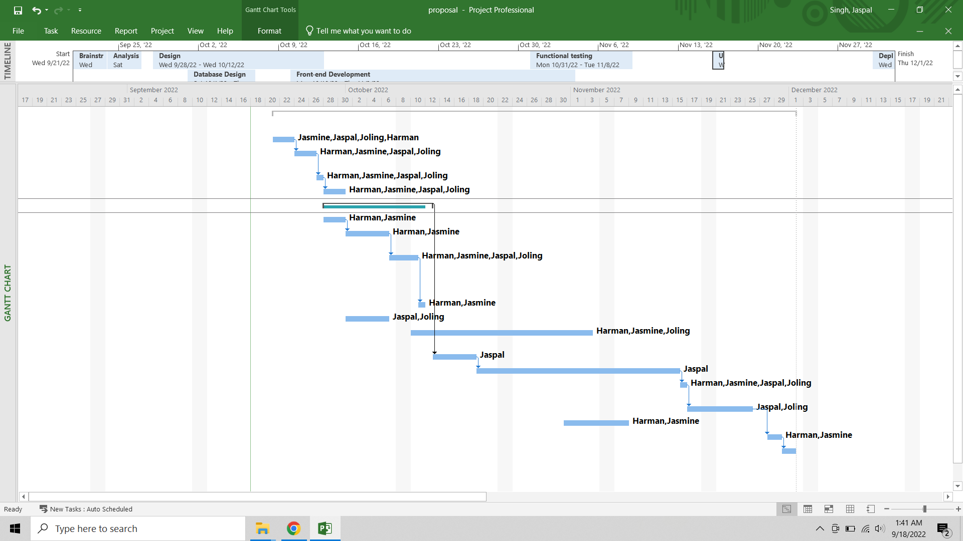

Timeline: All tasks have been completed.

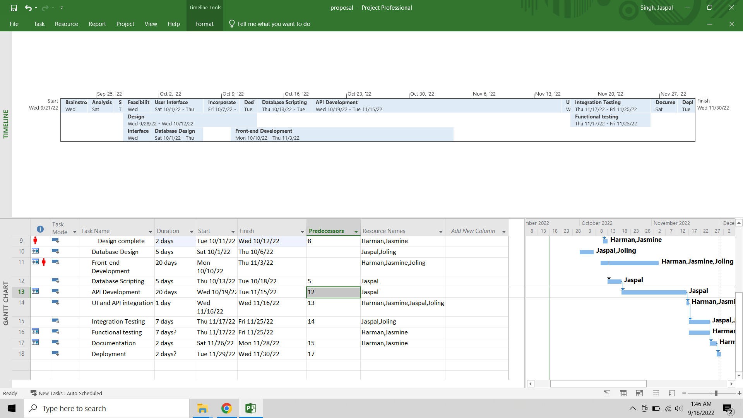

**Dashboard and logic**

* Dashboard widget charts have been completed. Managers can use widget tool to generate charts by pre-defined queries.
* Timesheet now can see employee leave, clock in/ clock out.

**Task**

* Bugs fixed for task updating. While user gets new tasks from manager, he/she will be able to modify and update the status in this page.

**Job**

* Job page has been completed. Now HR is able to create new jobs, delete job postings and see applied employee list.
* We also implemented a sweet alert to notify the user if he/she has already applied for the same job. Hence, same employee’s data won’t be duplicate in database.

**Database**

* Database is now hosted on Azure instead of local database.

# References

### **Front-end libraries**

Chart.js: <https://www.chartjs.org/>

Moment.js: <https://momentjs.com/>

MUI: <https://mui.com/x/introduction/>

React: <https://reactjs.org/>

React Router: <https://reactrouter.com/en/main>

Reactstrap: <https://reactstrap.github.io/?path=/story/home-installation--page>

React-bootstrap: <https://react-bootstrap.github.io/components/modal/>

### **SQL Server**

SQL Server: <https://learn.microsoft.com/en-us/sql/ssms/download-sql-server-management-studio-ssms?view=sql-server-ver16>

# Appendix

## Progress report 1

**Statement of the Problem:**

The Employee Management Systemhelps create an environment that motivates communication and keeps employees and managers working together to meet company goals.It also helps the company to manage the information and activities of employees.

The issue with the existing system is to access data about employee projects, leaves, payroll, and jobs applied internally, for accessing these details an individual has to use different web platforms.

Our system proposes that a person can access the details for projects, work history, team hierarchy, peers, timesheets, leaves and payroll information on one platform. The managers and company owners can access the records of employees and also check the resume of the candidates who applied for jobs on their company website with an improved user interface for a better user experience.

**Significance of the study**

Who would benefit from this project and how?

**Employee Engagement:** Our platform will provide employees to add their details, apply for leaves, and check their work history and payroll details on one platform. This will save time for an individual to concentrate on tasks for company growth. Employees can track their growth and improve their working efficiency.

**Biometric:** We will create an android app to get user biometric timestamp and will store it in the database. Employee can use his biometric to clock-in and clock-out of the system.

**Create Dashboard:** Our project will provide the dashboard of collective data of employees. A manager or company owner can perform descriptive analysis on employee’s data; with respect to programming languages, projects, leaves (sick leave, casual leave) in specific period and, salary. **We will give different graph options to select from and, can create multiple graphs to visualize data and show the dashboard on preview mode and can download it.** The HR at a company can do analytics; for example, number of employees have knowledge of programming language, salary of each employee in specific project. We will represent this information in a graphical format.

**Create Task:** The employee can fill his hours he is working on a particular task and then change the status of task to in-progress, after completing the task employee can change the task status to finish. The notification will be sent to the manager that this task has been completed. Manager can track the progress of the tasks assigned to team members.

**Improve communication:** Our platform provides the information of each employee to others by search option that will let them to stay connected, and an easy path for new joiners to get to know their peers. All in all, improve the connection which will reduce the problem of communication gap within an organization.

**Users:**

Employee**:**

* An employee will have access to a calendar where he can see clock-in and clock-out for a day
* Check total working hours
* Apply for leaves
* Check his payroll details (Read only),
* Get information of other employee working in an organization for communication
* Can get the team hierarchy
* Check the number and details of projects he is working on
* Employee will have the profile page where he will have his information saved or can update if required
* Can apply on internal jobs
* Apply for resignation

Admin (HR or Manager):

* An admin will have all the functionality that employee has
* Able to see information of employees in his team
* He can perform CRUD operations on them
* Check payroll info and can give increment to an employee
* Admin will have details of project’s budget and deadline
* Can assign project to employee
* Modify involvement of employees in different projects,
* Can approve leaves of an employee
* Check timesheets
* Create internal job postings for employees.
* Super admin (Company Owner): A super admin can perform CRUD operations on admins and employees.

**Project Implementations:**

**What have we done so far:**

1. **Android App for employee’s biometric**



Landing screen for an employee showcasing the project name, image, message for an employee for the attendance and loader.



This screen will ask employee for their employee

ID and allow him to clock-in or clock-out.

We are still working on design and few features.



After entering the employee id the button will be activated.



The app will ask for biometric verification, if the fingerprint matches to the record of fingerprint

in device the app will accept and allow user to clock-in or clock-out.



At last, the app will show the snack bar to show if an employee has been verified or not also displays the status clock-in or clock-out.

1. **APIs**

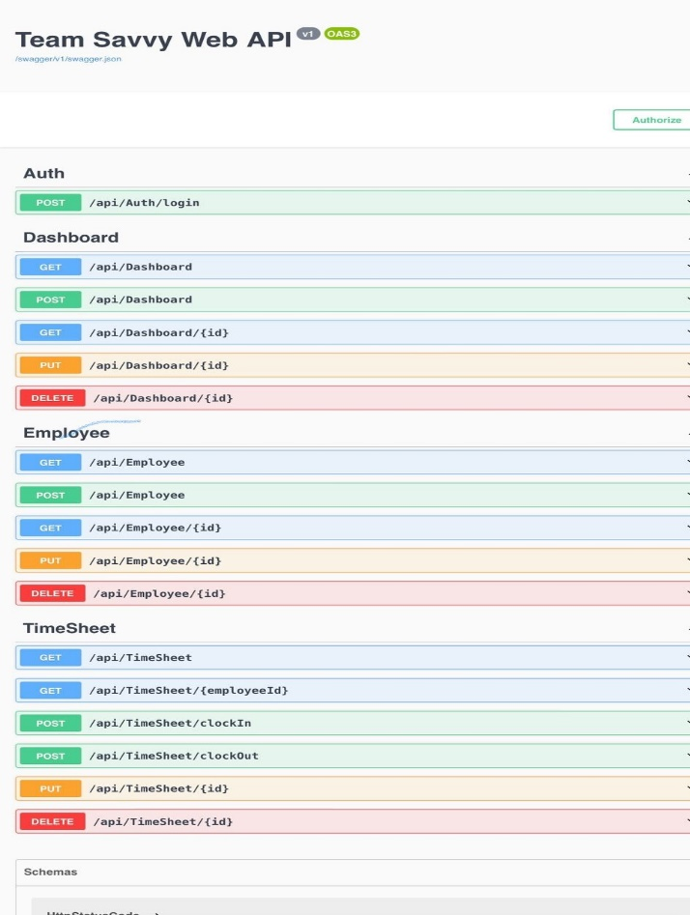

We have created API in .NET CORE which can do authentication and authorization of user, provide employee details, timesheet details of employee and dashboard.

1. **UI Design using Adobe XD**

The snapshots below shows the flow of our application.

**Login:**

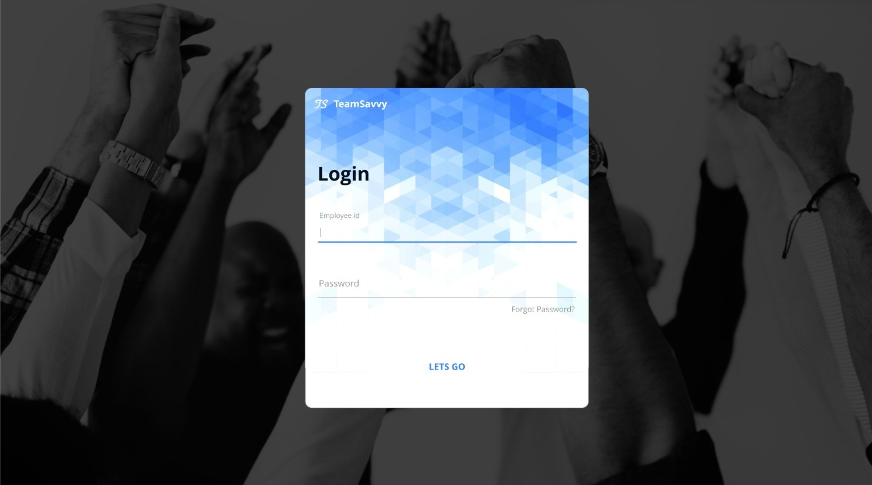 The employee and admin will login with the predefined credentials provided by organization.

**Timesheet:**

This screen will show the information of employee clock-in and clock-out, with total hours they worked per week. Additionally, employee can apply for leaves and it will displayed on the calendar

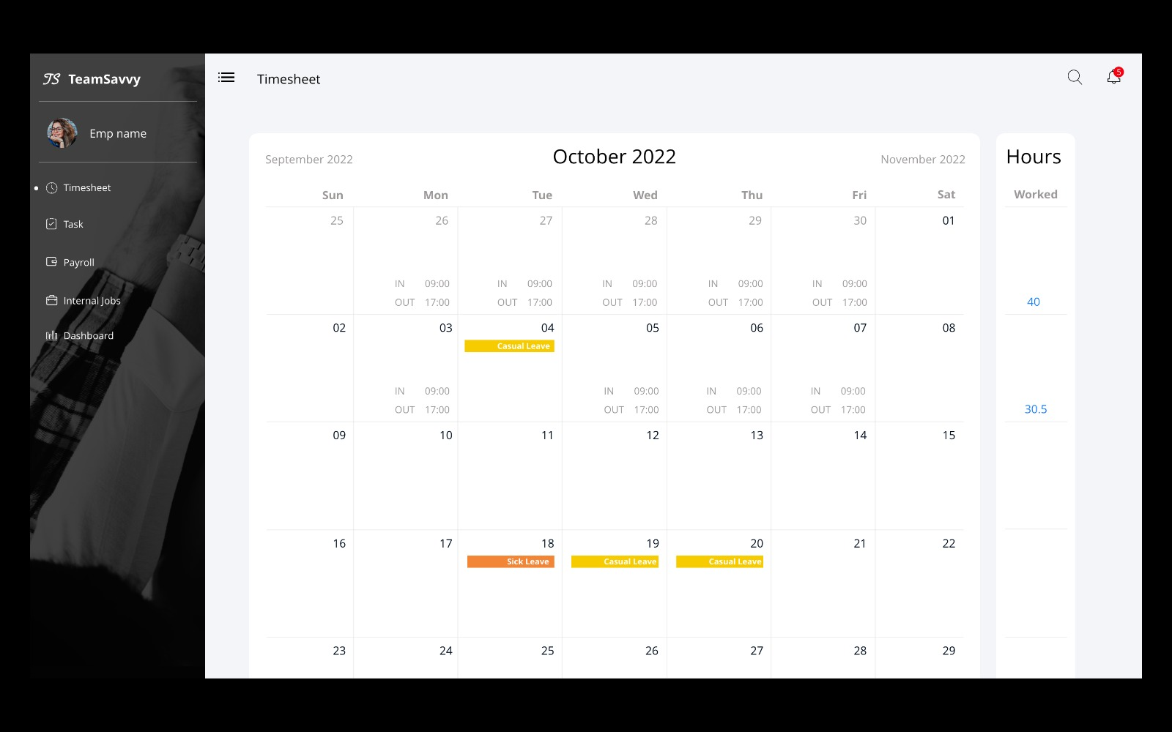

**Task:**

Task screen will have the assigned task for an employee, which he can modify to add hours, start date, and end date. Employee can also change the status from assigned to in-progress and then by using update status in in-progress lane he can change status to completed.

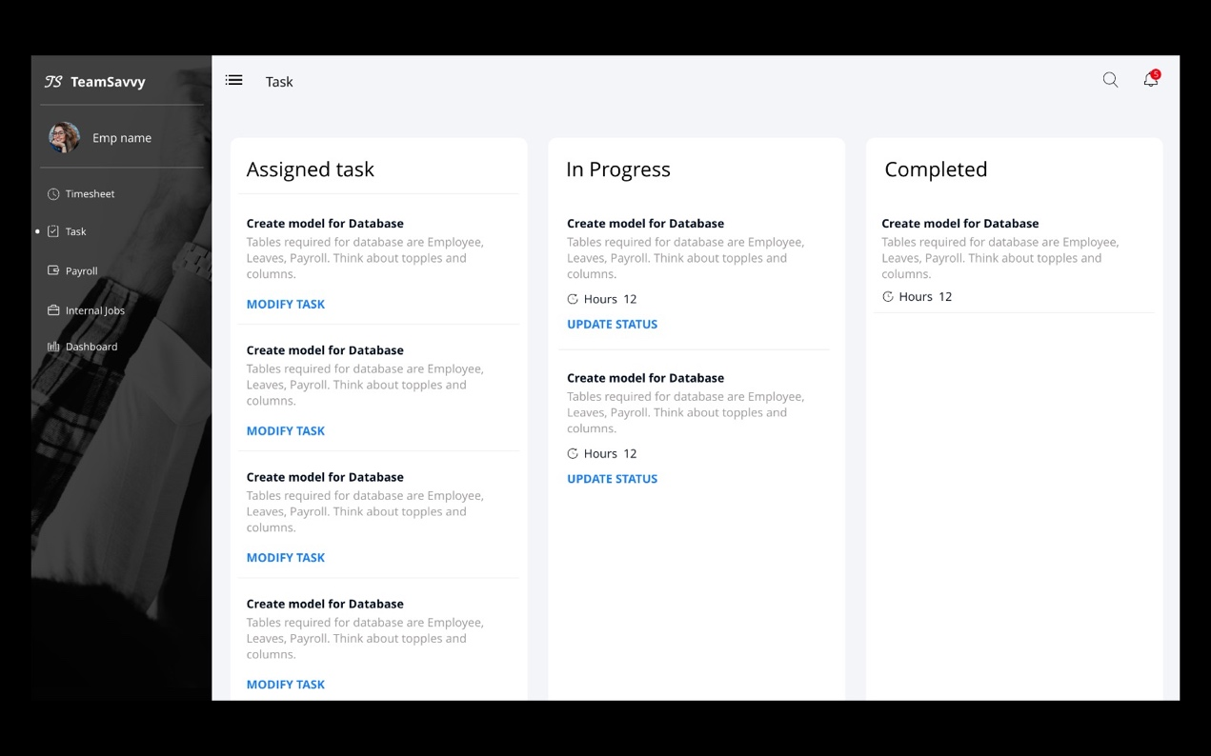

**Payroll:**

This screen will have the collection of pay slips with information of each month, total hours, and earnings, from here user can view each pay slip. The Pay Slip contains all the Earnings of an employee at the company from the date he has joined.



**Internal Jobs:**

This screen will display employee with the internal jobs postings which he can read the description and apply for the jobs.



**User Profile:**

This screen will show the personal details, team members, position, department, skill set and bank details of an employee.

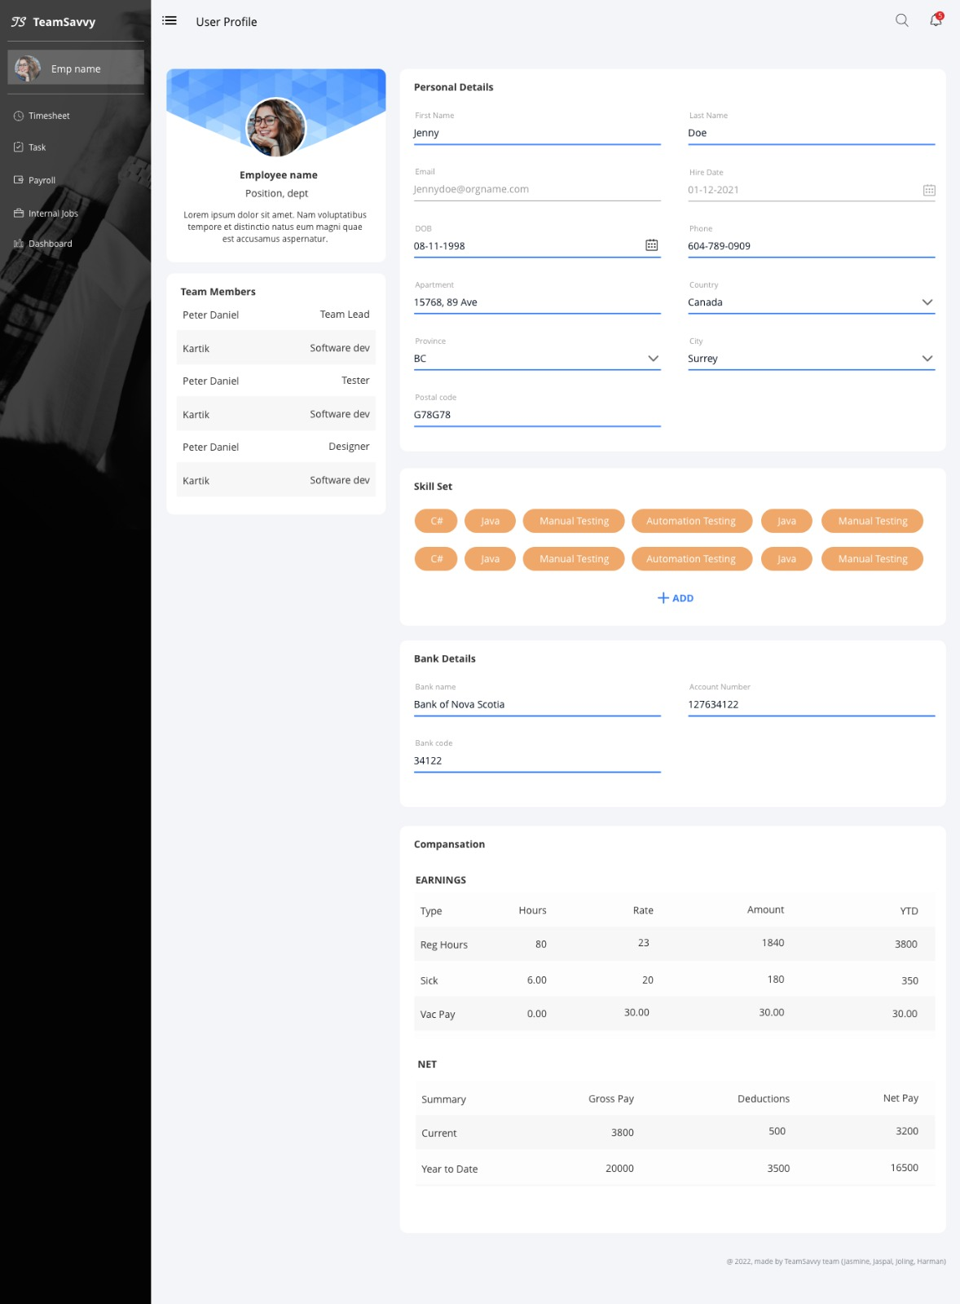

**Dashboard:**

This screen is for manager and HR, here they can view projects, team members, tasks, and other information. This screen will also have feature to create graphs widgets with predefined dropdowns. Manager can download, modify and delete the graph.



1. **Database**

\We’ve created all the Tables that are required for the functioning of the Application. These tables interlinked with each other has all the attributes that gives us the glimpse of how the Application will work.

**Structure of the Database:**



**Tables in our database:**

* **Employee**: PK-EmpID, FK – AddressID, DepartmentID, ProjectID, RoleID, StatuesID, First Name, Last Name, DOB, HireDate, Phone, Extension, Email, Bank Account No.
* **Project**: PK- PojectID, FK – Project Manager ID, Project Name, Project Start Date, Project End date, Project Budget, Project Description, Total Task Count, Total Inprogress Count, Total Completed Count, Project Manager, Project Client, Project Load, Project Total Emplyee
* **Leave**: PK – Leave Type ID, FK – Employee ID, Leave Start Date, Leave End Date, Leave Days, Leave Approval Date, Leave Approved By, Leave Status
* **Employee_Leave**: PK – Employee Leave ID, FK – Employee Type ID
* **Employee_Project:** PK – Employee Project ID, FK – Employee ID, Project ID
* **Payroll**: PK – Payroll ID, FK – Employee ID, Pay ID, Pay Date, Pay Type, Total Hours, Earning, Net Pay, Pay_Vacation, Pay_Sick
* **Status**: PK – Status ID, Status_Type
* **Skill**: PK – Skill ID, Skill Name
* **Employee_Skill**: PK – Employee Skill ID,FK – EmployeeID, SkillID
* **Time_Sheet:** PK – TimesheetID, FK – EmployeeID
* **Role**:PK – RoleID, RoleName
* **Department**: PK – DepartmentID, DepartmentName
* **Job:** PK – JobID, FK – JobCategoryID , JobLocationID, DepartmentID, JobRoleID, JobSalary, JobDesc
* **Job Applied**: PK- Job Applied ID, FK – EmployeeID, JobID
* **Job Category:** PK – JobCategoryID, JobCategoryName, JobCategoryValue
* **Job Location**: PK – JobLocationID, FK – JobLocationAddressID, JobLocationName
* **Address:** PK – Address ID, FK - City ID, Apartment, Postal Code
* **City**: PK – CityID, CityName, FK – Province ID
* **Province:** PK – Province ID, FK – Country ID, ProvinceName, ProvinceAbbreviations
* **Country**: PK – CountryID, Country Name
* **Dashboard**: PK – DashboardID,FK – EmployeeID, WidgetID
* **Widget**: PK – WidgetID, FK – WidgetTypeID, WidgetName)
* **Widget_Type:** PK – WidgetTypeID, WidgetType
* **Task:** PK – TaskID, FK – EmployeeID, FK-ProjectID, TaskName, TaskDescription, TaskStartDate, TaskEndDate, TaskTotalHours, AssignedBy, AssignedTo, AssignedDate, TaskStatus
* **Salary**: PK – (SalaryID,SalaryIncdate), FK – EmployeeID, SalaryType, Salary

**Pending Implementations:**

A Gantt chart, a Network Diagram and Timeline on Microsoft Project:

Network Diagram: We have completed the content under the green box so far. Every other task is in progress.



Gantt chart:



Timeline: We have completed the content under the green box so far.



**Proposed Revisions:**

We have created an android app but according to our research, android doesn’t allow us to access the fingerprint. Therefore, we have designed android app where we assume that employee will put his id and fingerprint for clock-in and clock-out.

Glitch in this, if employee can add someone else’s id and his fingerprint to clock-in or clock-out, then functionality will work according to the employee id entered.

## Progress report 2

**Statement of the Problem:**

The Employee Management Systemhelps create an environment that motivates communication and keeps employees and managers working together to meet company goals.It also helps the company to manage the information and activities of employees.

The issue with the existing system is to access data about employee projects, leaves, payroll, and jobs applied internally, for accessing these details an individual has to use different web platforms.

Our system proposes that a person can access the details for projects, work history, team hierarchy, peers, timesheets, leaves and payroll information on one platform. The managers and company owners can access the records of employees and also check the resume of the candidates who applied for jobs on their company website with an improved user interface for a better user experience.

**Significance of the study**

Who would benefit from this project and how?

**Employee Engagement:** Our platform will provide employees to add their details, apply for leaves, and check their work history and payroll details on one platform. This will save time for an individual to concentrate on tasks for company growth. Employees can track their growth and improve their working efficiency.

**Biometric:** We will create an android app to get user biometric timestamp and will store it in the database. Employee can use his biometric to clock-in and clock-out of the system.

**Create Dashboard:** Our project will provide the dashboard of collective data of employees. A manager or company owner can perform descriptive analysis on employee’s data; with respect to programming languages, projects, leaves (sick leave, casual leave) in specific period and, salary. **We will give different graph options to select from and, can create multiple graphs to visualize data and show the dashboard on preview mode and can download it.** The HR at a company can do analytics; for example, number of employees have knowledge of programming language, salary of each employee in specific project. We will represent this information in a graphical format.

**Create Task:** The employee can fill his hours he is working on a particular task and then change the status of task to in-progress, after completing the task employee can change the task status to finish. The notification will be sent to the manager that this task has been completed. Manager can track the progress of the tasks assigned to team members.

**Improve communication:** Our platform provides the information of each employee to others by search option that will let them to stay connected, and an easy path for new joiners to get to know their peers. All in all, improve the connection which will reduce the problem of communication gap within an organization.

**Users:**

Employee**:**

* An employee will have access to a calendar where he can see clock-in and clock-out for a day
* Check total working hours
* Apply for leaves
* Check his payroll details (Read only),
* Get information of other employee working in an organization for communication
* Can get the team hierarchy
* Check the number and details of projects he is working on
* Employee will have the profile page where he will have his information saved or can update if required
* Can apply on internal jobs
* Apply for resignation

Admin (HR or Manager):

* An admin will have all the functionality that employee has
* Able to see information of employees in his team
* He can perform CRUD operations on them
* Check payroll info and can give increment to an employee
* Admin will have details of project’s budget and deadline
* Can assign project to employee
* Modify involvement of employees in different projects,
* Can approve leaves of an employee
* Check timesheets
* Create internal job postings for employees.

Super admin (Company Owner): A super admin can perform CRUD operations on admins and employees.

**Project Implementations:**

**What have we done so far ?**

Test Cases and screenshot: Testing the API gives the following results:

**Checking the Employee Database:**

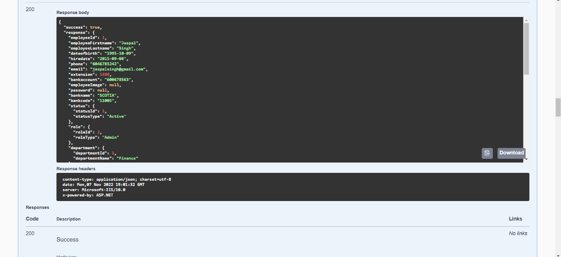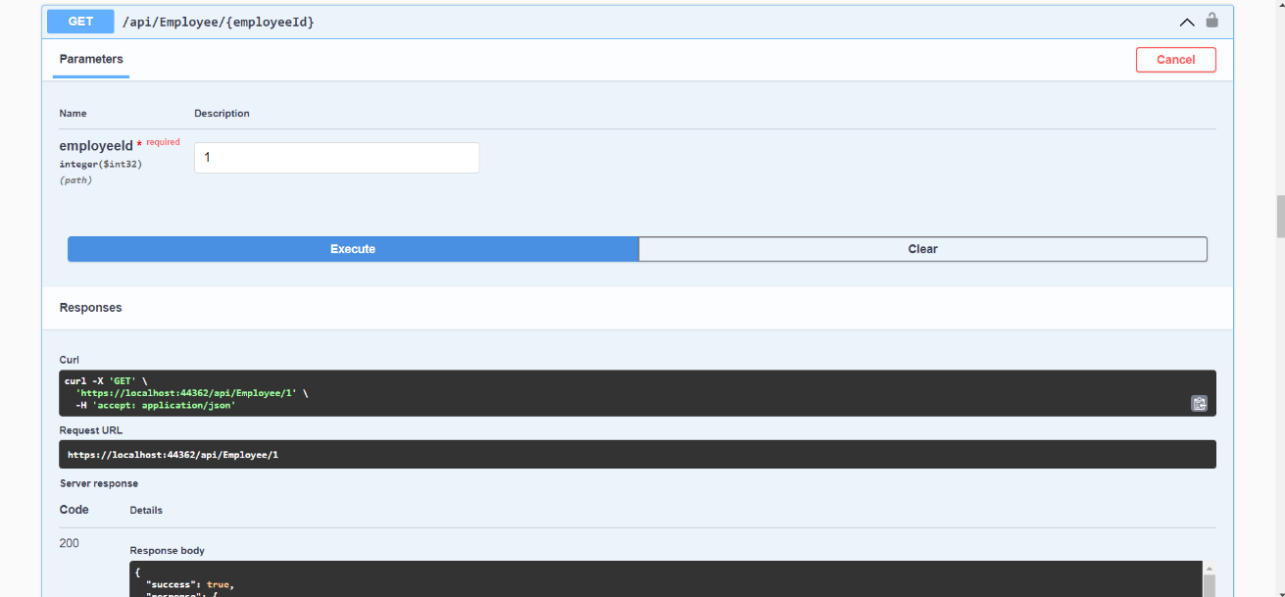In this we enter the employee id which will correspond to the employee details associated to the database. As an output of this we get the response from the API with desired user details.

**To add a new Employee :**

When HR enter the details of a new employee. The API will save the data from frontend to database. This part of the API needs fixation as so far we’re not able to add the Employee. It will generate an error stating that response status is 400.

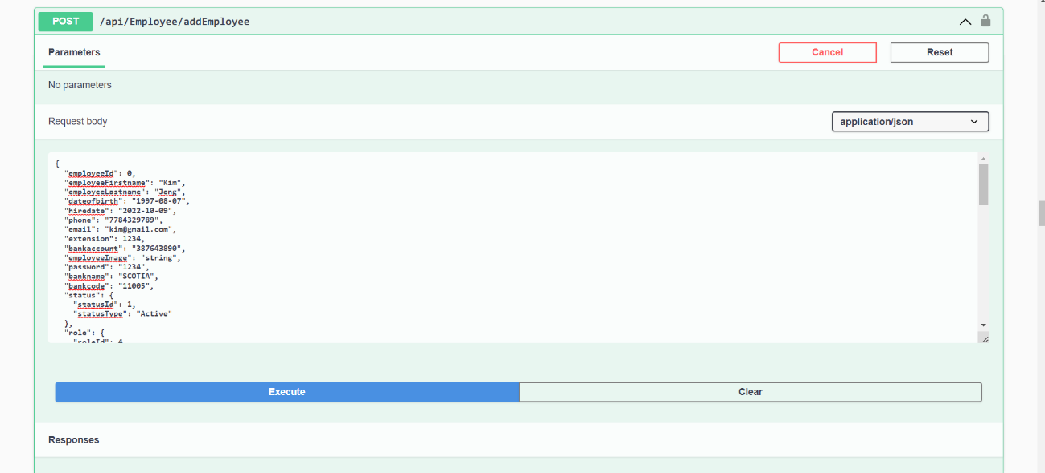

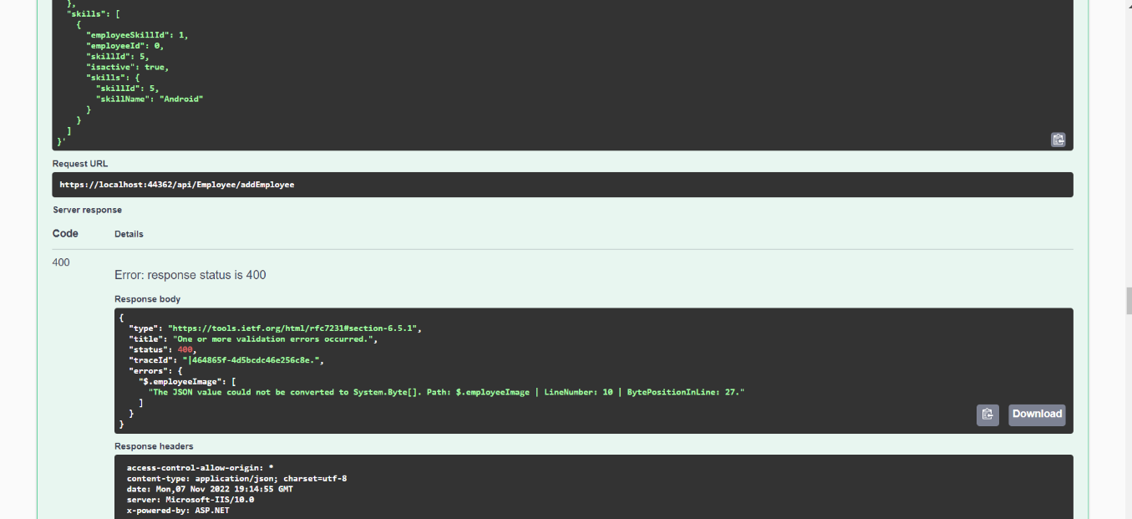

Due to this **Deletion of an Employee** cannot bedone.

**Jobs :**

The job API retrieves the data from database that is related to the Jobs posted in the company.

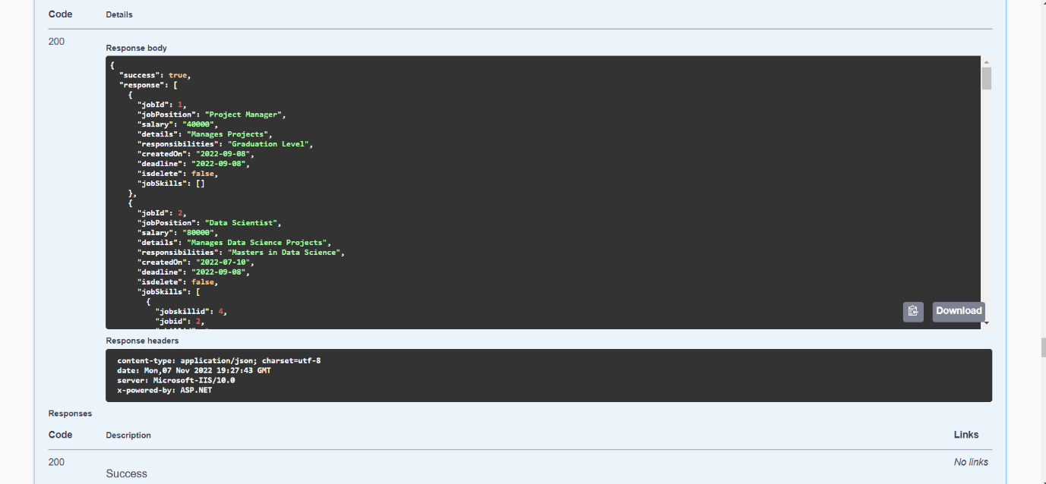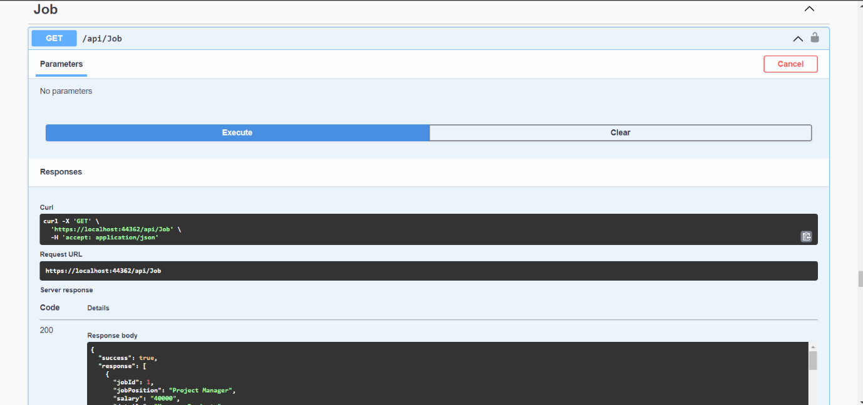

**Add a Job:**

While adding a new job, generate a new job posting with required attributes. Simliar to adding the Employee, this part gives an error code 400 as well.

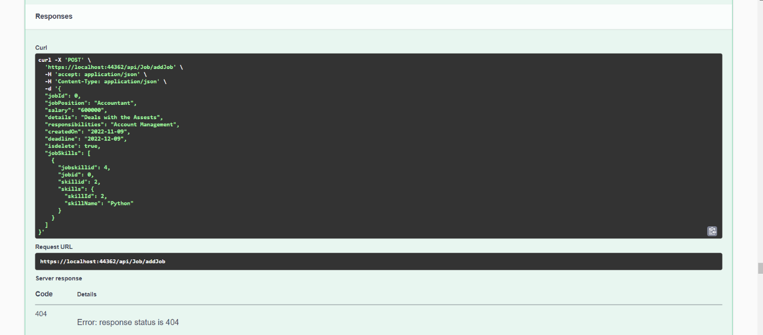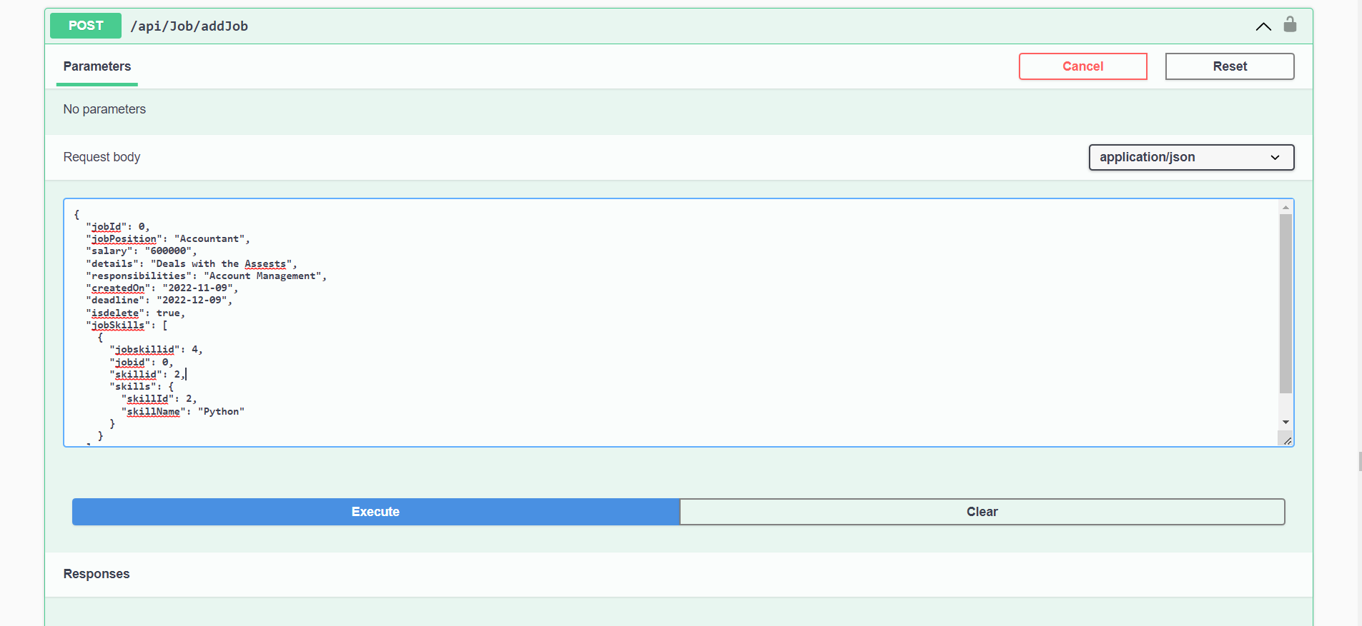Therefore, the deletion of a job will not proceed as well.

**Payroll:**

Payroll API gets the data of monthly salary associated to each employee. And holds the record of all the increments, deduction, Sick pay, Vacation pay, Number of hours an employee has worked on monthly bases. Calculating all these attributes gives the actual payment associated to each employee.

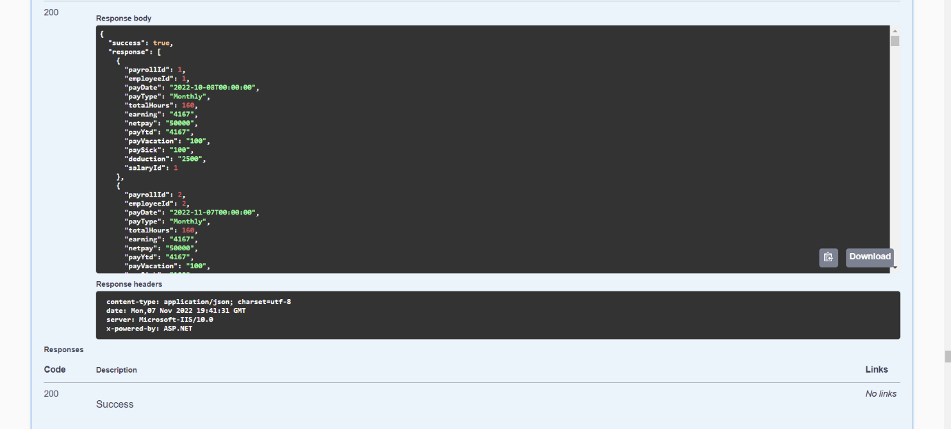

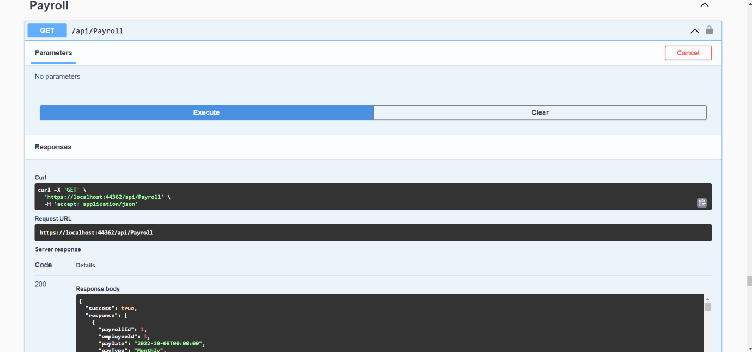

**Payroll List with respect to Employee ID :**

This API will use employee id and show all the information of payroll receipts that employee has received throughout the Year.

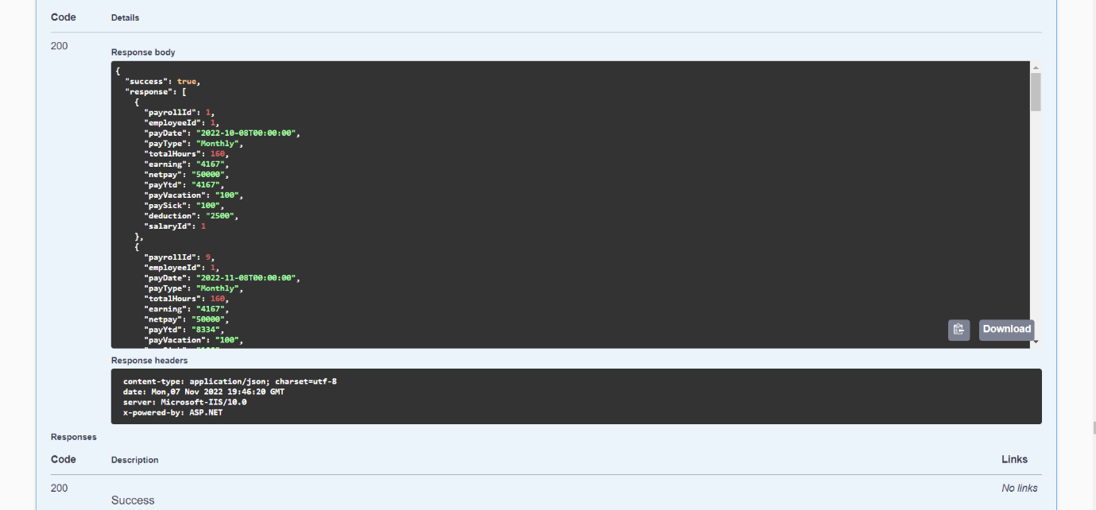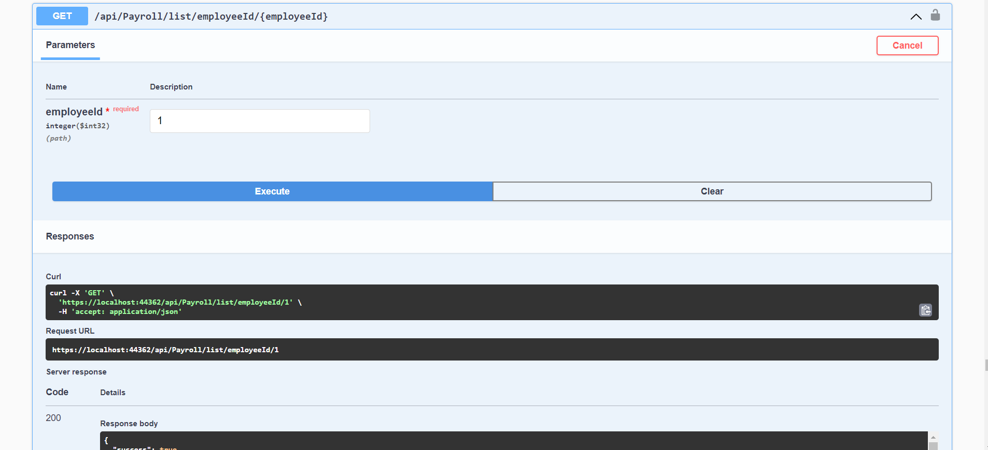

**Projects:**

This will display all the projects that are undergoing in the company with detailed information associated to Employee Id and Project Id.

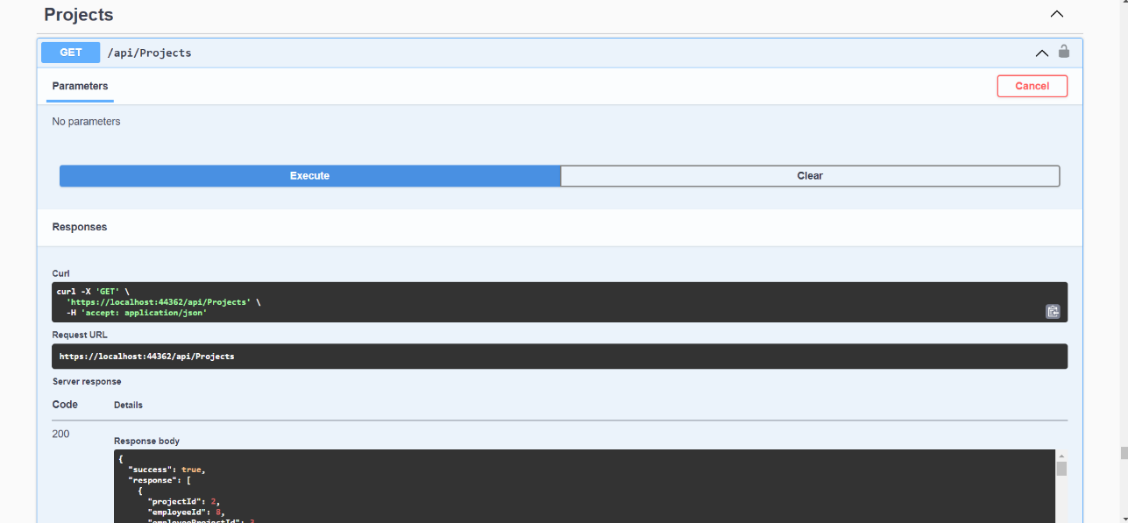

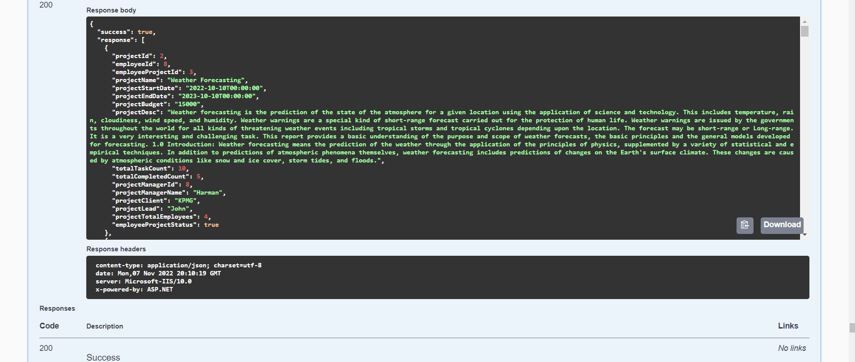

**Project with respect to Employee ID:**

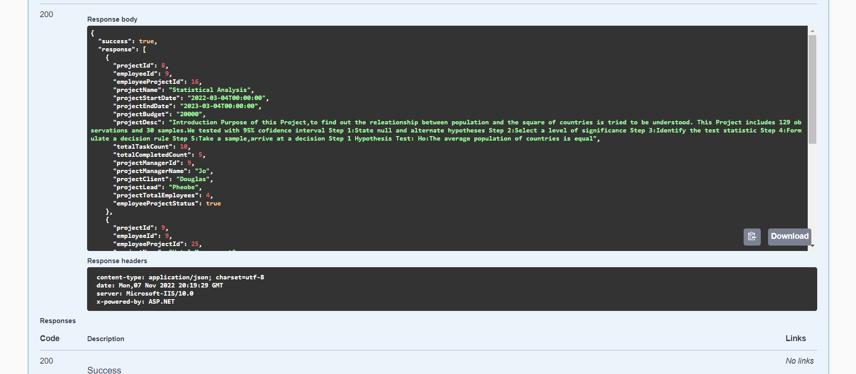This API will use employee id and display the projects that are associated to that employee. Managers are assigned more than one projects so this will give the information of all the projects a manager is monitoring over.

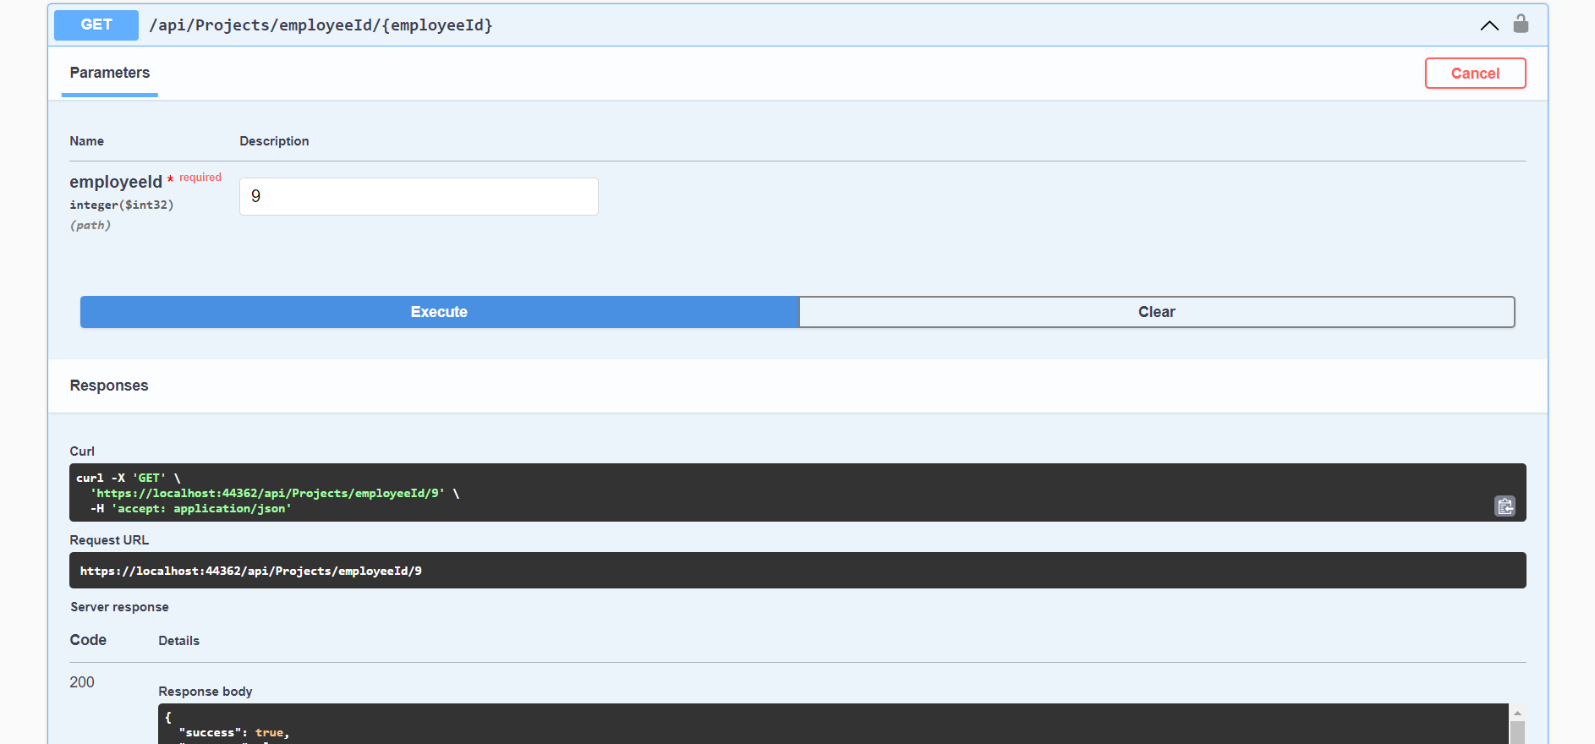

**Adding a New Project:**

This API will get information from Create Project screen and . Since, project Id is primary key this will be added automatically in the Database.

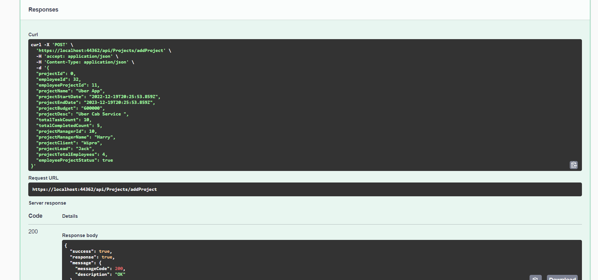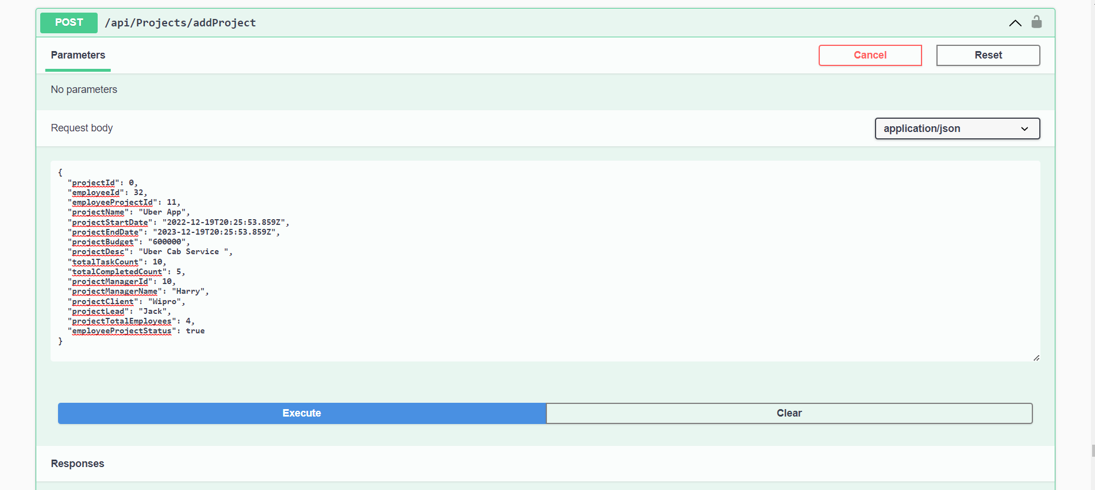

**Deleting a Project:**

It will ask user to enter the project Id that user wants to delete and it will erase the row associated to that project id in the Database.

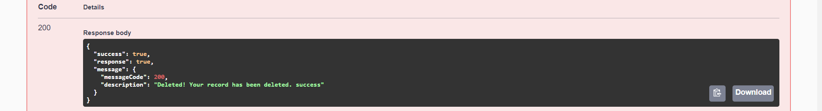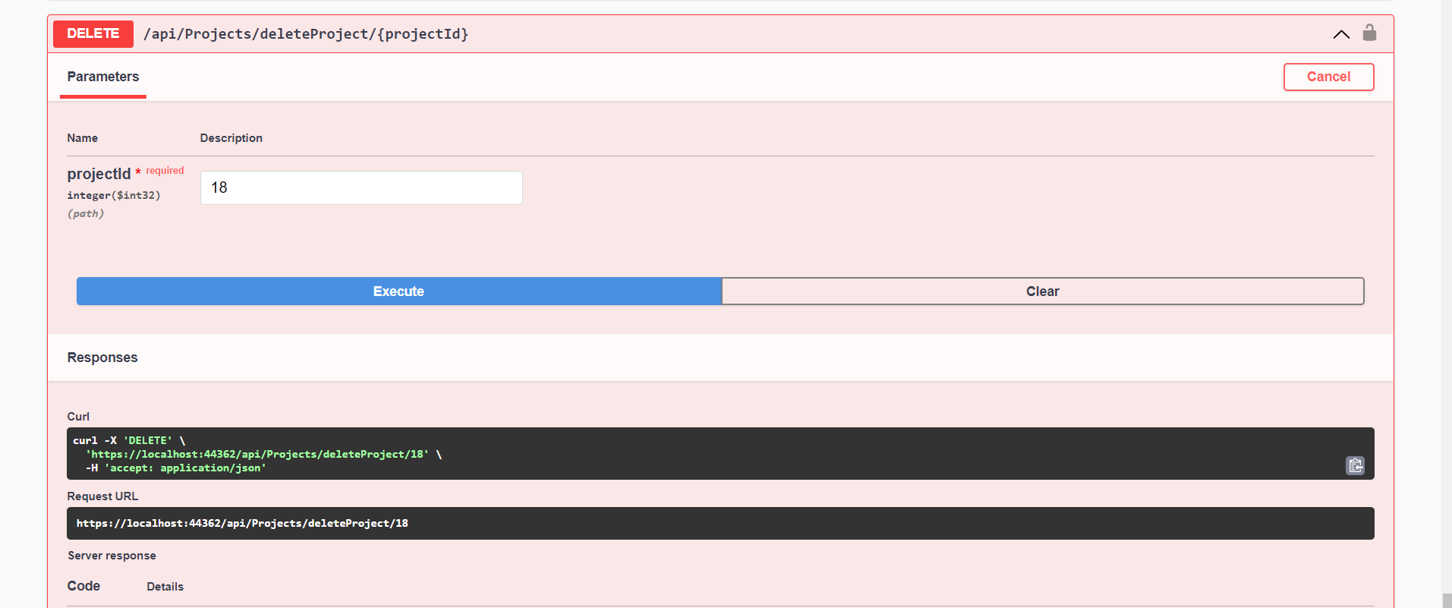

## 

**Fetch API & Client side React Code**

After creating the front-end UI and back-end logic, from this stage we are focusing on connecting the front-end and back-end together. Although different React structures are still used widely, we chose the most popular and on trend one – hook, to manage the data flow. Since we have 21 tables and populating data takes time, the pages may seem empty. However, the data now is mostly dynamic and be able to maintain using CRUD.

**Profile Update**

* Fetching and putting employee data from/ to API
* Adding skills showing on page as badges
* After clicking on resignation, system will send notification to manager’s email

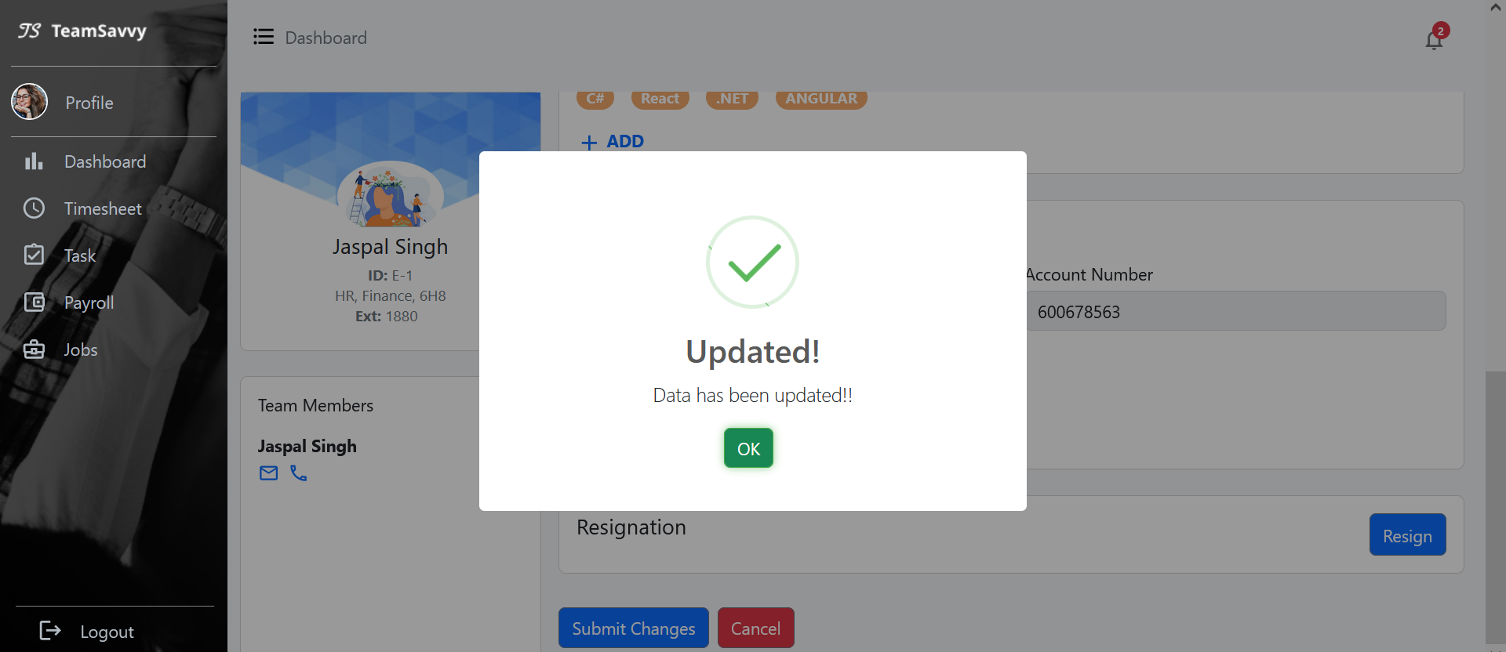

Figure 1: employee profile update to database

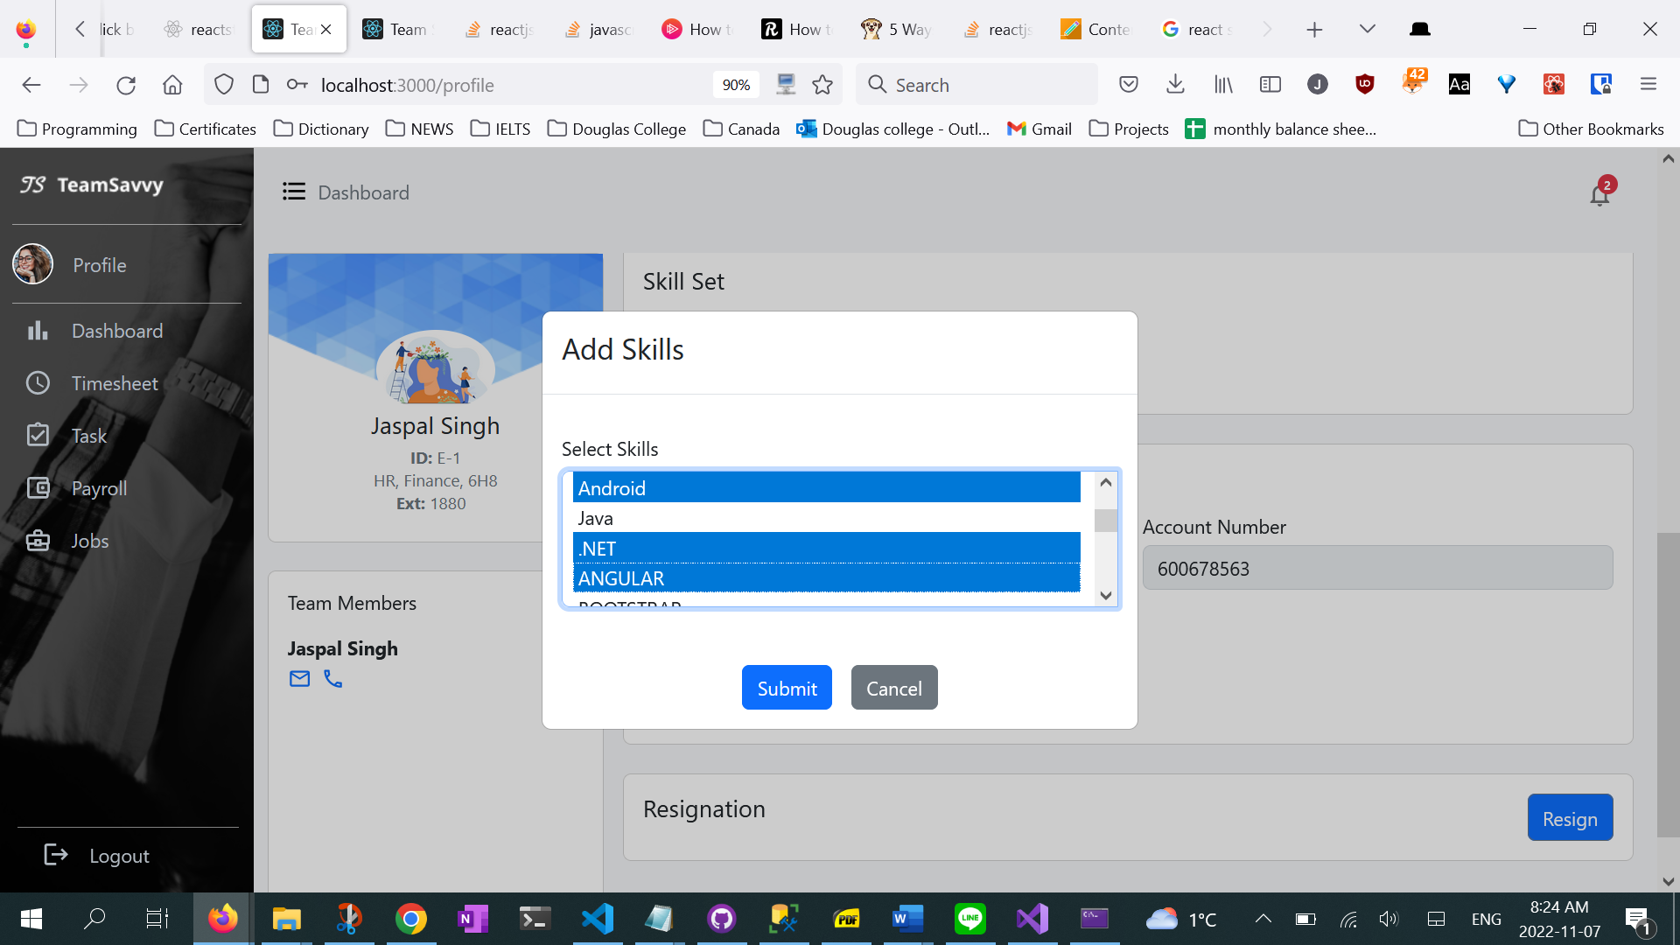

Figure 2: multiple skills can be added and deleted

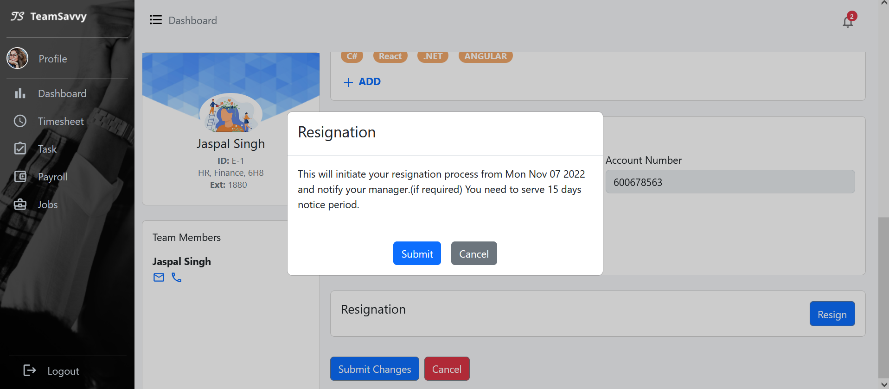

Figure 3:simplify resignation process allowing employee to send auto resignation email to manager by simple click

**Modify and validate task:**

* Fetch data from api: get assigned jobs list
* Modal input validation: validate input at run time, preventing modal from closing if data is empty or not correct.
* Put request: update modified task to api using http put request

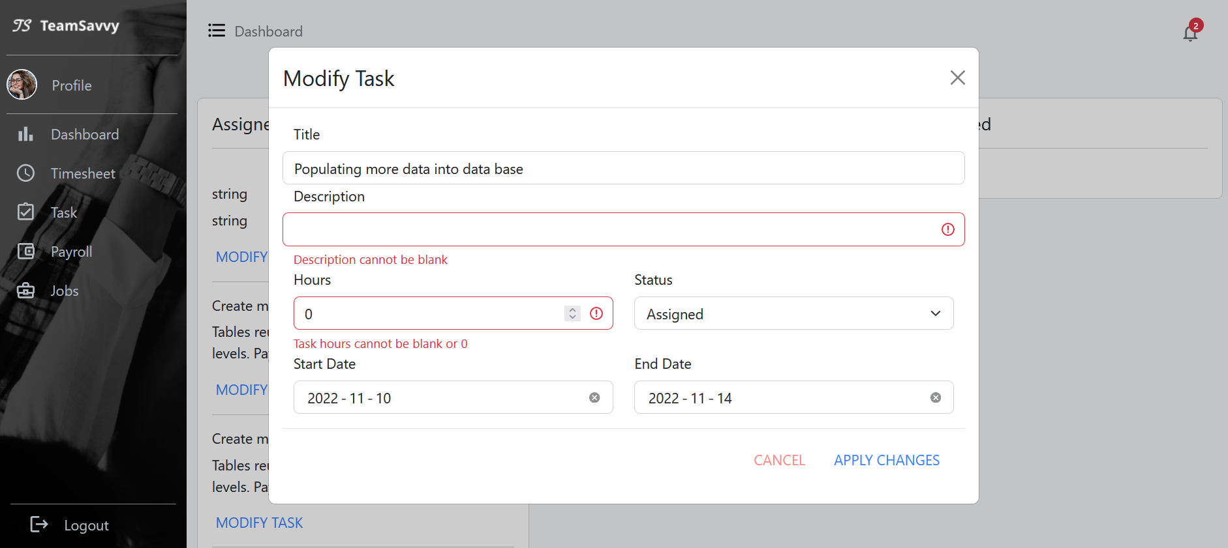

Figure 4: simple validation for input. Modified task will be updated to database

**Payslips and pay stub**

Fetching data from payroll and employee API, using Links to pass prop and render detail in the child page

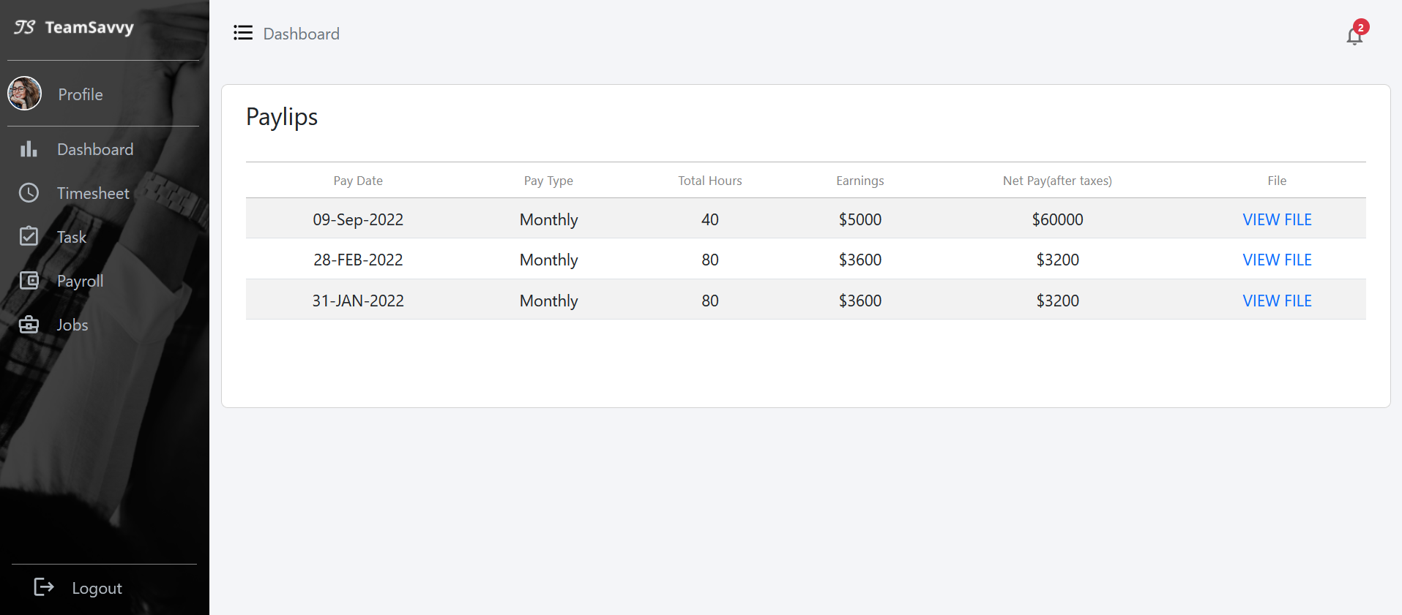

Figure 5: Fetch payslips data for individuals. Paystub details will be shown in view file.

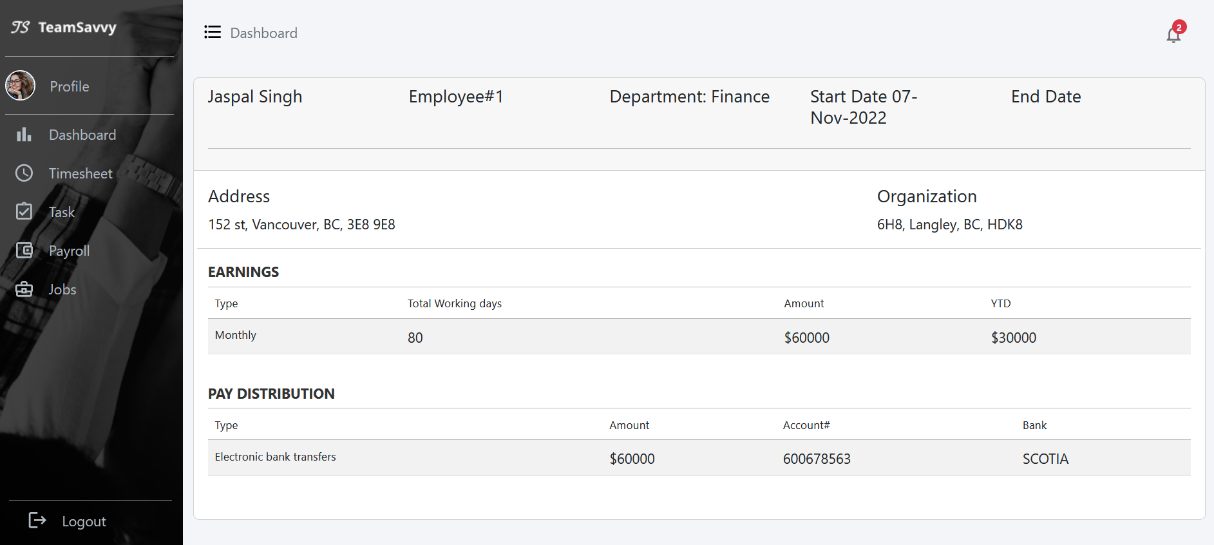

Figure 6: Passing data from payroll and employee api

**Jobs**

* View change according to the employee role. For example, engineer won’t be able to create jobs and see the applied details
* Fetching data from Jobs API, clicking on the view will show the corresponding detail on the right-side card.
* Clicking on Create Job shows the job creating card. The post request here hasn’t implemented yet.
* Clicking on the applied button shows the employee applied for this job. The detail link will then show the employee’s profile.

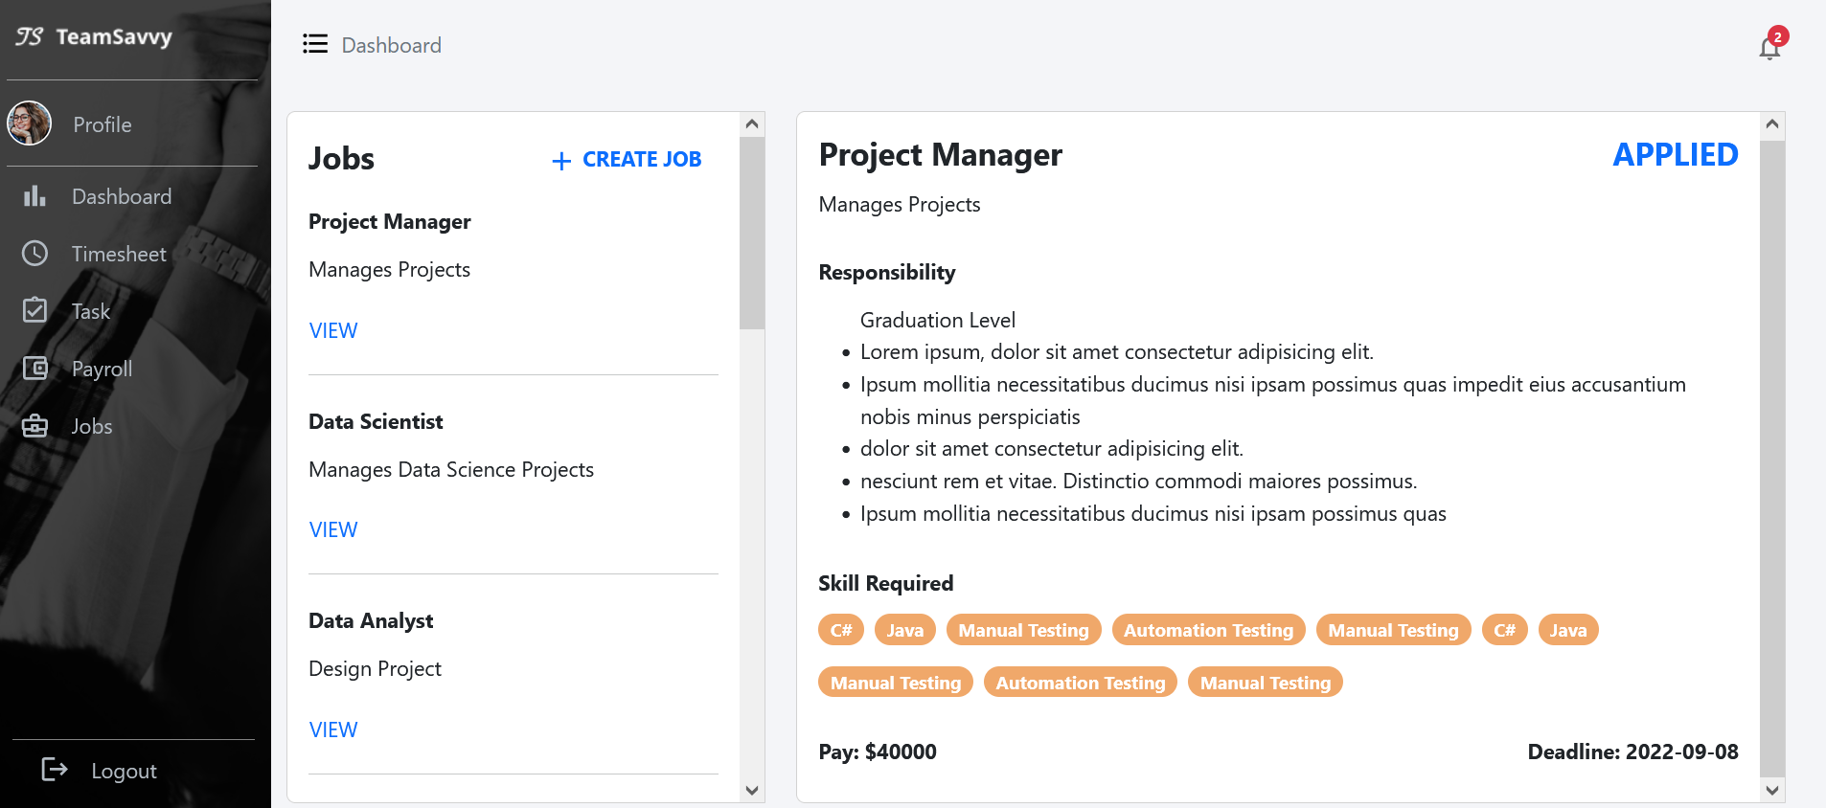

Figure 7: hr view of job page

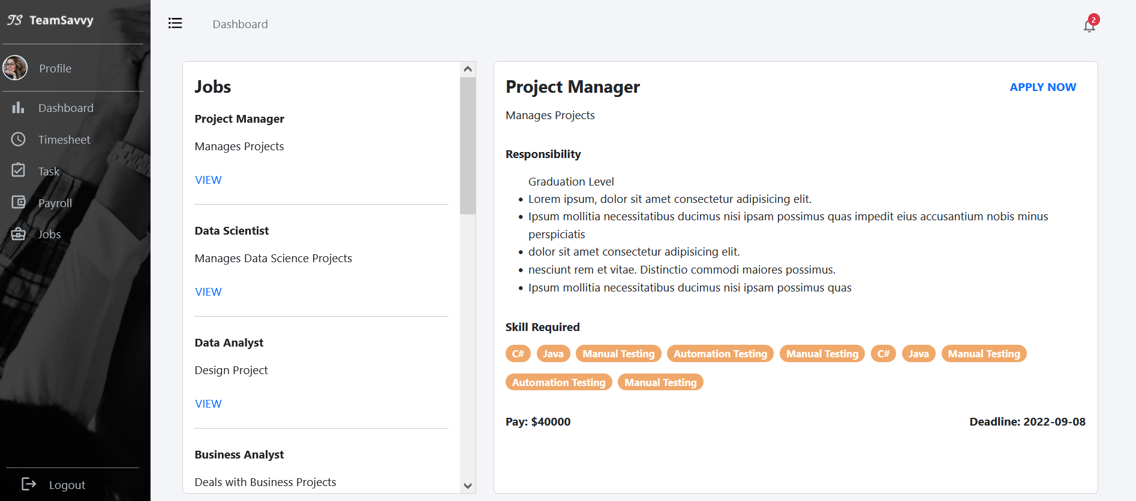

Figure 8:employee view of job page

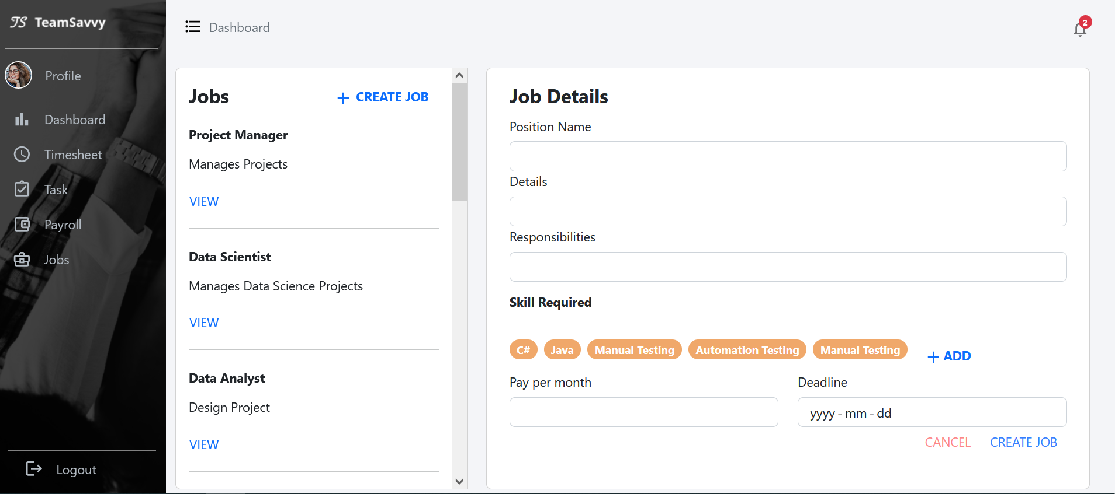

Figure 9: create new internal job card

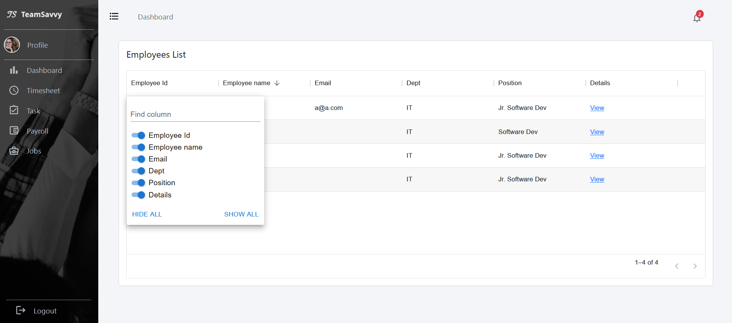

Figure 10: hr view of employees applied for this job

**Front-end**

We started working with react js, bootstrap for developing our front-end with responsive screens, we decided to start with role ’employee’. Pages we have achieved so far:

**Project List:**

This list depicts the Information about the projects under manager or for HR total number of projects in organization. The screen will have project names, number of tasks assigned, number of team members in each project, project budget, project description and view link to show project details.

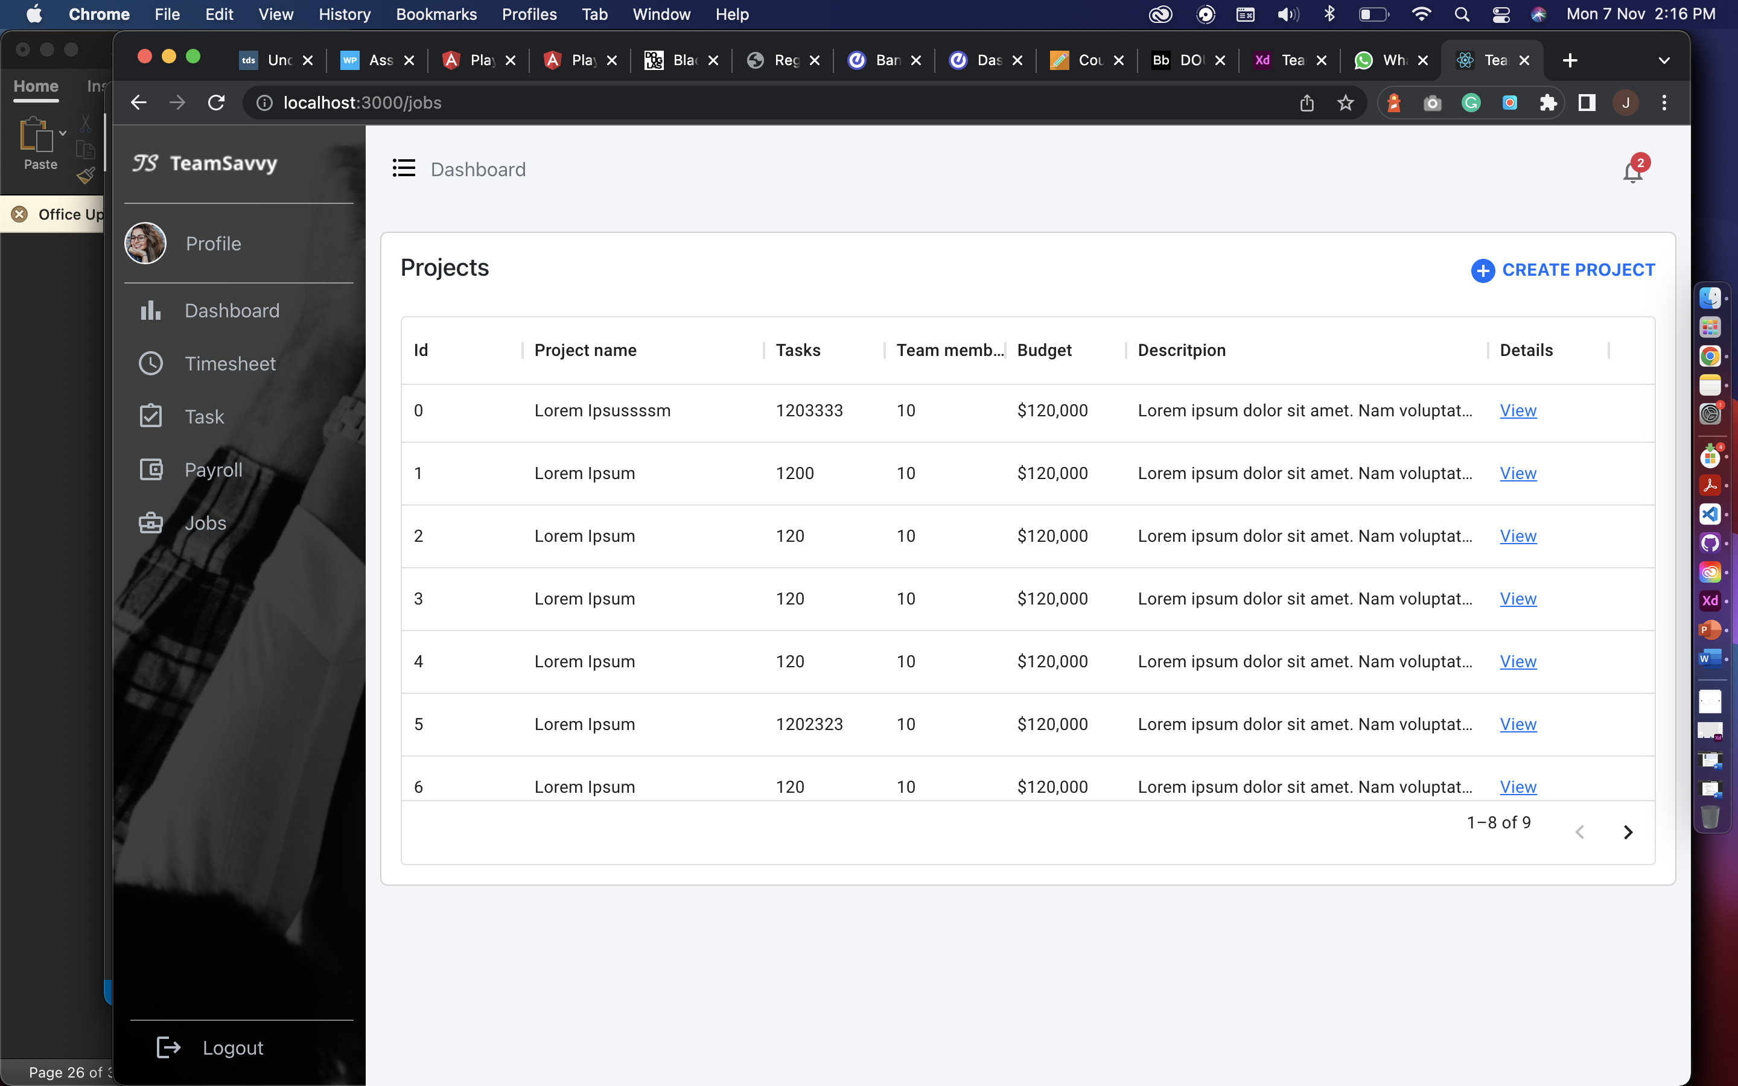

Create project popup for manger to add new project in the list

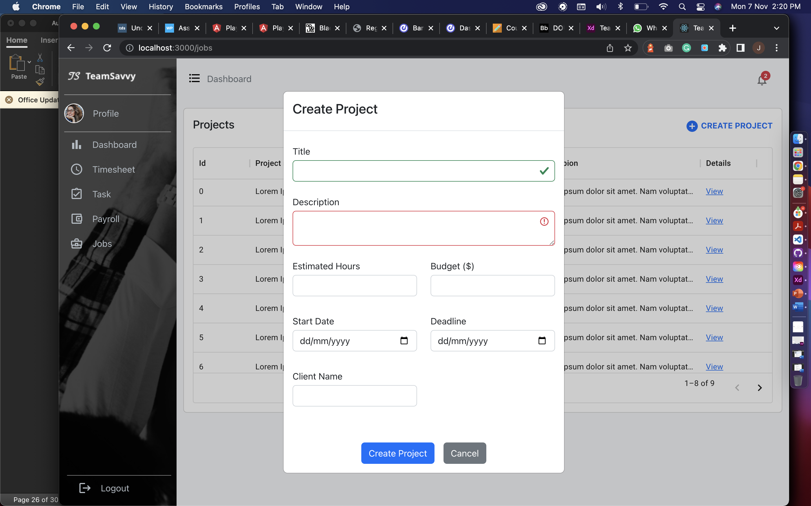

Project details page is for managers to assign tasks to employees in his team. It also has a simple statistic to manage the process of project by showing how many tasks are still in progress and how many are completed.

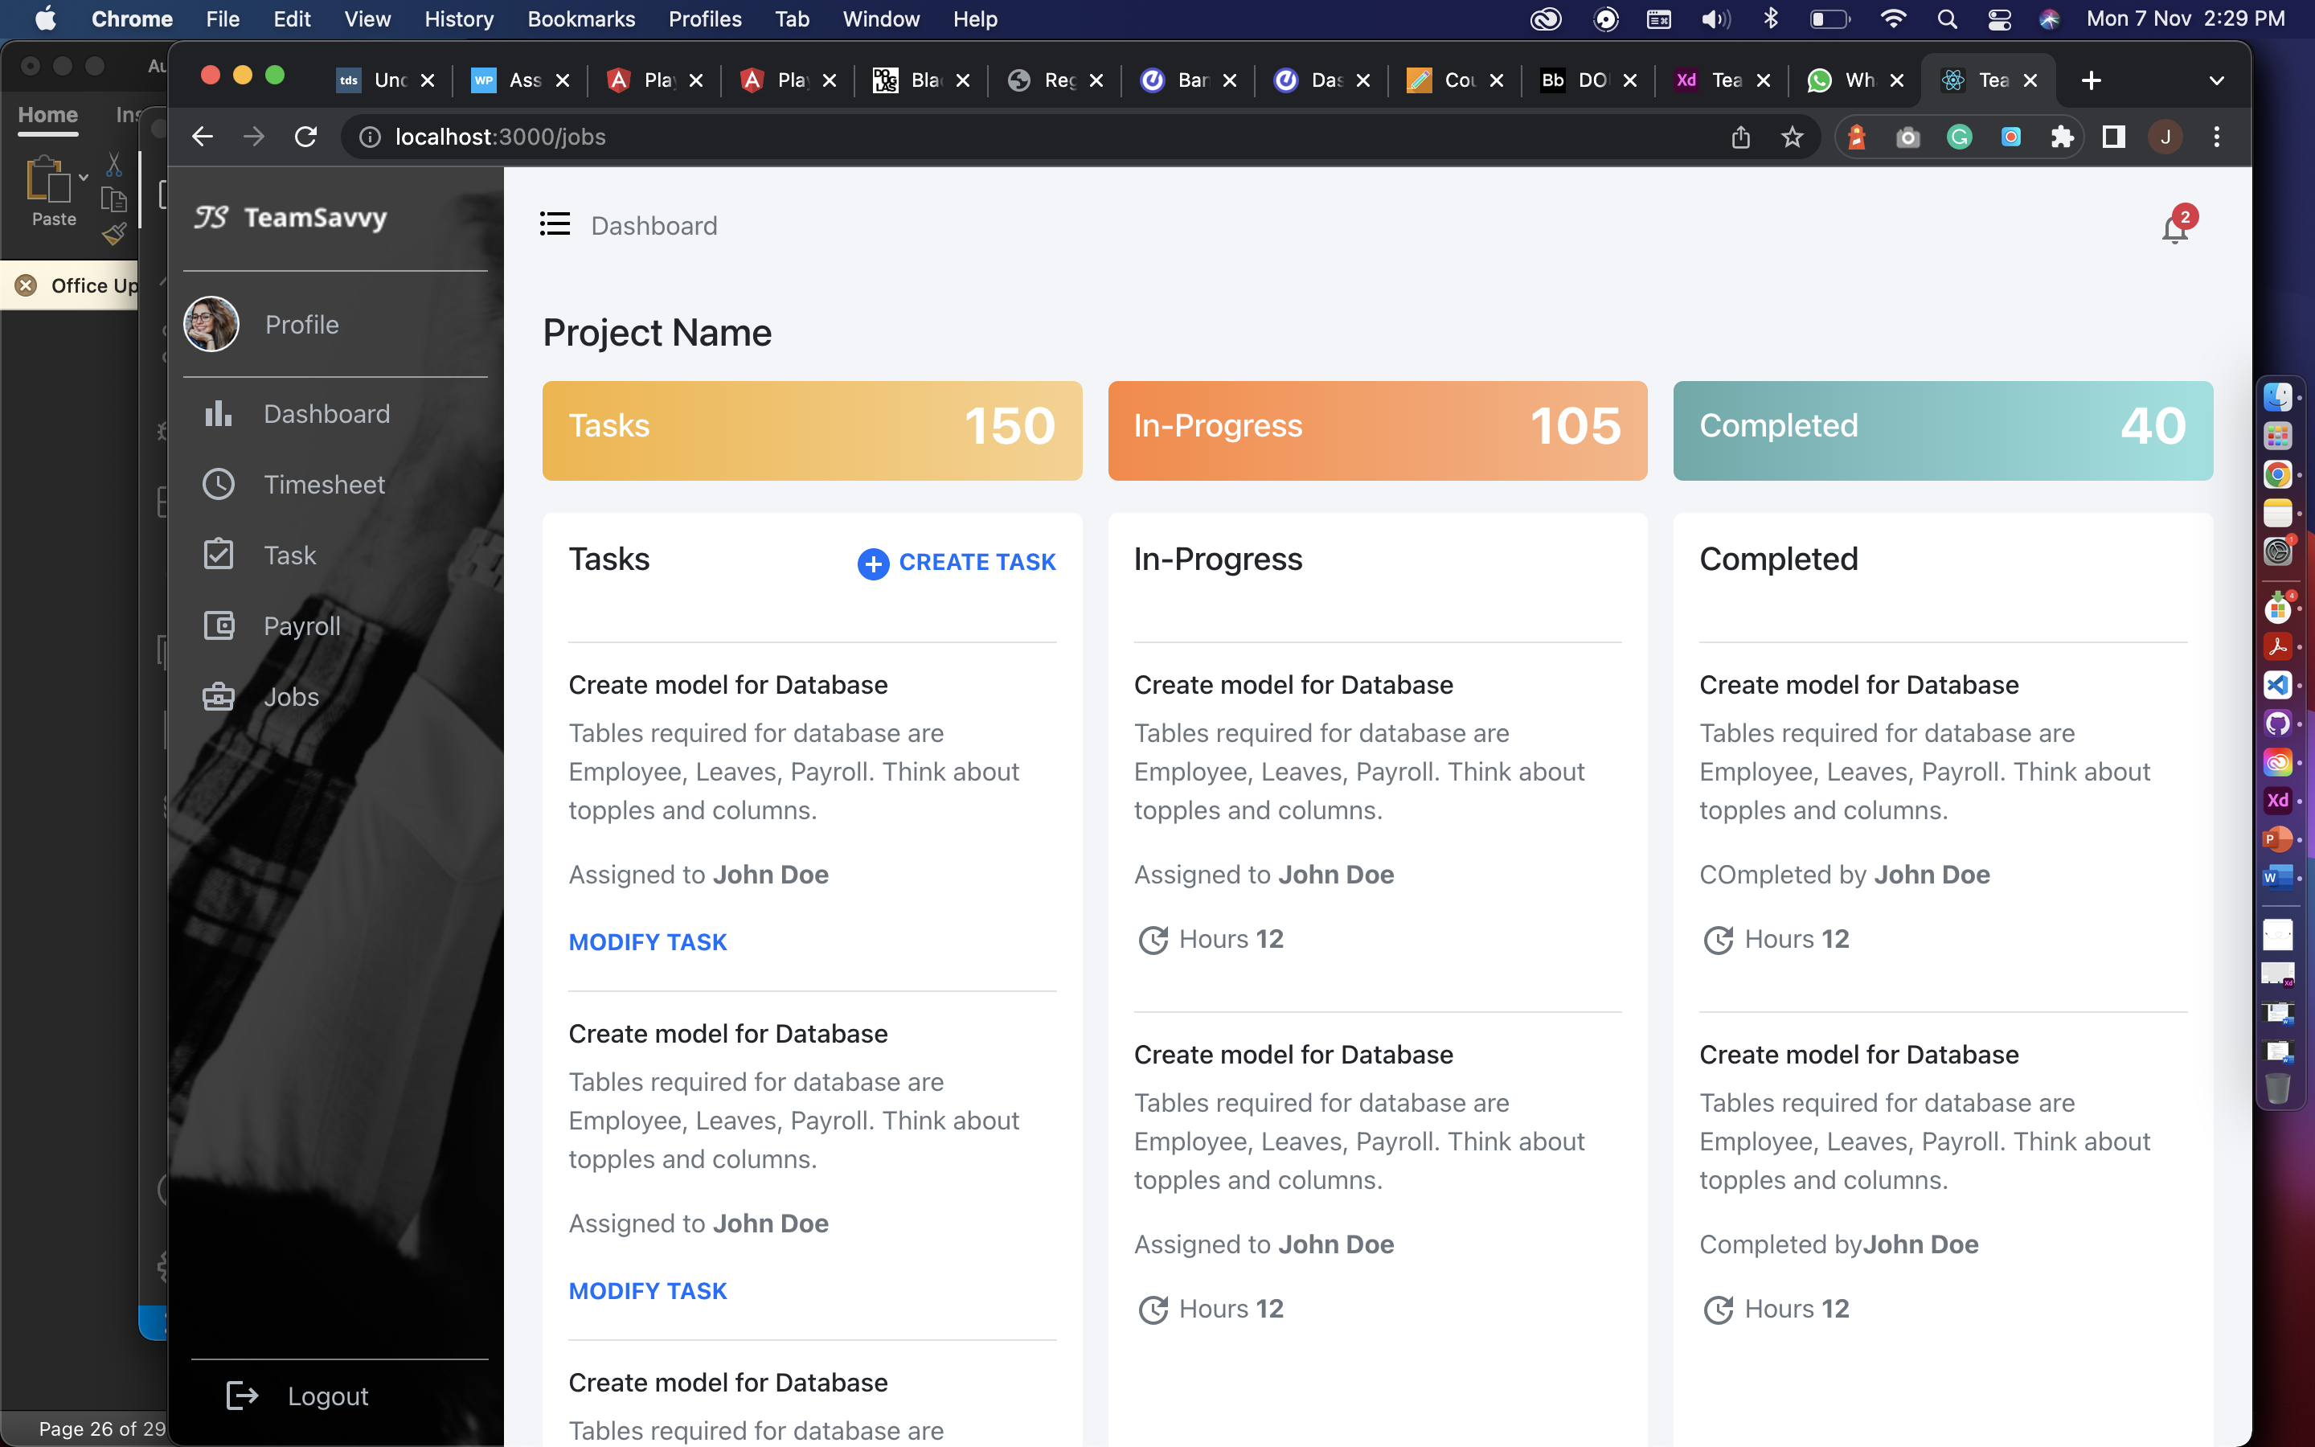

Create task for creating new task in current project and assign an employee.

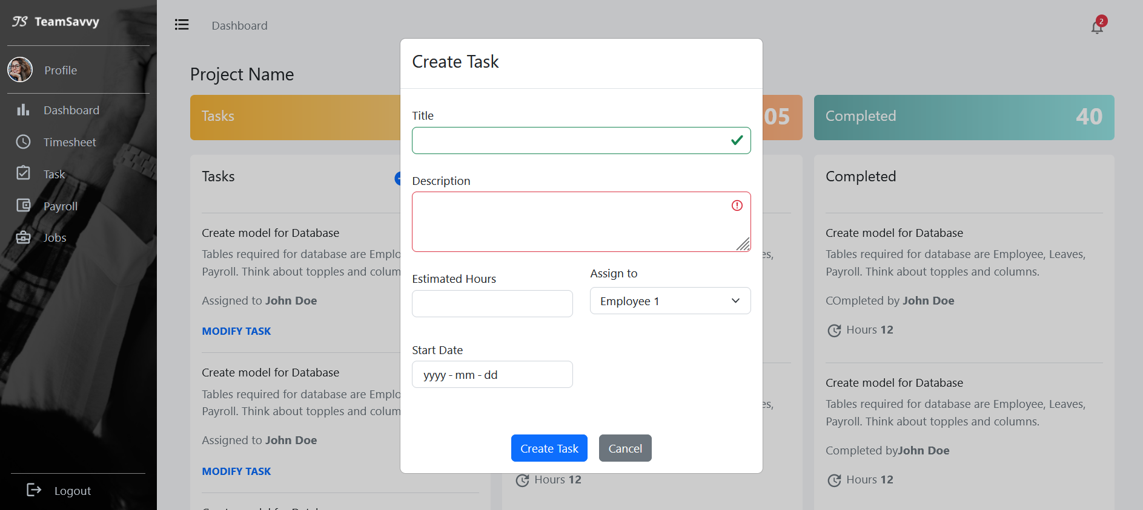

**Team Members:**

The screen will show the team members in the project selected from the list and Bench and Add new employee will only be shown to HR. It will have employee name, Dept , position, salary, progress and manager can delete the team member from this table and view button to show details about each team member.

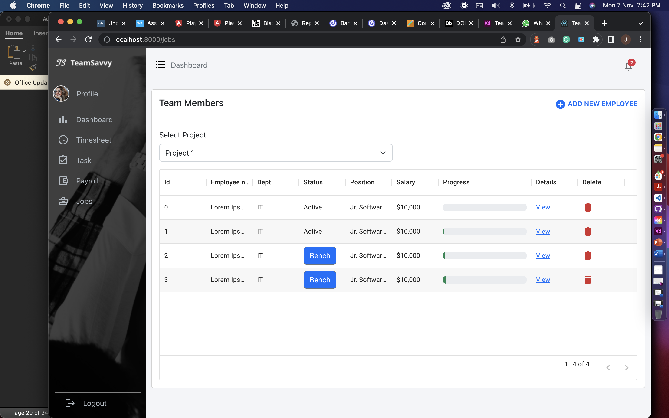

From view link the manager or HR can see employee’s timesheet, task and profile.

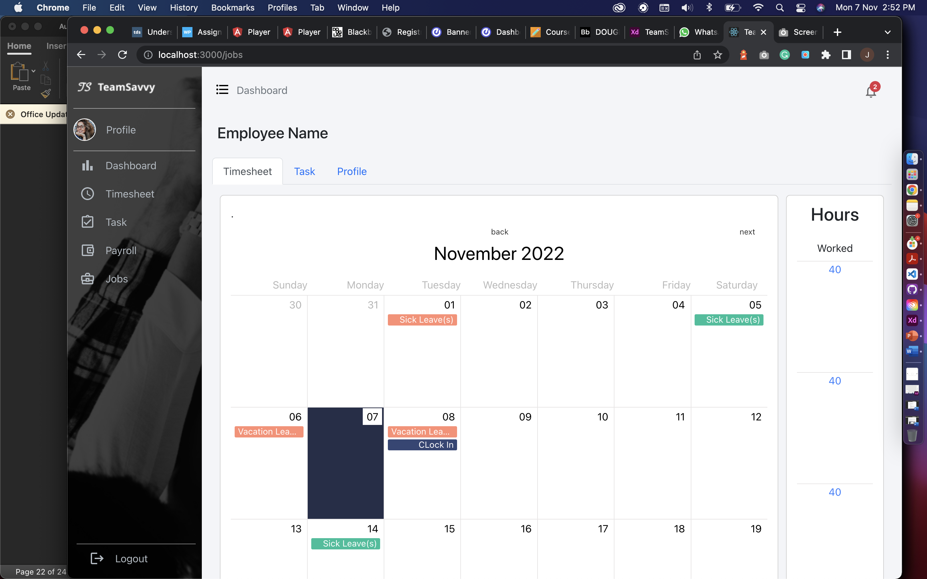

HR can assign project to an employee from bench button

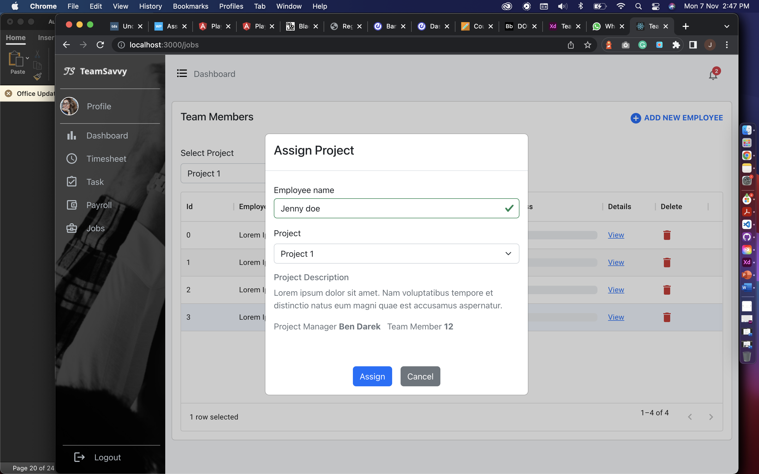

HR can add new employee by clicking on add new employee and can add below given details.

**Previous Project Implementations:**



Landing screen for an employee showcasing the project name, image, message for an employee for the attendance and loader.



This screen will ask employee for their employee

ID and allow him to clock-in or clock-out.

We are still working on design and few features.



After entering the employee id the button will be activated.



The app will ask for biometric verification, if the fingerprint matches to the record of fingerprint

in device the app will accept and allow user to clock-in or clock-out.



At last, the app will show the snack bar to show if an employee has been verified or not also displays the status clock-in or clock-out.

**APIs**

We have created API in .NET CORE using Entity Framework, LINQ, Automapper and swagger documentation.





This is the swagger documentation to give a user interface to an API so developer can test API like postman. In this interface we can test all the request like post, delete, update, and get request. Above are the endpoints for Auth (Authorization), Dropdown, Email, Employee, Employee Task, Leaves, Payroll, Projects and Timesheet controllers.









Above screenshots showing separate endpoints (GET,POST,PUT,DELETE) of all controllers created.

**UI Design using Adobe XD**

The snapshots below shows the flow of our application. Design Link:

<https://xd.adobe.com/view/732c0d35-1e41-41d7-876c-25bde1a844a9-267f/?fullscreen>

**Login:**

The employee and admin will login with the predefined credentials provided by organization.



**Timesheet:**

This screen will show the information of employee clock-in and clock-out, with total hours they worked per week. Additionally, employee can apply for leaves and it will be displayed on the calendar



**Task:**

Task screen will have the assigned task for an employee, which he can modify to add hours, start date, and end date. Employee can also change the status from assigned to in-progress and then by using update status in in-progress lane he can change status to completed.



**Payroll:**

This screen will have the collection of pay slips with information of each month, total hours, and earnings, from here user can view each pay slip. The Pay Slip contains all the Earnings of an employee at the company from the date he has joined.



**Internal Jobs:**

This screen will display employee with the internal jobs postings which he can read the description and apply for the jobs.



**User Profile:**

This screen will show the personal details, team members, position, department, skill set and bank details of an employee.



**Dashboard:**

This screen is for manager and HR, here they can view projects, team members, tasks, and other information. This screen will also have feature to create graphs widgets with predefined dropdowns. Manager can download, modify and delete the graph.



**Front-end**

We started working with react js, bootstrap for developing our front-end with responsive screens, we decided to start with role ’employee’. Pages we have achieved so far:

**Login:**

This screen will allow users to login with credentials provided by organization or can reset password using OTP







**Sidenav:**

The animated sidebar with navigation links to access the platform.

 

**Open** **Closed**

**Header and Navigation:**

Header has dashboard title which will be breadcrumb for navigation and notification with indicator, it is hardcoded for now. We will work on it after midterm.

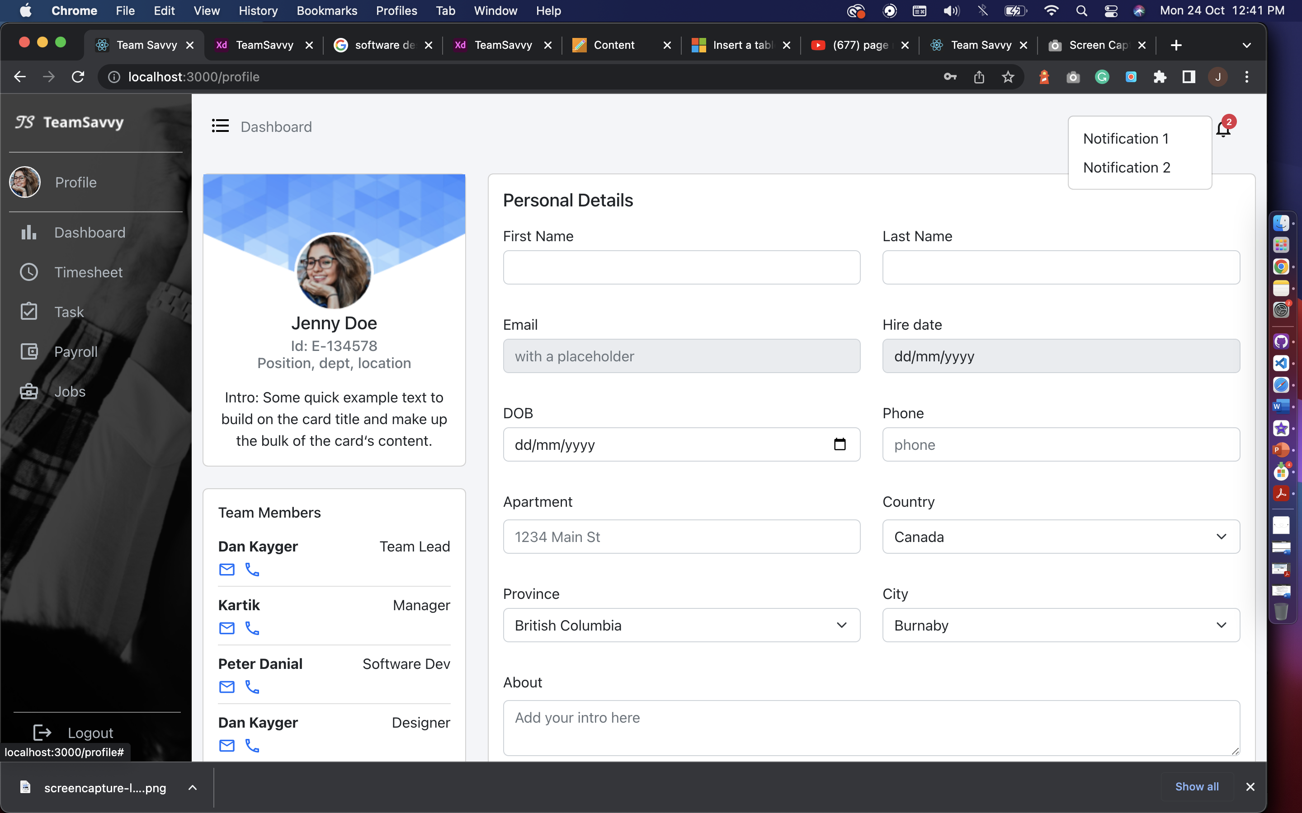

**User Profile:**

The user profile page has employee information, which is consist of Personal details, Team members with their contact details, Skill set and add new skill option, bank details, and resign option. From here HR or manager can get the overview of an employee and what skills they acquire.

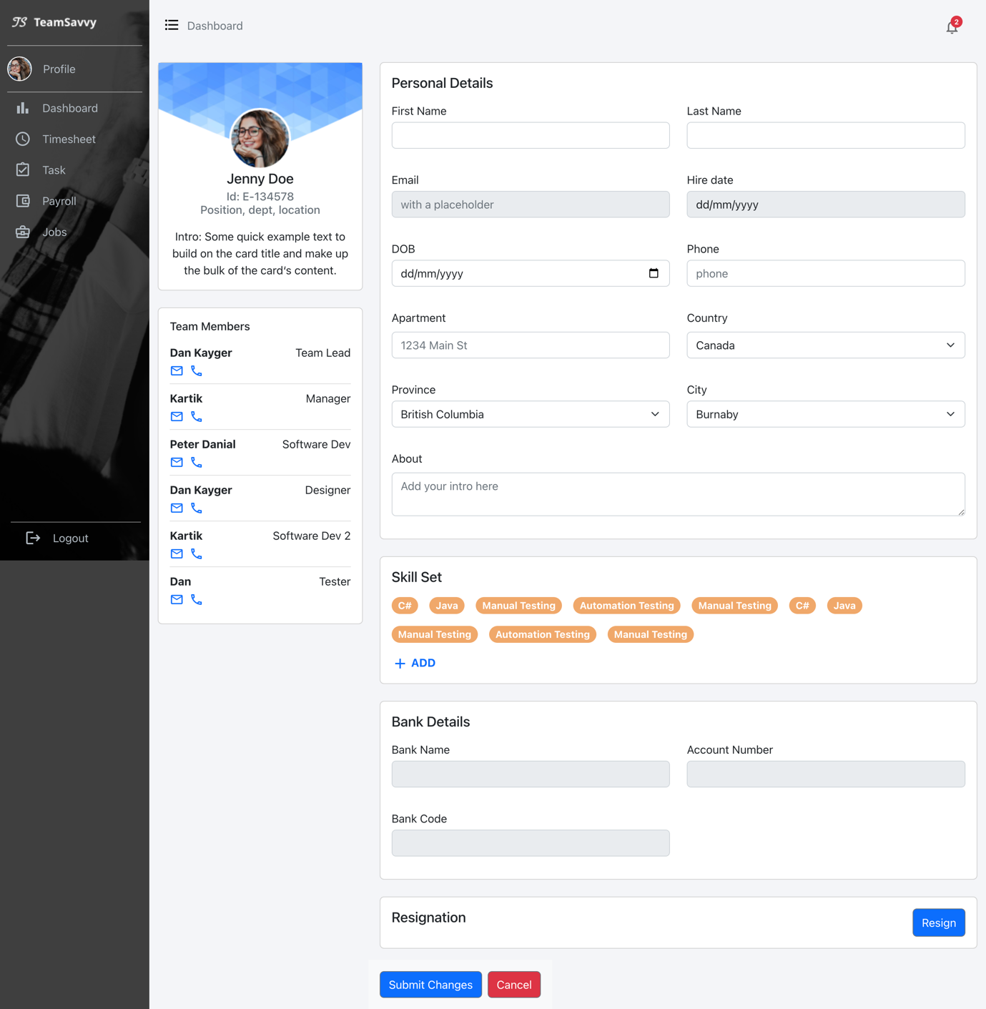

**Timesheet:**The Calendar is generated with react-big-calendar which has custom tags for leaves and popups for deleting existing leaves and add new leave. Also have clock-in and clock-out indicator. The page also has Worked total hours per week for an employee.

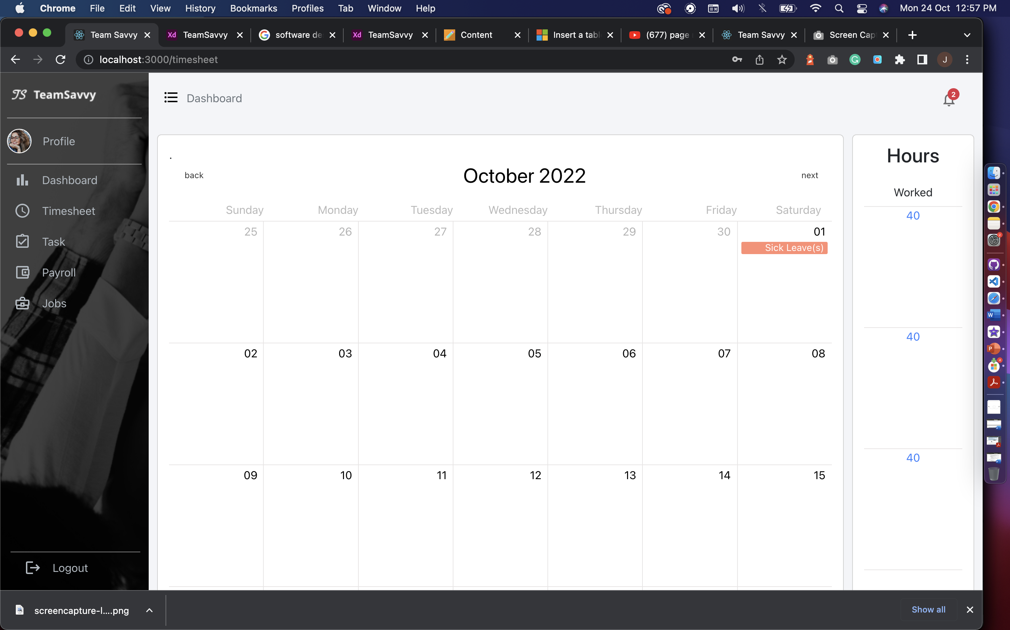

**Task:**The task page has feature to show assigned, in progress and completed tasks for an employee. We are assuming the employee only working in one project at a time. On click of modify task user will get pop-up to add hours and change status of the task. On update status, the employee can only change status to completed task.

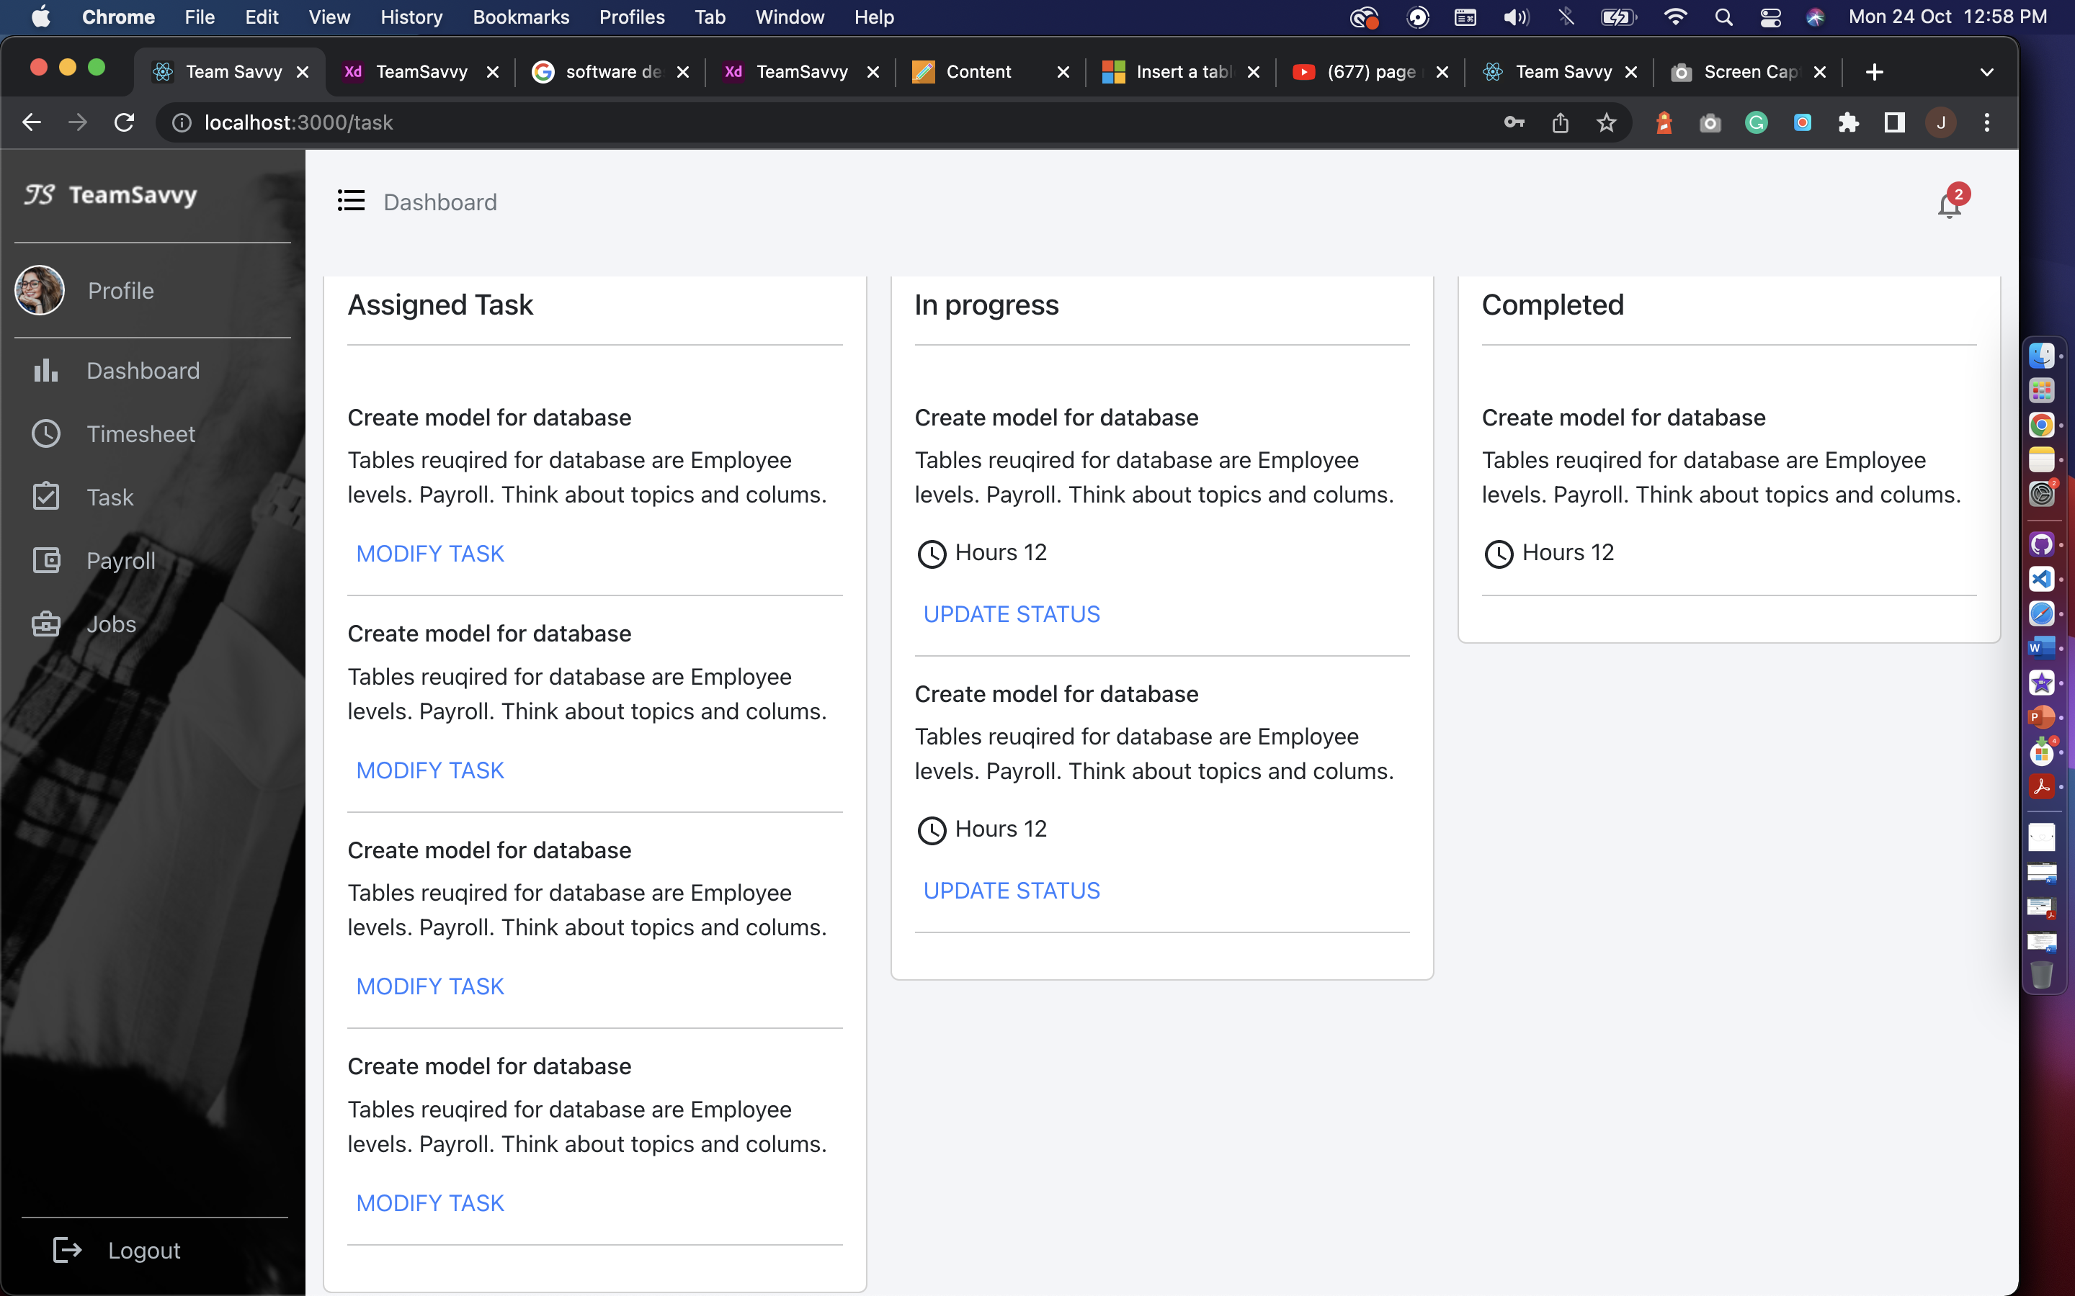

**Payroll:**The payroll has payslips screens where employee can check the list of paystubs and also can view the paystubs individually by clicking on view file.

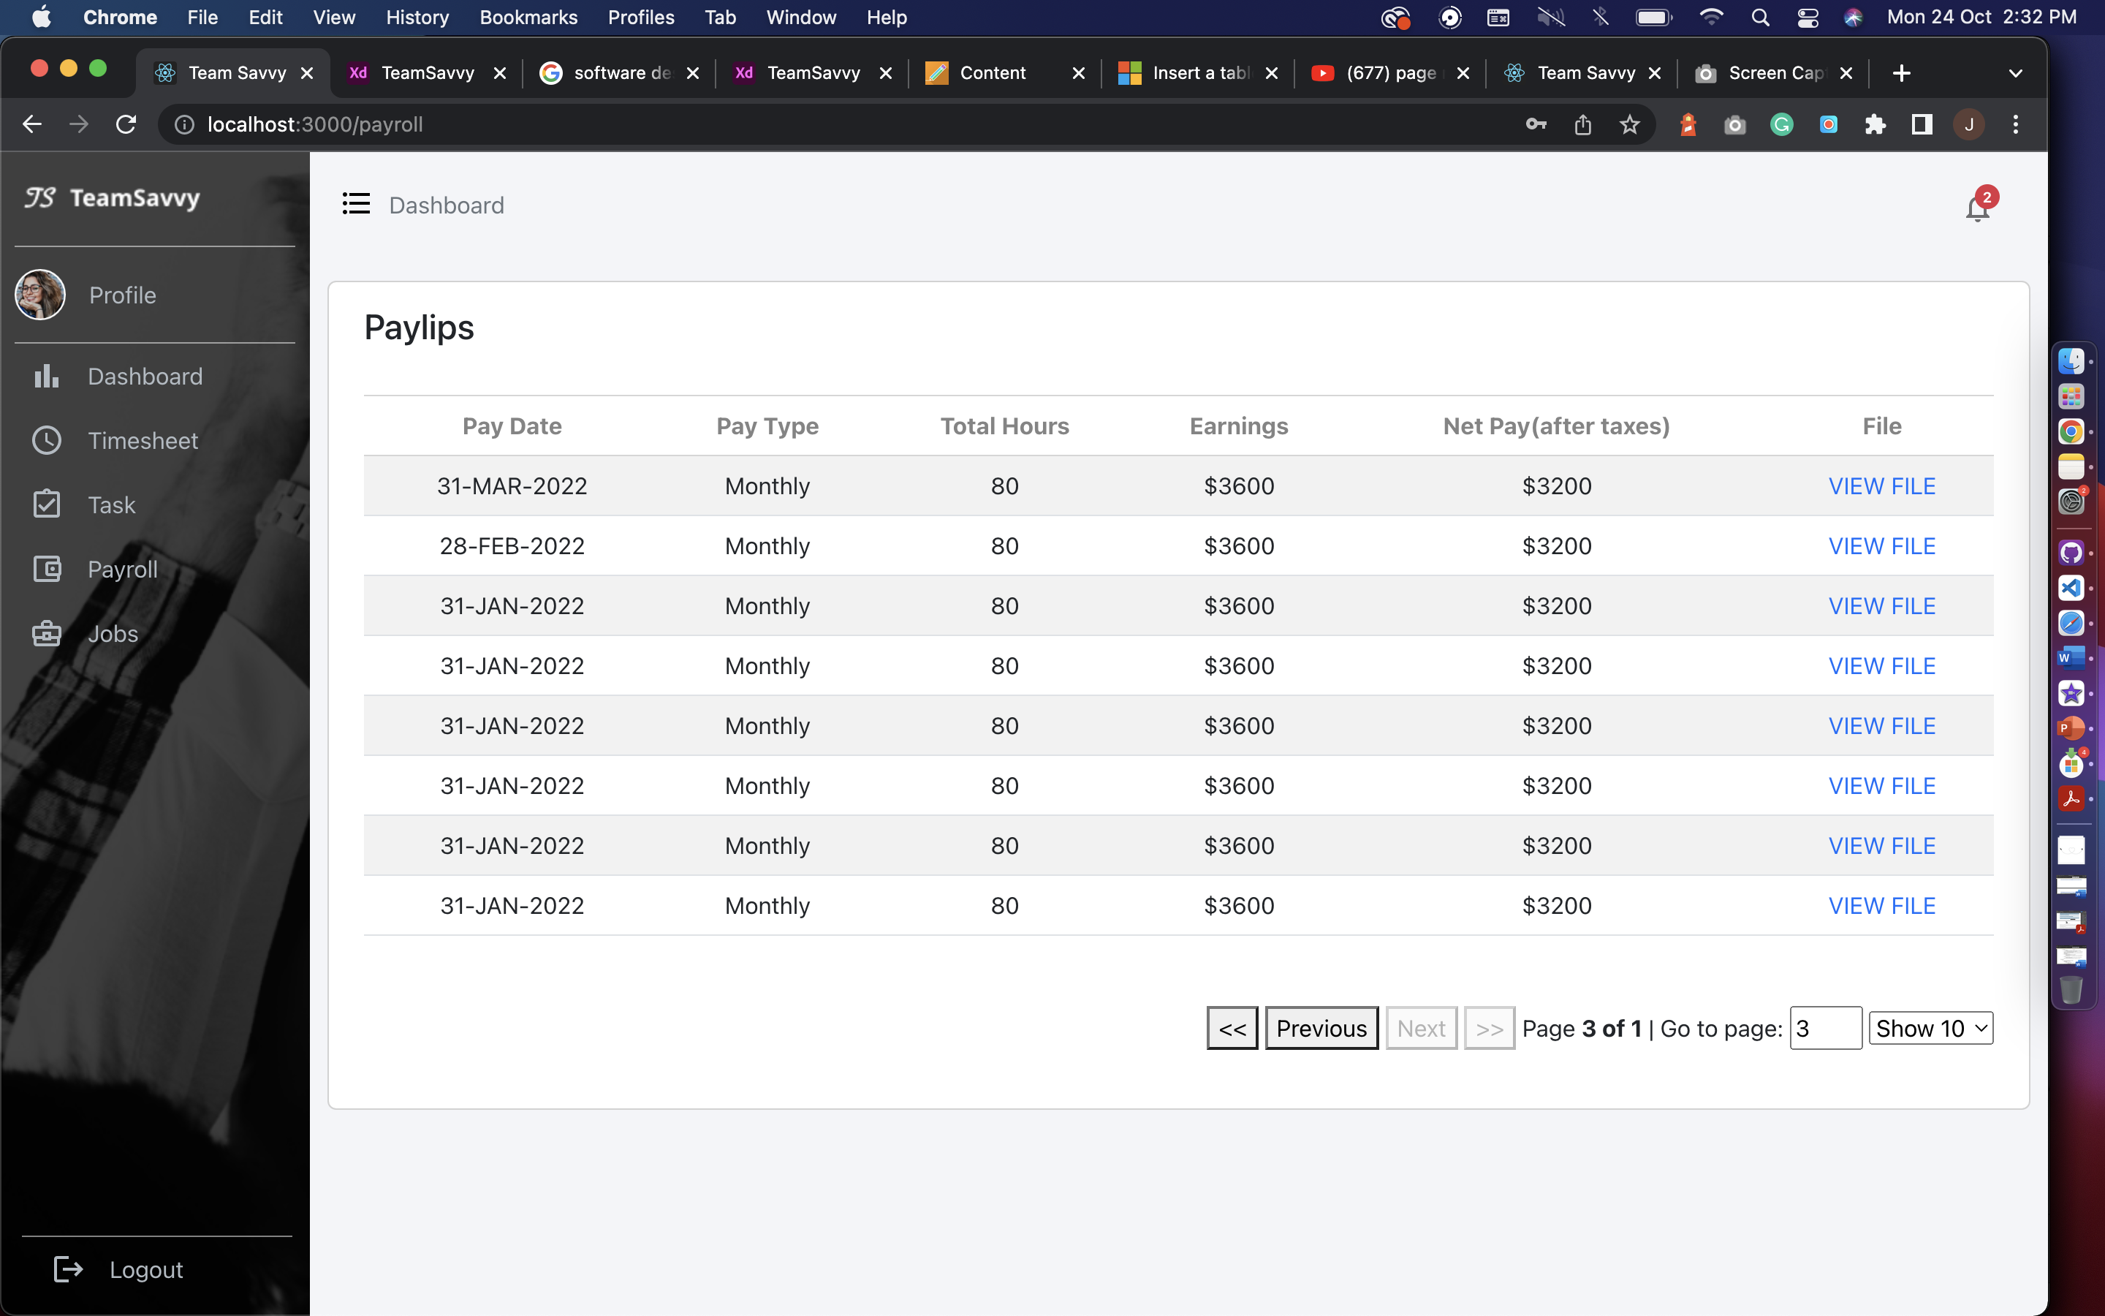

**Jobs:**The jobs page for employee have internal jobs created by HR and employee will not see the create job option. Employee can directly apply using Apply now button. HR will get the notification on their portal from where they can check the profile of an employee who applied.

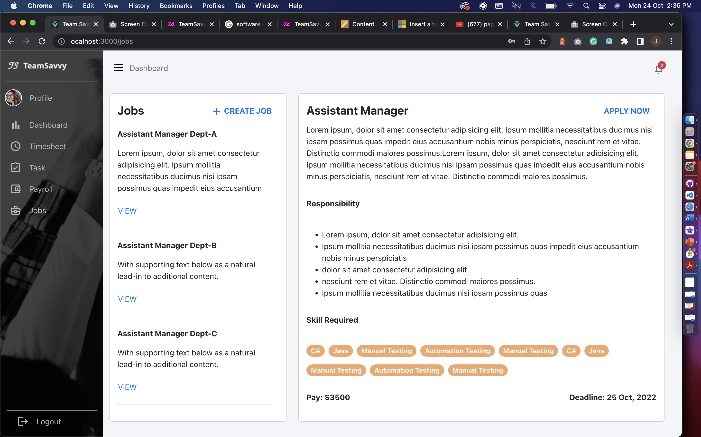

**Database**

We’ve created all the Tables that are required for the functioning of the Application. These tables interlinked with each other has all the attributes that gives us the glimpse of how the Application will work.

**Structure of the Database:**



**Tables in our database:**

* **Employee**: PK-EmpID, FK – AddressID, DepartmentID, ProjectID, RoleID, StatuesID, First Name, Last Name, DOB, HireDate, Phone, Extension, Email, Bank Account No.
* **Project**: PK- PojectID, FK – Project Manager ID, Project Name, Project Start Date, Project End date, Project Budget, Project Description, Total Task Count, Total Inprogress Count, Total Completed Count, Project Manager, Project Client, Project Load, Project Total Emplyee
* **Leave**: PK – Leave Type ID, FK – Employee ID, Leave Start Date, Leave End Date, Leave Days, Leave Approval Date, Leave Approved By, Leave Status
* **Employee_Leave**: PK – Employee Leave ID, FK – Employee Type ID
* **Employee_Project:** PK – Employee Project ID, FK – Employee ID, Project ID
* **Payroll**: PK – Payroll ID, FK – Employee ID, Pay ID, Pay Date, Pay Type, Total Hours, Earning, Net Pay, Pay_Vacation, Pay_Sick
* **Status**: PK – Status ID, Status_Type
* **Skill**: PK – Skill ID, Skill Name
* **Employee_Skill**: PK – Employee Skill ID,FK – EmployeeID, SkillID
* **Time_Sheet:** PK – TimesheetID, FK – EmployeeID
* **Role**:PK – RoleID, RoleName
* **Department**: PK – DepartmentID, DepartmentName
* **Job:** PK – JobID, FK – JobCategoryID , JobLocationID, DepartmentID, JobRoleID, JobSalary, JobDesc
* **Job Applied**: PK- Job Applied ID, FK – EmployeeID, JobID
* **Job Category:** PK – JobCategoryID, JobCategoryName, JobCategoryValue
* **Job Location**: PK – JobLocationID, FK – CityID, Location, PostalCode
* **Address:** PK – AddressID, FK - CityID, Apartment, Postal Code
* **City**: PK – CityID, CityName, FK – Province ID
* **Province:** PK – Province ID, FK – Country ID, ProvinceName, ProvinceAbbreviations
* **Country**: PK – CountryID, Country Name
* **Dashboard**: PK – DashboardID,FK – EmployeeID, WidgetID
* **Widget**: PK – WidgetID, FK – WidgetTypeID, WidgetName)
* **Widget_Type:** PK – WidgetTypeID, WidgetType
* **Task:** PK – TaskID, FK – EmployeeID, FK-ProjectID, TaskName, TaskDescription, TaskStartDate, TaskEndDate, TaskTotalHours, AssignedBy, AssignedTo, AssignedDate, TaskStatus
* **Salary**: PK – (SalaryID,SalaryIncdate), FK – EmployeeID, SalaryType, Salary



Above screenshot is about TeamSavvy database with all the tables required for application as of now and attaching the SQL script to generate the above database with tables and populate data.

**Pending Implementations:**

A Gantt chart, a Network Diagram and Timeline on Microsoft Project:

Network Diagram: We have completed the content under the green box so far. Every other task is in progress.



Gantt chart:



Timeline: We have completed the content under the green box so far.



**Dashboard, Timesheet UI, and logic**

* The dashboard requires to use additional chart tools and the data fetching and queries are more complicated. Hence, we need more time on this part.
* Timesheet page shows employee leaves, clock in/ clock out time and, allowing employee to manage leaves. We’re still figuring out how to implement the logic and debugging.

**Task, Job**

* Logic for task page is almost done. There is a status update issue with the connection to API. We will fix the logic before next report.
* For job page, we still haven’t implemented the connection for posting new jobs from HR and the logic when the employee clicks on apply now. Also, the applied button in HR view will show the corresponding employees’ profile.

**Database**

* Since we were focusing on the UI and logic, we haven’t populated enough data for showing and testing. We will insert more data to show so that the application will look more alive and reasonable.
* Also, while we’re doing the logic and connection, we found out that we might need to change the database a little to make the application more user-friendly. We will be keeping optimizing it.

**Proposed Revisions:**

As shown in the previous report, due to the restriction of device, we will only use mobile app for clock in/ clock out purpose for each employee without saving the biometric information to user database. This is because Android has restricted it and only shares the function for using.

## Progress report 3

**Statement of the Problem:**

The Employee Management Systemhelps create an environment that motivates communication and keeps employees and managers working together to meet company goals.It also helps the company to manage the information and activities of employees.

The issue with the existing system is to access data about employee projects, leaves, payroll, and jobs applied internally, for accessing these details an individual has to use different web platforms.

Our system proposes that a person can access the details for projects, work history, team hierarchy, peers, timesheets, leaves and payroll information on one platform. The managers and company owners can access the records of employees and also check the resume of the candidates who applied for jobs on their company website with an improved user interface for a better user experience.

**Significance of the study**

Who would benefit from this project and how?

**Employee Engagement:** Our platform will provide employees to add their details, apply for leaves, and check their work history and payroll details on one platform. This will save time for an individual to concentrate on tasks for company growth. Employees can track their growth and improve their working efficiency.

**Biometric:** We will create an android app to get user biometric timestamp and will store it in the database. Employee can use his biometric to clock-in and clock-out of the system.

**Create Dashboard:** Our project will provide the dashboard of collective data of employees. A manager or company owner can perform descriptive analysis on employee’s data; with respect to programming languages, projects, leaves (sick leave, casual leave) in specific period and, salary. **We will give different graph options to select from and, can create multiple graphs to visualize data and show the dashboard on preview mode and can download it.** The HR at a company can do analytics; for example, number of employees have knowledge of programming language, salary of each employee in specific project. We will represent this information in a graphical format.

**Create Task:** The employee can fill his hours he is working on a particular task and then change the status of task to in-progress, after completing the task employee can change the task status to finish. The notification will be sent to the manager that this task has been completed. Manager can track the progress of the tasks assigned to team members.

**Improve communication:** Our platform provides the information of each employee to others by search option that will let them to stay connected, and an easy path for new joiners to get to know their peers. All in all, improve the connection which will reduce the problem of communication gap within an organization.

**Users:**

Employee**:**

* An employee will have access to a calendar where he can see clock-in and clock-out for a day
* Check total working hours
* Apply for leaves
* Check his payroll details (Read only),
* Get information of other employee working in an organization for communication
* Can get the team hierarchy
* Check the number and details of projects he is working on
* Employee will have the profile page where he will have his information saved or can update if required
* Can apply on internal jobs
* Apply for resignation

Admin (HR or Manager):

* An admin will have all the functionality that employee has
* Able to see information of employees in his team
* He can perform CRUD operations on them
* Check payroll info and can give increment to an employee
* Admin will have details of project’s budget and deadline
* Can assign project to employee
* Modify involvement of employees in different projects,
* Can approve leaves of an employee
* Check timesheets
* Create internal job postings for employees.

Super admin (Company Owner): A super admin can perform CRUD operations on admins and employees.

**Project Implementations:**

**What have we done so far?**

**Test cases and proof of concept**

**APIs**

We have created Dashboard API for retrieving data for dashboard page.

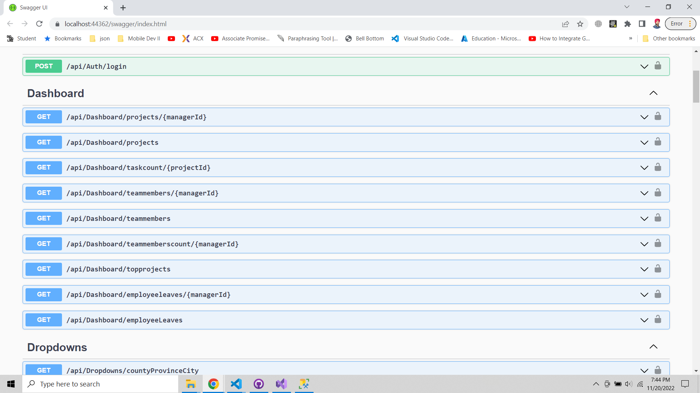

**Front-end**

**Team members**

This screen will display when manger click on dashboard widget team members and this can only be accessible by manager, for HR the widget and list will be employee list in the company.

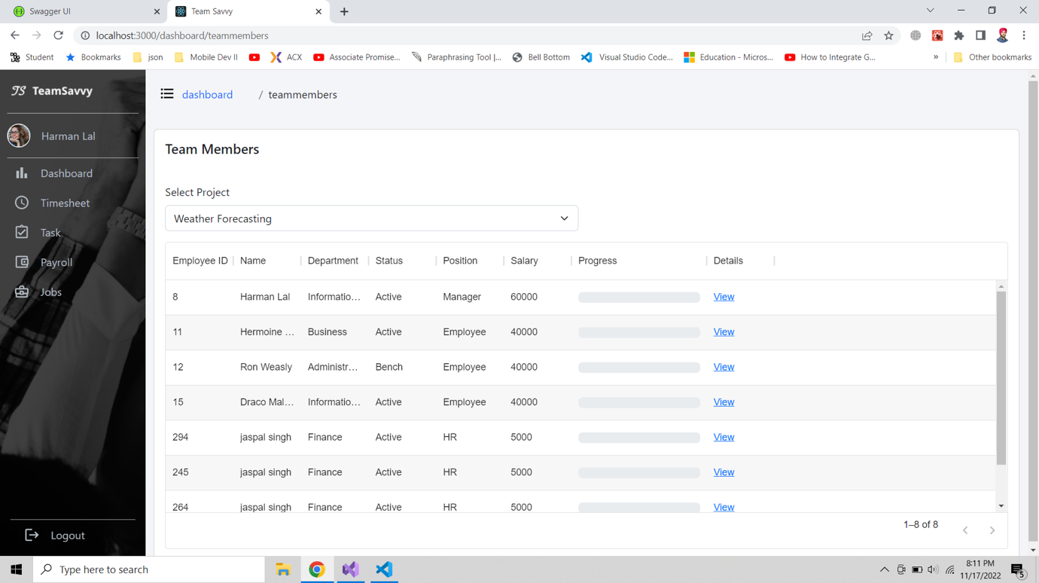

**Timesheet**

The screen have leave indicators, in and out time of an employee which will be connected from mobile app to the web platform. Employee can apply for leaves and delete applied leaves.



Employee can apply for leaves by clicking on date cell.

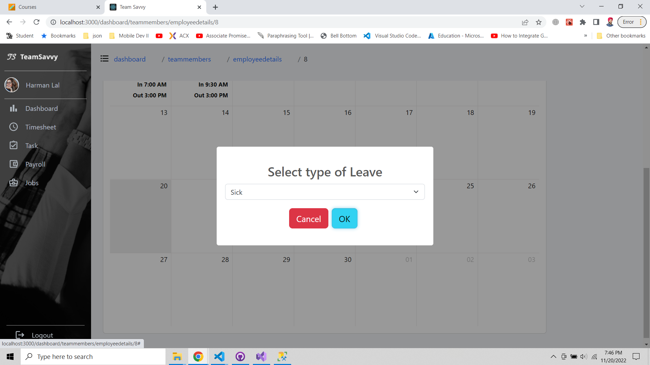

Leave added popup screen

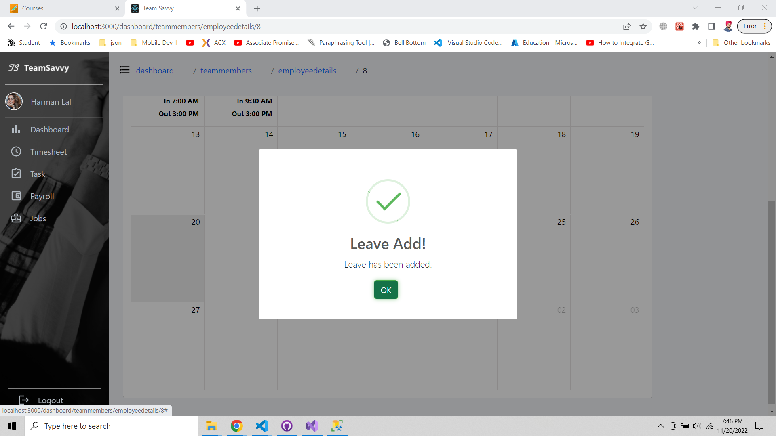

Leave has been added on the calendar

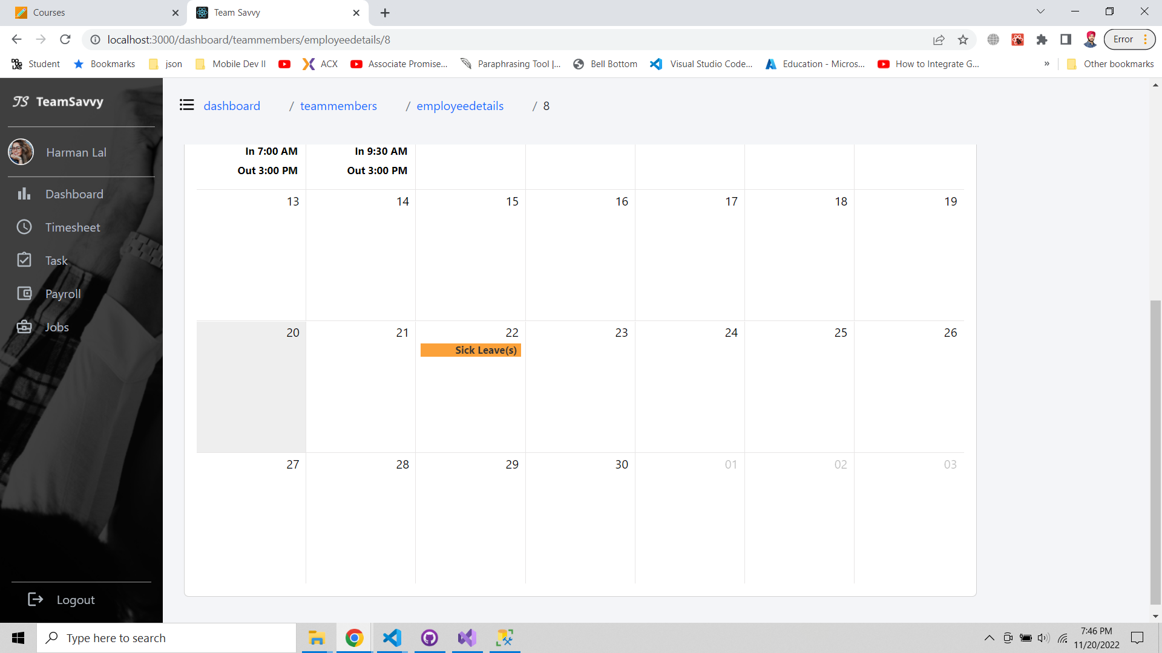

Delete leave popup screen.

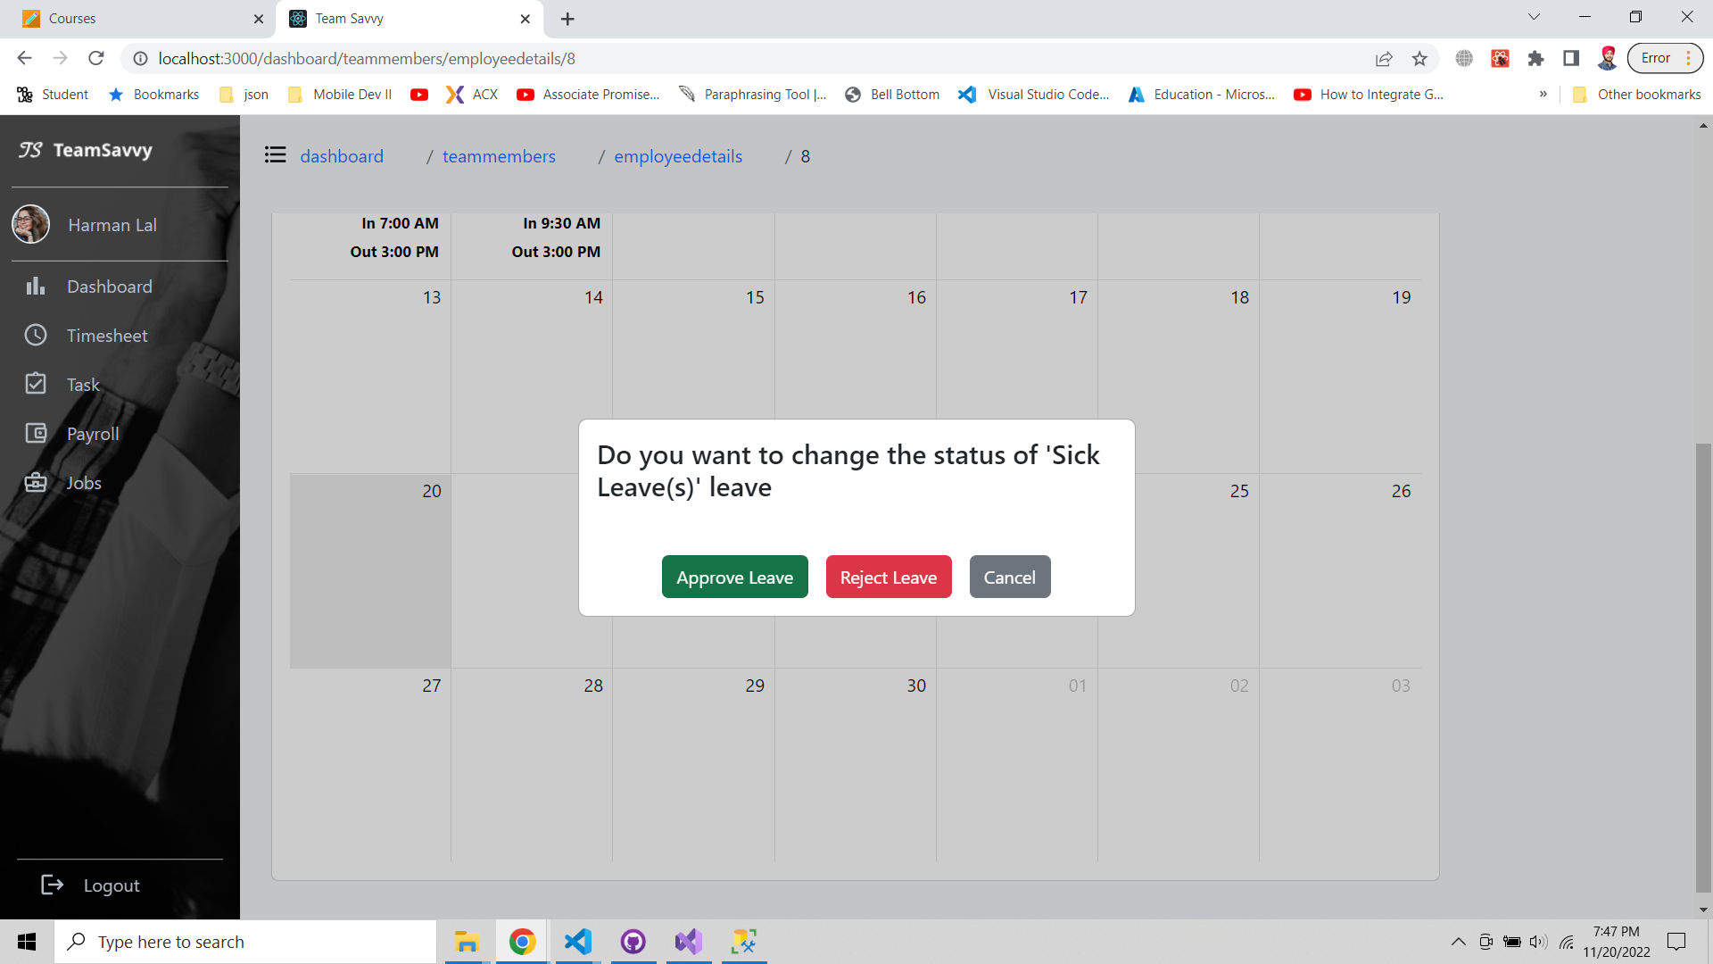

**Dashboard**

We are working on the add widget part and till now we have implemented the screen with three widgets for projects, employee list and jobs created for HR and for manager we have different widgets (projects, team members, tasks created). Bottom two widgets which have top 5 projects and leaves approval for both manager and HR on row click there is a popup to approve or reject leave.

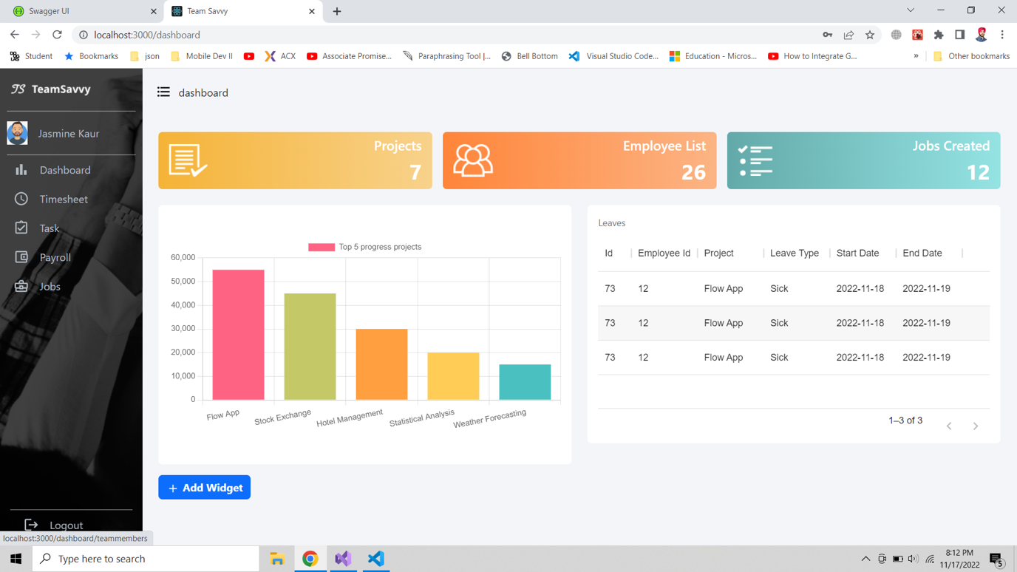

Manager or HR can save the graph as image for future use.



Reject or approve leave popup for HR or manager which will show user images, name, ID, contact details of an employee.



**Projects**

This screen have project list customised for HR and manager. HR can see all the projects in company and on click of view link, they can see project details which will have number of tasks created, completed and details of each task. Create project button is only for manager to create new project it will show popup for entering project details, end, start date and budget.

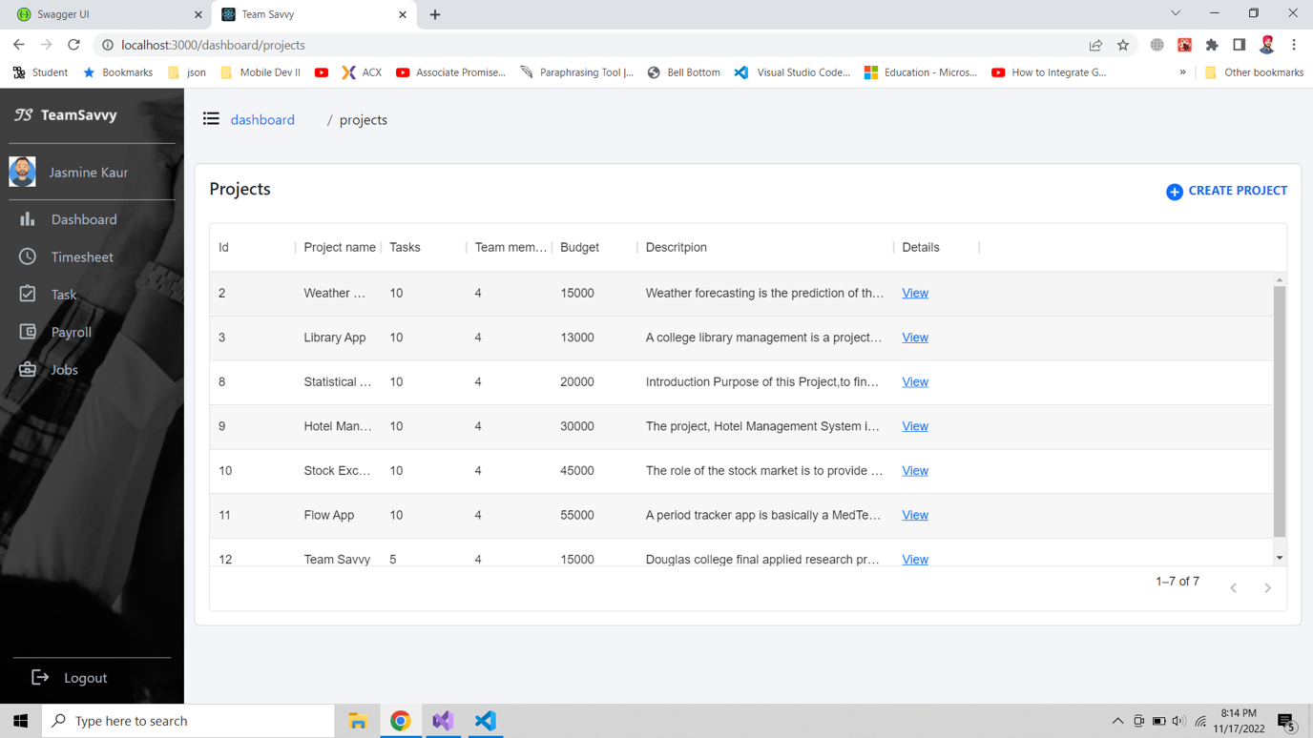

**Employee List**

This screen displayed after click on employee list widget in dashboard and this is for HR where they can check the employee details, check progress based on number of completed task and can also add a new employee by clicking on link and new page will open with empty profile to enter the details of new employee.

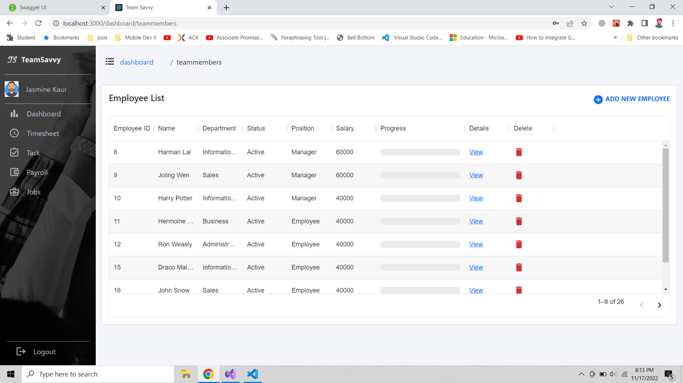

**Breadcrumbs**

We have implemented the breadcrumbs to move back from current page to back pages.

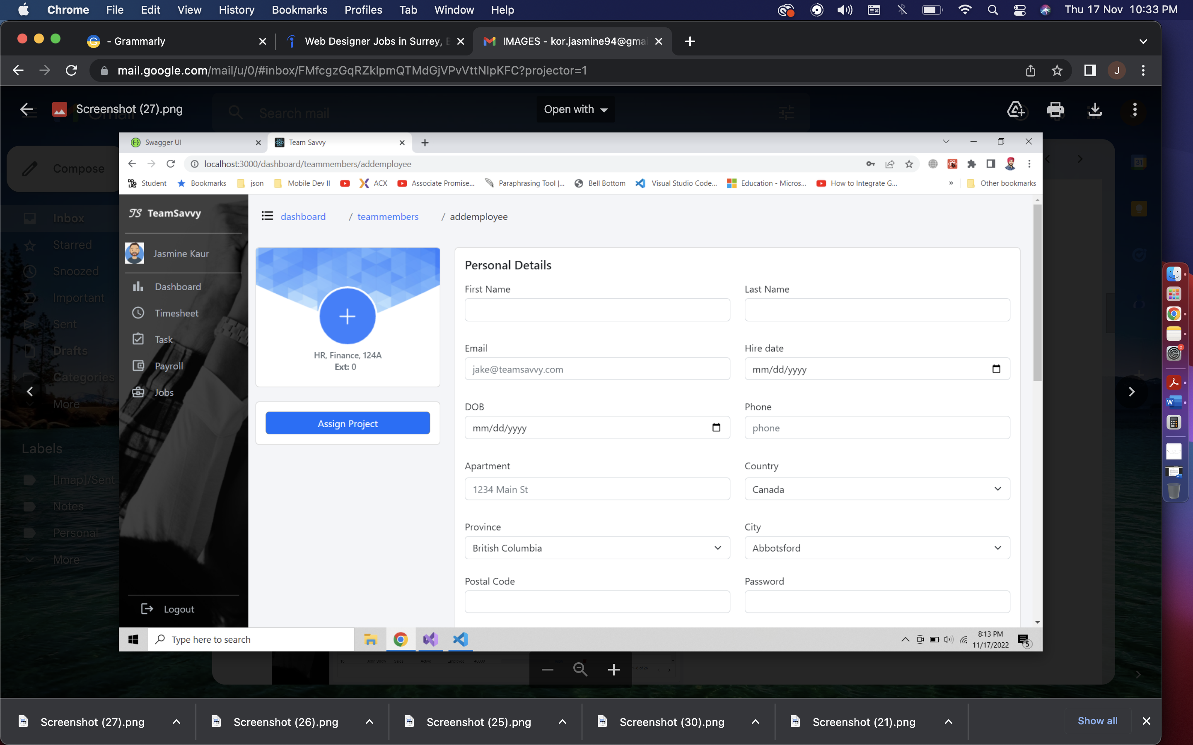

**Employee Details**

This screen will show the employee’s timesheet, task and profile within one page with different tabs. HR or manager can access all the details of an employee except payroll details.

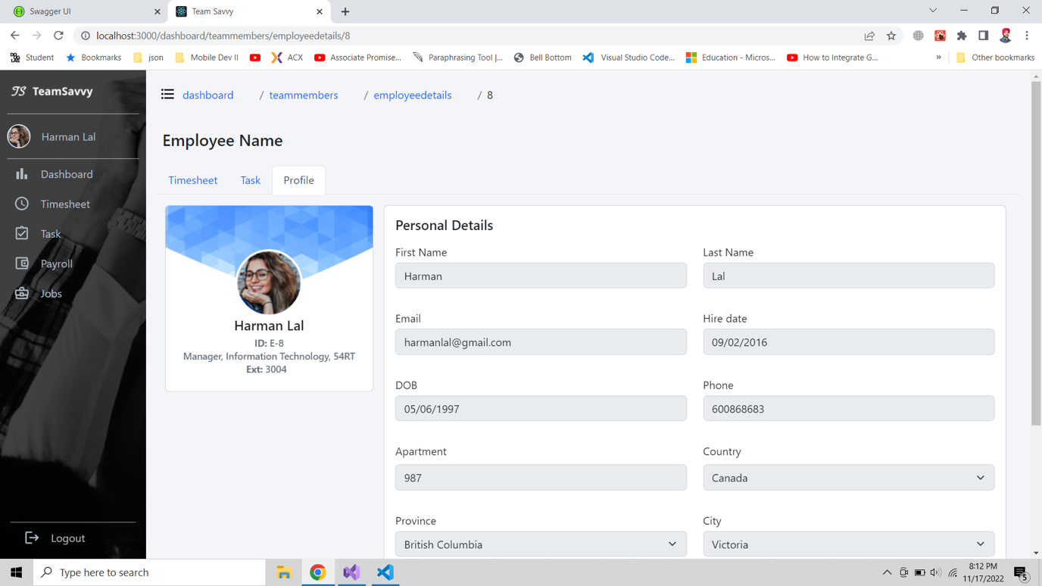

**Updated Job Details**

We have updated the job details page, added ‘Applied’ link for HR to see who has applied for this job, on click of it new page will be displayed with list of employees.

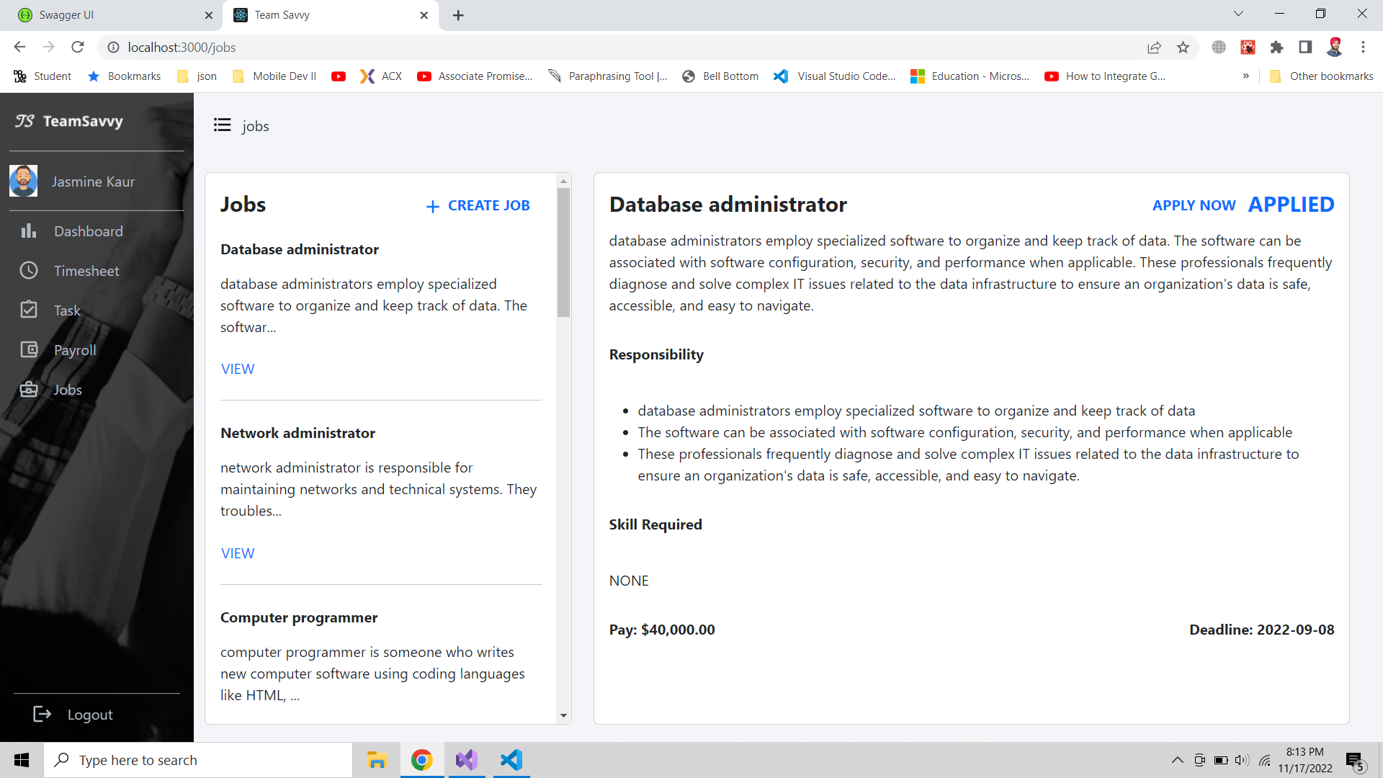

**Jobs Applied Employees**

The screen will have employees who have applied for a particular job.

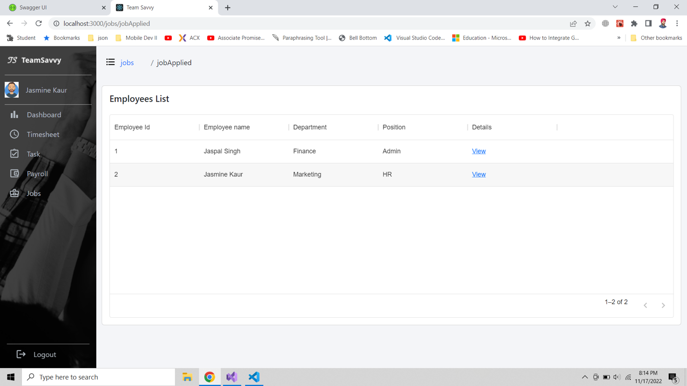

**Add profile image**

From this screen employee can update his profile image by selecting a file from system.



**Previous Project Implementations:**



Landing screen for an employee showcasing the project name, image, message for an employee for the attendance and loader.



This screen will ask employee for their employee

ID and allow him to clock-in or clock-out.

We are still working on design and few features.



After entering the employee id the button will be activated.



The app will ask for biometric verification, if the fingerprint matches to the record of fingerprint

in device the app will accept and allow user to clock-in or clock-out.



At last, the app will show the snack bar to show if an employee has been verified or not also displays the status clock-in or clock-out.

**APIs**

We have created API in .NET CORE using Entity Framework, LINQ, Automapper and swagger documentation.





This is the swagger documentation to give a user interface to an API so developer can test API like postman. In this interface we can test all the request like post, delete, update, and get request. Above are the endpoints for Auth (Authorization), Dropdown, Email, Employee, Employee Task, Leaves, Payroll, Projects and Timesheet controllers.









Above screenshots showing separate endpoints (GET,POST,PUT,DELETE) of all controllers created.

**UI Design using Adobe XD**

The snapshots below shows the flow of our application. Design Link:

<https://xd.adobe.com/view/732c0d35-1e41-41d7-876c-25bde1a844a9-267f/?fullscreen>

**Login:**

The employee and admin will login with the predefined credentials provided by organization.



**Timesheet:**

This screen will show the information of employee clock-in and clock-out, with total hours they worked per week. Additionally, employee can apply for leaves and it will be displayed on the calendar



**Task:**

Task screen will have the assigned task for an employee, which he can modify to add hours, start date, and end date. Employee can also change the status from assigned to in-progress and then by using update status in in-progress lane he can change status to completed.



**Payroll:**

This screen will have the collection of pay slips with information of each month, total hours, and earnings, from here user can view each pay slip. The Pay Slip contains all the Earnings of an employee at the company from the date he has joined.



**Internal Jobs:**

This screen will display employee with the internal jobs postings which he can read the description and apply for the jobs.



**User Profile:**

This screen will show the personal details, team members, position, department, skill set and bank details of an employee.



**Dashboard:**

This screen is for manager and HR, here they can view projects, team members, tasks, and other information. This screen will also have feature to create graphs widgets with predefined dropdowns. Manager can download, modify and delete the graph.



**Front-end**

We started working with react js, bootstrap for developing our front-end with responsive screens, we decided to start with role ’employee’. Pages we have achieved so far:

**Login:**

This screen will allow users to login with credentials provided by organization or can reset password using OTP







**Sidenav:**

The animated sidebar with navigation links to access the platform.

 

**Open** **Closed**

**Header and Navigation:**

Header has dashboard title which will be breadcrumb for navigation and notification with indicator, it is hardcoded for now. We will work on it after midterm.



**User Profile:**

The user profile page has employee information, which is consist of Personal details, Team members with their contact details, Skill set and add new skill option, bank details, and resign option. From here HR or manager can get the overview of an employee and what skills they acquire.



**Timesheet:**The Calendar is generated with react-big-calendar which has custom tags for leaves and popups for deleting existing leaves and add new leave. Also have clock-in and clock-out indicator. The page also has Worked total hours per week for an employee.



**Task:**The task page has feature to show assigned, in progress and completed tasks for an employee. We are assuming the employee only working in one project at a time. On click of modify task user will get pop-up to add hours and change status of the task. On update status, the employee can only change status to completed task.



**Payroll:**The payroll has payslips screens where employee can check the list of paystubs and also can view the paystubs individually by clicking on view file.



**Jobs:**The jobs page for employee have internal jobs created by HR and employee will not see the create job option. Employee can directly apply using Apply now button. HR will get the notification on their portal from where they can check the profile of an employee who applied.



**Database**

We’ve created all the Tables that are required for the functioning of the Application. These tables interlinked with each other has all the attributes that gives us the glimpse of how the Application will work.

**Structure of the Database:**



**Tables in our database:**

* **Employee**: PK-EmpID, FK – AddressID, DepartmentID, ProjectID, RoleID, StatuesID, First Name, Last Name, DOB, HireDate, Phone, Extension, Email, Bank Account No.
* **Project**: PK- PojectID, FK – Project Manager ID, Project Name, Project Start Date, Project End date, Project Budget, Project Description, Total Task Count, Total Inprogress Count, Total Completed Count, Project Manager, Project Client, Project Load, Project Total Emplyee
* **Leave**: PK – Leave Type ID, FK – Employee ID, Leave Start Date, Leave End Date, Leave Days, Leave Approval Date, Leave Approved By, Leave Status
* **Employee_Leave**: PK – Employee Leave ID, FK – Employee Type ID
* **Employee_Project:** PK – Employee Project ID, FK – Employee ID, Project ID
* **Payroll**: PK – Payroll ID, FK – Employee ID, Pay ID, Pay Date, Pay Type, Total Hours, Earning, Net Pay, Pay_Vacation, Pay_Sick
* **Status**: PK – Status ID, Status_Type
* **Skill**: PK – Skill ID, Skill Name
* **Employee_Skill**: PK – Employee Skill ID,FK – EmployeeID, SkillID
* **Time_Sheet:** PK – TimesheetID, FK – EmployeeID
* **Role**:PK – RoleID, RoleName
* **Department**: PK – DepartmentID, DepartmentName
* **Job:** PK – JobID, FK – JobCategoryID , JobLocationID, DepartmentID, JobRoleID, JobSalary, JobDesc
* **Job Applied**: PK- Job Applied ID, FK – EmployeeID, JobID
* **Job Category:** PK – JobCategoryID, JobCategoryName, JobCategoryValue
* **Job Location**: PK – JobLocationID, FK – CityID, Location, PostalCode
* **Address:** PK – AddressID, FK - CityID, Apartment, Postal Code
* **City**: PK – CityID, CityName, FK – Province ID
* **Province:** PK – Province ID, FK – Country ID, ProvinceName, ProvinceAbbreviations
* **Country**: PK – CountryID, Country Name
* **Dashboard**: PK – DashboardID,FK – EmployeeID, WidgetID
* **Widget**: PK – WidgetID, FK – WidgetTypeID, WidgetName)
* **Widget_Type:** PK – WidgetTypeID, WidgetType
* **Task:** PK – TaskID, FK – EmployeeID, FK-ProjectID, TaskName, TaskDescription, TaskStartDate, TaskEndDate, TaskTotalHours, AssignedBy, AssignedTo, AssignedDate, TaskStatus
* **Salary**: PK – (SalaryID,SalaryIncdate), FK – EmployeeID, SalaryType, Salary



Above screenshot is about TeamSavvy database with all the tables required for application as of now and attaching the SQL script to generate the above database with tables and populate data.

**Test Cases and screenshot: Testing the API gives the following results:**

**Checking the Employee Database:**

In this we enter the employee id which will correspond to the employee details associated to the database. As an output of this we get the response from the API with desired user details.

**To add a new Employee :**

When HR enter the details of a new employee. The API will save the data from frontend to database. This part of the API needs fixation as so far we’re not able to add the Employee. It will generate an error stating that response status is 400.





Due to this **Deletion of an Employee** cannot bedone.

**Jobs :**

The job API retrieves the data from database that is related to the Jobs posted in the company.



**Add a Job:**

While adding a new job, generate a new job posting with required attributes. Simliar to adding the Employee, this part gives an error code 400 as well.

Therefore, the deletion of a job will not proceed as well.

**Payroll:**

Payroll API gets the data of monthly salary associated to each employee. And holds the record of all the increments, deduction, Sick pay, Vacation pay, Number of hours an employee has worked on monthly bases. Calculating all these attributes gives the actual payment associated to each employee.





**Payroll List with respect to Employee ID :**

This API will use employee id and show all the information of payroll receipts that employee has received throughout the Year.



**Projects:**

This will display all the projects that are undergoing in the company with detailed information associated to Employee Id and Project Id.





**Project with respect to Employee ID:**

****This API will use employee id and display the projects that are associated to that employee. Managers are assigned more than one projects so this will give the information of all the projects a manager is monitoring over.



**Adding a New Project:**

This API will get information from Create Project screen and . Since, project Id is primary key this will be added automatically in the Database.



**Deleting a Project:**

It will ask user to enter the project Id that user wants to delete and it will erase the row associated to that project id in the Database.



**Fetch API & Client side React code**

After creating the front-end UI and back-end logic, from this stage we are focusing on connecting the front-end and back-end together. Although different React structures are still used widely, we chose the most popular and on trend one – hook, to manage the data flow. Since we have 21 tables and populating data takes time, the pages may seem empty. However, the data now is mostly dynamic and be able to maintain using CRUD.

**Profile Update**

* Fetching and putting employee data from/ to API
* Adding skills showing on page as badges
* After clicking on resignation, system will send notification to manager’s email



Figure 1: employee profile update to database



Figure 2: multiple skills can be added and deleted



Figure 3:simplify resignation process allowing employee to send auto resignation email to manager by simple click

**Modify and validate task:**

* Fetch data from api: get assigned jobs list
* Modal input validation: validate input at run time, preventing modal from closing if data is empty or not correct.
* Put request: update modified task to api using http put request



Figure 4: simple validation for input. Modified task will be updated to database

**Payslips and pay stub**

Fetching data from payroll and employee API, using Links to pass prop and render detail in the child page



Figure 5: Fetch payslips data for individuals. Paystub details will be shown in view file.



Figure 6: Passing data from payroll and employee api

**Jobs**

* View change according to the employee role. For example, engineer won’t be able to create jobs and see the applied details
* Fetching data from Jobs API, clicking on the view will show the corresponding detail on the right-side card.
* Clicking on Create Job shows the job creating card. The post request here hasn’t implemented yet.
* Clicking on the applied button shows the employee applied for this job. The detail link will then show the employee’s profile.



Figure 7: hr view of job page



Figure 8:employee view of job page



Figure 9: create new internal job card



Figure 10: hr view of employees applied for this job

**Front-end**

We started working with react js, bootstrap for developing our front-end with responsive screens, we decided to start with role ’employee’. Pages we have achieved so far:

**Project List:**

This list depicts the Information about the projects under manager or for HR total number of projects in organization. The screen will have project names, number of tasks assigned, number of team members in each project, project budget, project description and view link to show project details.



Create project popup for manger to add new project in the list



Project details page is for managers to assign tasks to employees in his team. It also has a simple statistic to manage the process of project by showing how many tasks are still in progress and how many are completed.



Create task for creating new task in current project and assign an employee.



**Team Members:**

The screen will show the team members in the project selected from the list and Bench and Add new employee will only be shown to HR. It will have employee name, Dept , position, salary, progress and manager can delete the team member from this table and view button to show details about each team member.



From view link the manager or HR can see employee’s timesheet, task and profile.



HR can assign project to an employee from bench button



HR can add new employee by clicking on add new employee and can add below given details.

**Pending Implementations:**

A Gantt chart, a Network Diagram and Timeline on Microsoft Project:

Network Diagram: We have completed the content under the green box so far. Every other task is in progress.



Gantt chart:



Timeline: We have completed the content under the green box so far.



**Dashboard and logic**

* The dashboard page has custom chart creation we are working on that part, there are some UI and logic changes.
* Timesheet page shows employee leaves, clock in/ clock out time and, allowing employee to manage leaves.

**User Interface**

* We are fixing user interface to make our web platform responsive and also some elements to make them according to our initial design.

**Task, Job**

* Logic for task page is almost done. There is a status update issue with the connection to API. We will fix the logic before next report.
* For job page, we still haven’t implemented the connection for posting new jobs from HR and the logic when the employee clicks on apply now. Also, the applied button in HR view will show the corresponding employees’ profile.

**Database**

* Since we were focusing on the UI and logic, we haven’t populated enough data for showing and testing. We will insert more data to show so that the application will look more alive and reasonable.
* Also, while we’re doing the logic and connection, we found out that we might need to change the database a little to make the application more user-friendly. We will be keeping optimizing it.

**Proposed Revisions:**

As shown in the previous report, due to the restriction of device, we will only use mobile app for clock in/ clock out purpose for each employee without saving the biometric information to user database. This is because Android has restricted it and only shares the function for using.

We are not able to implement total hours as we are using react big calendar library which is not allowing us to give exact row location of per week.